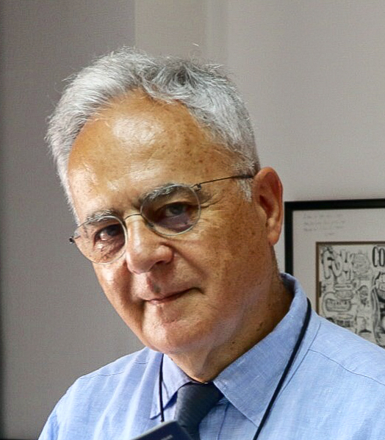

Haluk Topaloglu MD
Director of Pediatric Neurology
Yeditepe University, Istanbul, Turkey
Former Head of Pediatric Neurology, Hacettepe University Children’s Hospital, Ankara, Turkey
Secretary General, World Muscle Society

Dr. Topaloglu graduated from Hacettepe School of Medicine in Ankara, Turkey in 1978 where he finished his Pediatric residency in 1982. He completed a Child Neurology fellowship in the Dept. of Pediatrics at the University of Calgary, Alberta, Canada in 1985. He then held the Christine Saunders Memorial Fellowship in Neuromuscular Disorders at the Royal Postgraduate Medical School of Hammersmith Hospital, Dept. of Paediatrics and Neonatal Medicine in London, UK, in 1995. In 1996, he was appointed Professor of Pediatrics at Hacettepe University Children’s Hospital in the Child Neurology Unit in Ankara becoming Division Head in 2014. In 2020, he moved to Istanbul to set up Child Neurology in the Pediatric Dept. at Yeditepe University.

Dr. Topaloglu actively serves on the boards of national and international societies including International Child Neurology Association, Infantile Seizure Society, and World Muscle Society for which he has been the Secretary General for 18 years since 2002, and through which he is a strong advocate for best standards of care. He is on the Scientific Board of Française contre les Myopathies since 2016, and Head of the Muscular Dystrophy consortium (2017-2019). He is a member of the Turkish Academy of Sciences (TÜBA). In his role on Scientific Committees, he has helped to organize > 20 international meetings. He also serves on the editorial boards of Neuromuscular Disorders (as Associate Editor), Neuropediatrics, and J. of Neuromuscular Diseases.

Dr. Topaloglu’s research interests include Pediatric Neuromuscular disorders in which he has characterized new disorders, Neurogenetics, Developmental disorders, and more recently phase II/III Clinical Trials in muscular dystrophies and spinal muscular atrophy (SMA). He and his department have assisted in the development of novel drugs for muscular dystrophy and SMA through international multi-centre clinical trials, certain of which are currently in the market.

Dr. Topaloglu is recipient of the medical research award from Hacettepe University (2002), and the medical research award from the Turkish Scientific and Technical Research Council (TÜBİTAK) (2003), the most prestigious award in Turkey. He was also awarded the Gaetano Conte Academy prize (2015) from the Mediterranean Society of Myology. He has published over 250 peer-reviewed articles with an h factor of 55 and has given over 100 international talks. He is deeply committed to teaching and mentorship of the next generation of child neurologists.

