Charles Newton: Biosketch

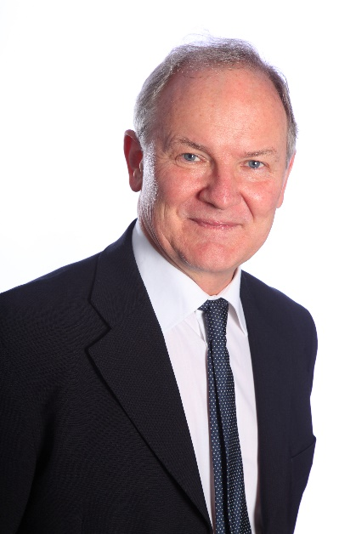
Charles Newton was born in Kenya, qualified at the University of Cape Town, South Africa. He did his postgraduate training in Paediatrics in Manchester and London, United Kingdom (UK). As a lecturer at the University of Oxford, he returned to Kilifi Kenya in 1989, to set up a unit to study severe malaria in African children. Thereafter he spent 2 years as a Postdoctoral fellow at Johns Hopkins, USA; studying mechanisms of brain damage in central nervous system infections. He completed his training in Paediatric Neurology at Great Ormond Street Hospital, UK. In 1998 he was awarded a Wellcome Trust Senior Clinical Fellowship at University College London, to return to Kilifi, to study CNS infections in children. He conducts research on brain infections in children; epidemiological studies of epilepsy and neurological impairment; tetanus, jaundice and sepsis in neonates. At present, he is conducting studies of Neurodevelopmental disorders and Epilepsy in Africa. In 2011 he took up a professorship in Psychiatry at the University of Oxford to concentrate on the neurological and neurodevelopmental disorders in children living in Africa. He has experience of the management of children with neurological disorders in 7 countries on 4 continents (Africa, Asia, Europe and North America).
Charles has published over 300 peer-reviewed research papers, 75 peer-reviewed review papers, and 40 chapters on a wide range of neurological topics. He has supervised over 20 PhD students on neurological and mental disorders of children. He has worked with international organizations, such as the International Brain Research Organization and the World Health Organization producing guidelines on epilepsy, neurodevelopmental disorders, brain infections and most recently on the support the families of children with neurological problems.
Charles has been an active member of the Executive Board of ICNA since 2002, sitting on following committees: Research; Technology; Education, Nomination and Selection Committee for the Sheila Wallace Award. He has organised ICNA meetings in Africa and Asia, lectured at ICNA meetings in Europe, Asia and North America.
He was the Senior Editor for the International Review of Child Neurology Series (2006 – 2014) and founding editor of ICNApedia. He is the founding and editor-in-chief of the Journal of International Child Neurology Association (JICNA) and is preparing for its recognition by PubMed.

