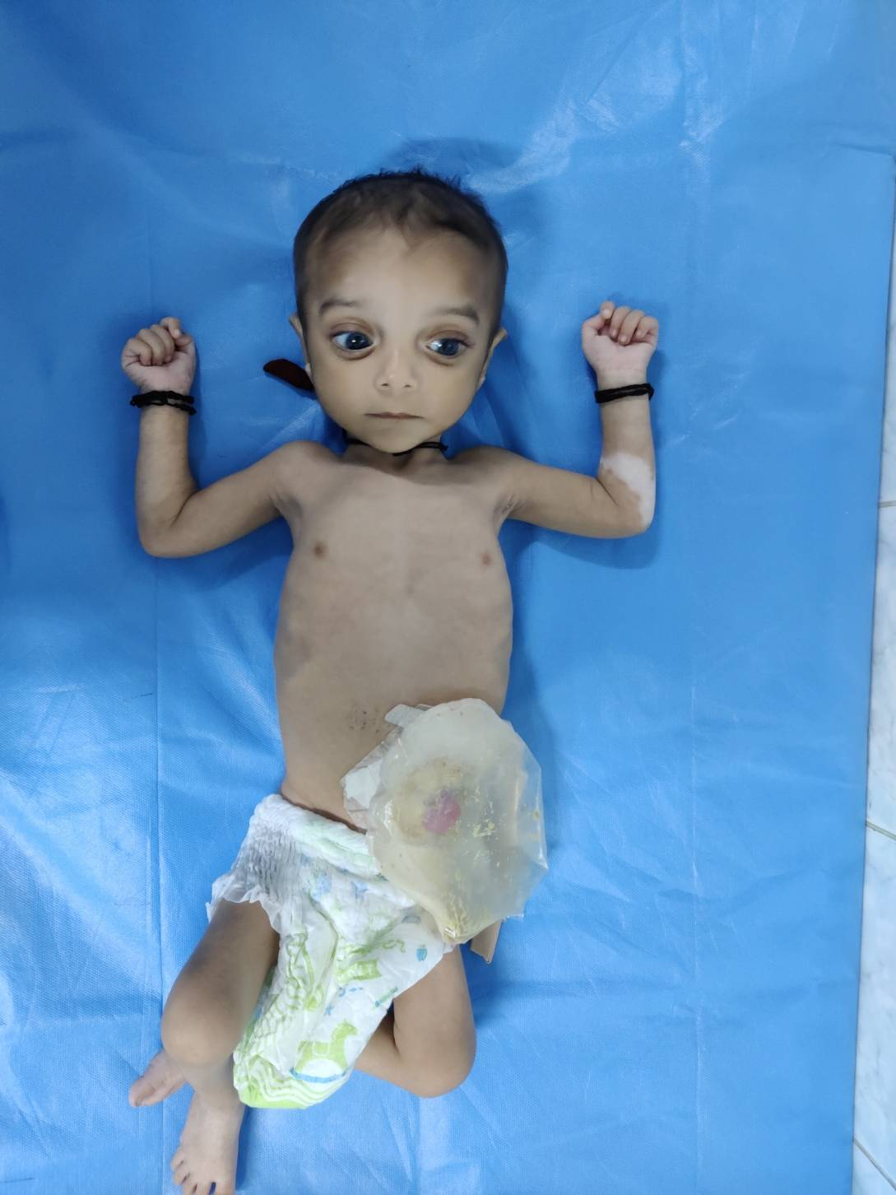

Figure 1: Proband showing a Hypopigmented vitiligenous patch on the anterior aspect of left forearm and a colostomy bag attached at the site of left iliac fossa following surgery for Hirschsprung disease.

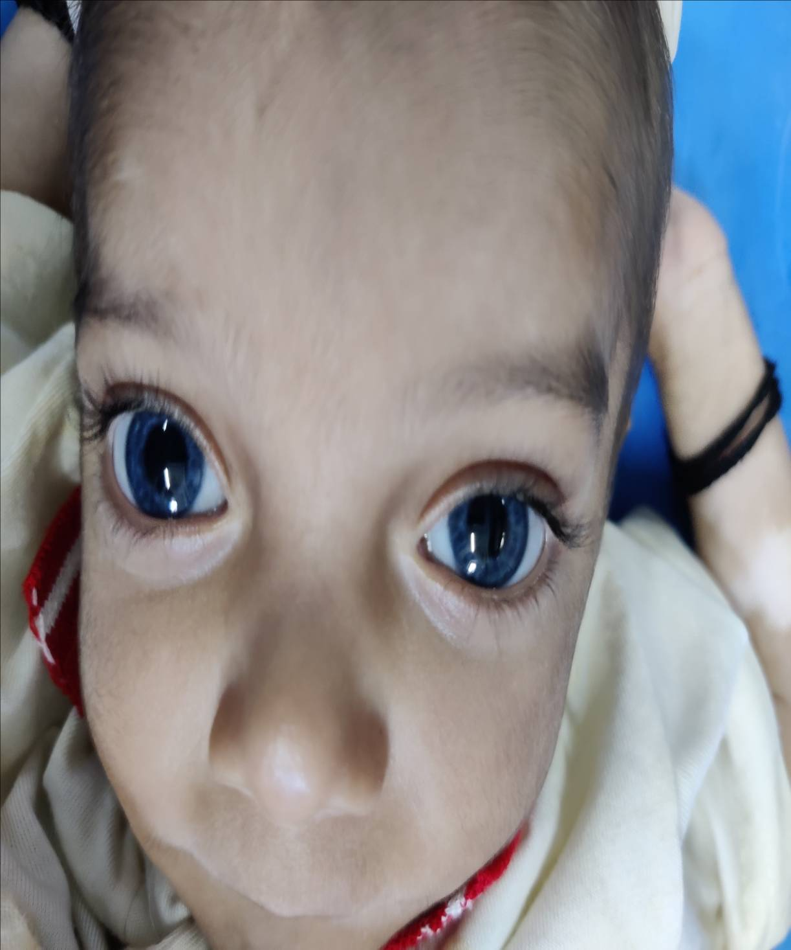

Figure 2: Proband showing Heterochromia Irides