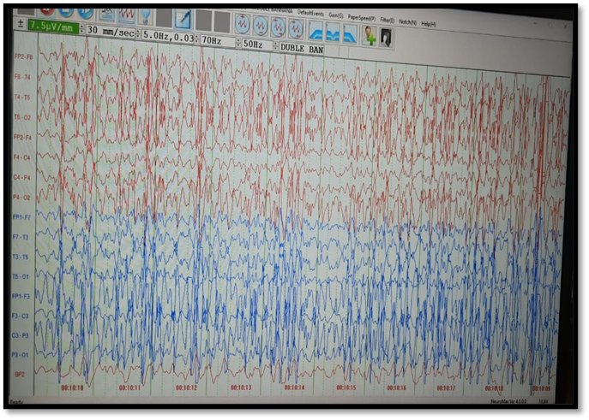

Figure 1: EEG is showing electrical status epilepticus. Day 1 OF IMMUNOTHERAPHY started (Inj Methylprednisolone and Inj Immuno globulin given)

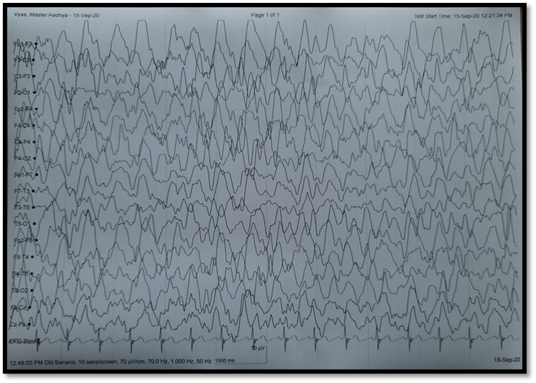
Fig 2: Below shown EEG (done on Day 4 after onset of immunotherapy) shows generalised slowing of background activity with interspersed spike and wave activity, improved compared to previous EEG at this point immunotherapy escalated and Inj Rituximab given

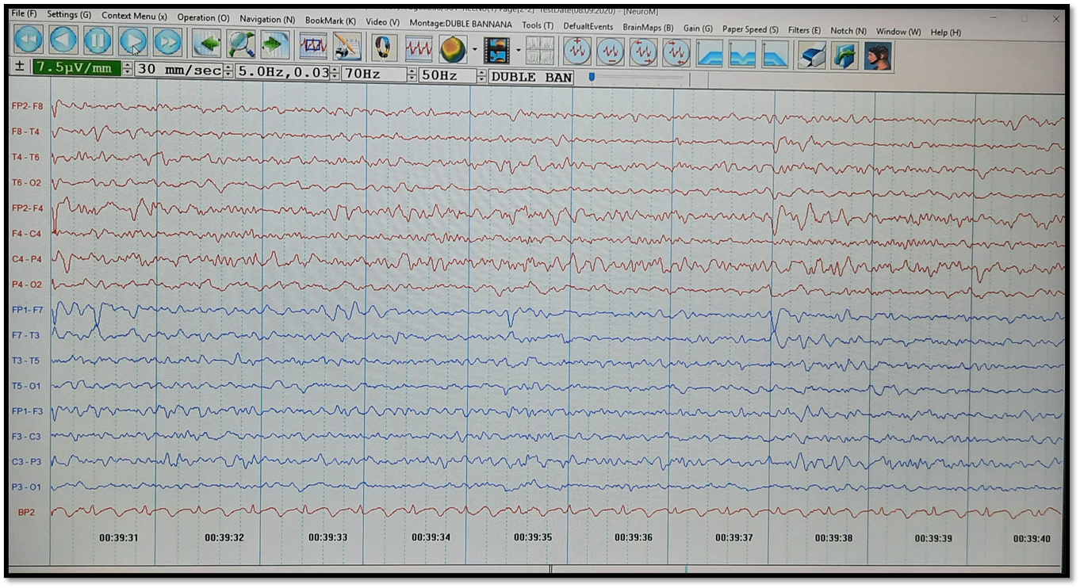
Fig 3(same patient): Day 8 after the onset of immunotherapy.No pharmacological coma was given.Seizure termination is achieved. :-This EEG shows significant improvement in the background activity with only occasional sharp activity along with clinically substantial improvement in consciousness and cessation of clinical ictal activity.

