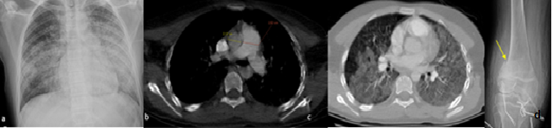

**Figure 1**: On the plain chest radiograph, alveolar opacity and consolidations are observed in bilateral diffuse tendency to coalesce (a). Pulmonary CT angiography shows a diffuse alveolar damage pattern in the form of ground-glass areas with a diffuse bilateral convergence tendency in the lung parenchyma (b) and enlargement of the pulmonary trunk (c). An impacting fracture (yellow arrow) in the distal femur is observed in the anterior-posterior knee joint.

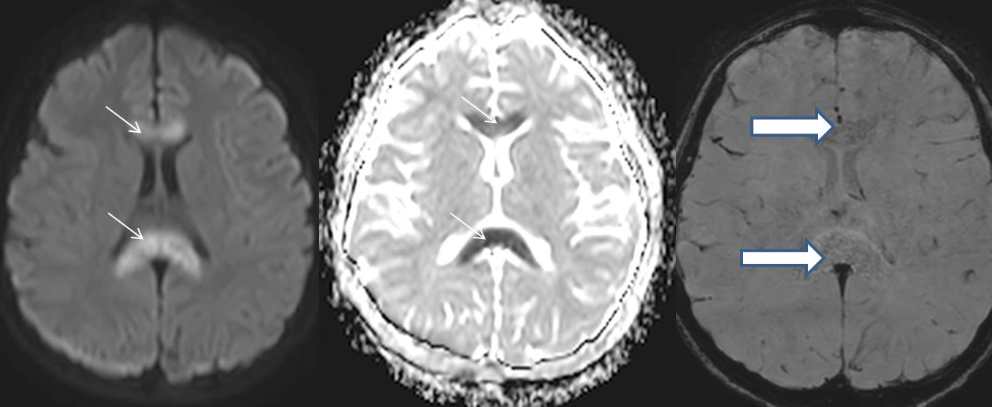**Figure 2:** Diffusion weighted imaging b1000 (a) and appearent diffusion coefficient (ADC) map (b) show extensive diffusion restriction of corpus callosum (thin arrows) with minimal punctate foci of susceptibility (thick arrows) best seen on the ven bold sequence (c).