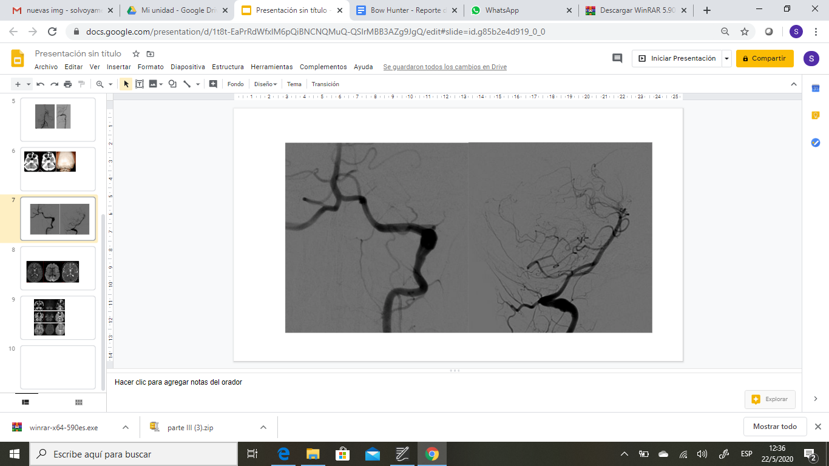
Fig1. Left vertebral artery selective digital angiography, front (a) and side view (b). Fusiform focal dilation in segment V3 compatible with pseudoaneurysm. No associated thrombus is detected.

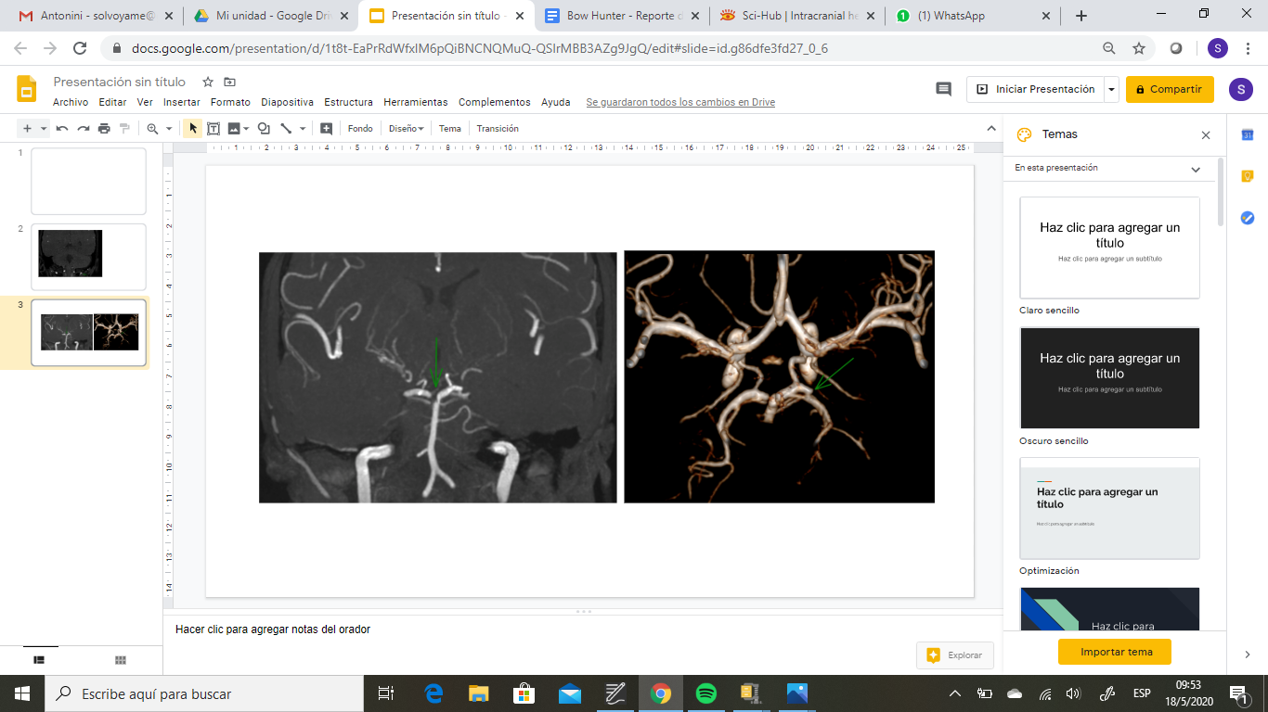
Fig2. Magnetic resonance angiography, MIP technique (a) and 3D reconstruction (b). A filling defect is observed in the right portion of the distal basilar artery (a). The distal segment of the left posterior cerebellar artery is absent (b).

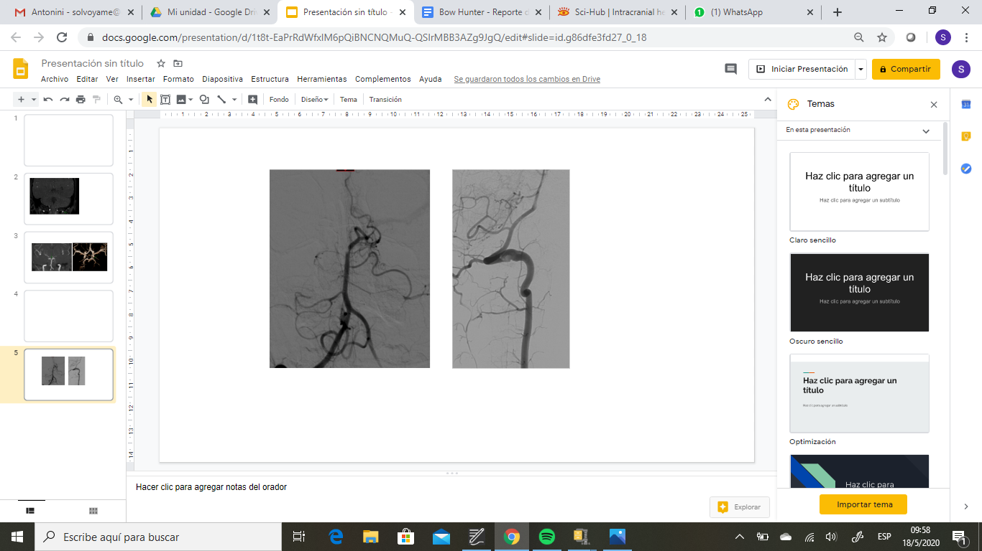

Fig3. Digital angiography of the posterior circuit showing both vertebral arteries and the basilar trunk (a) as well as the left vertebral artery (b). A filling defect is present in the right segment of the distal basilar artery similar to the MRA findings. Irregular contour of the vertebral artery in V3 segment (b) with a dissection flap observed in the basal portion and a small filling defect consistent with associated thrombus.

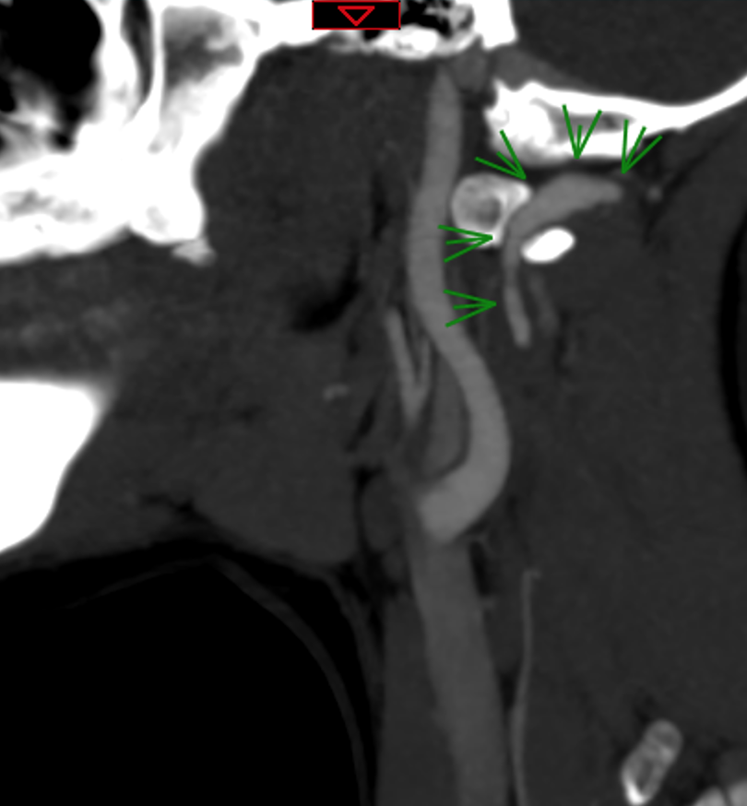
Fig4. Left paracondylar process, which constricted V3 and V4 segments of the left vertebral artery (LVA).

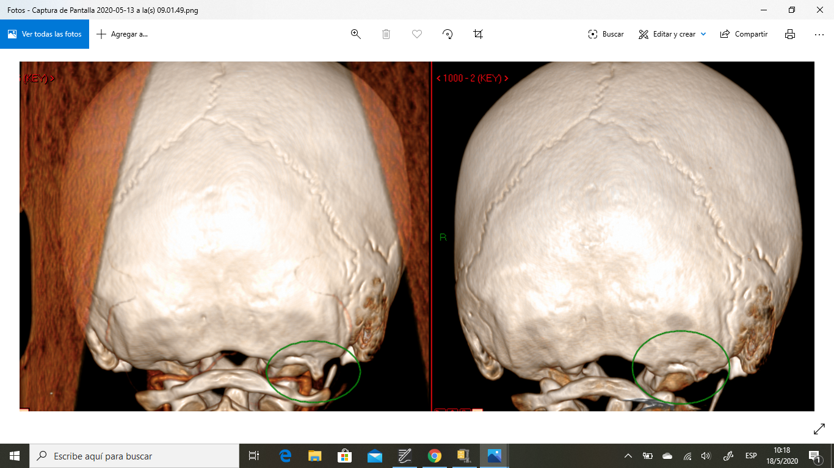
Fig5. CT 3D reconstruction. Pre (a) and postoperative (b) comparison showing complete resection of the left paracondylar exophytic bone spur on the occipital bone.

