|  |  |
| --- | --- |
| (a) | (b) |
| (c) |  |

**Figure 1.** The error bar plots of alpha diversity indeces **a)** Shannon-Wiener diversity index, **b)** Simpson diversity index, **c)** Pielou’s evenness index at genus level according to group

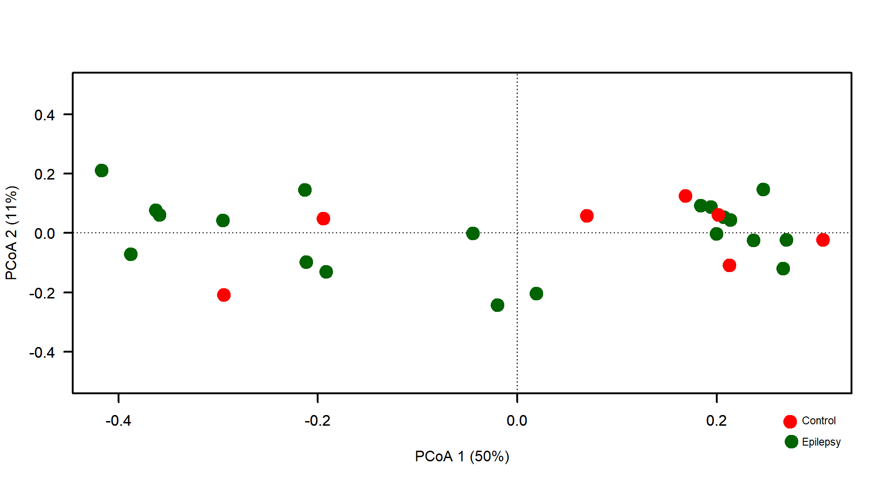

**Figure 2.** The plot of Principal component ordination analysis (PCoA) with Bray-Curtis dissimilarity distance

|  |
| --- |
| (a) |
| (b) |

**Figure 3.** Thestacked bar plots of relative abundances of each sample at **a)** phylum and **b)** family levels

|  |  |
| --- | --- |
| (a) | (b) |
| (c) |  |

**Figure 4.** The bar plots of relative abundances of **a)** Flavobacterium, **b)** Holdemania, and **c)** Hyphomicrobium genus according epilepsy (E) and control (C)

|  |
| --- |
| (a) |
| (b) |

**Figure 5.** Thestacked bar plots of relative abundances according to groups at **a)** family and **b)** phylum levels

|  |
| --- |
| (a) |
| (b) |

**Figure 6. a)** The plot of linear discriminant analysis effect size (LEfSe) results of gut microbiota of patients in epilepsy (E) and control (C) groups, **b)** The cladogram plot of gut microbiota of patients in epilepsy (E) and control (C) groups

F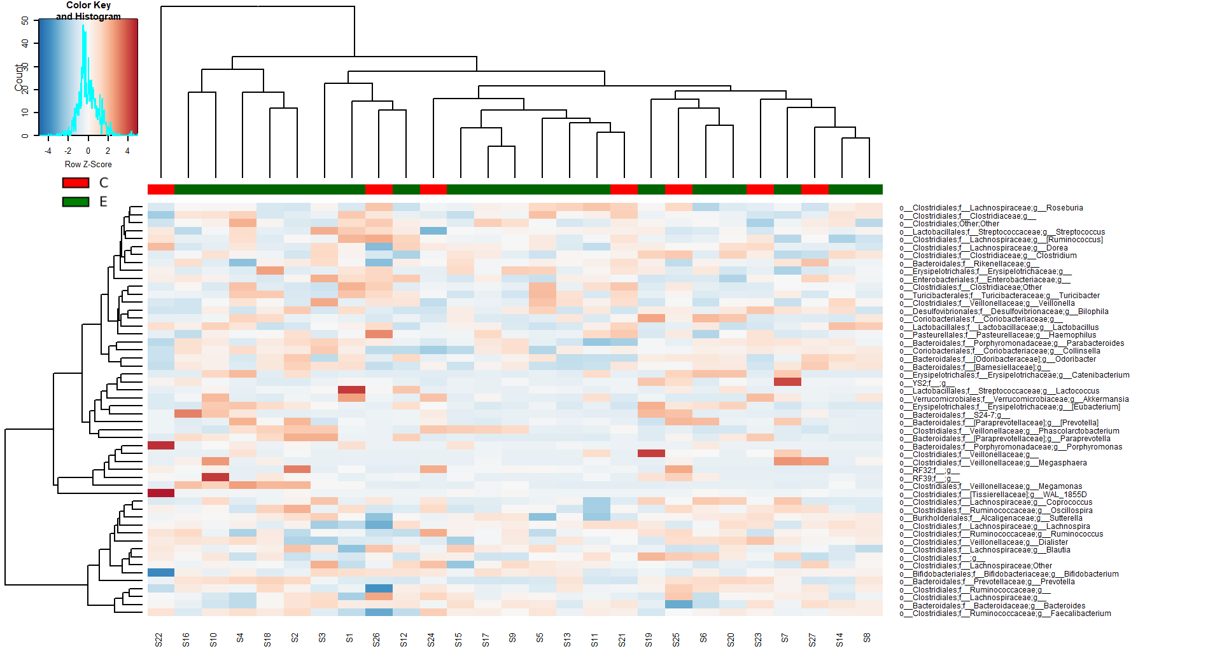

**Figure 7.** The heatmap plot with dendrograms for the 52 most abundant bacteria at genus level (row Z-score: rlog-transformed value, C: Control, E: Epilepsy)