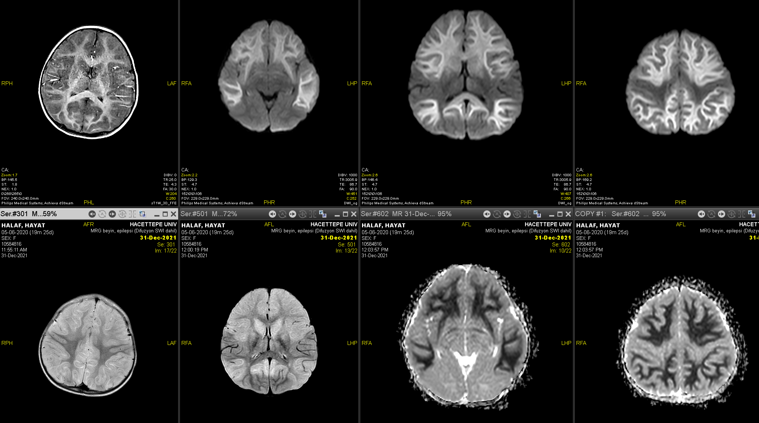

FIGURE 1: The first 3 images are diffusion, the middle 2 images are ADC and the last image is FLAİR sections. There is diffusion restriction in the cerebral white
matter. In addition, Corpus callosum is involved, but perirolandic and perisylvian regions are spared.

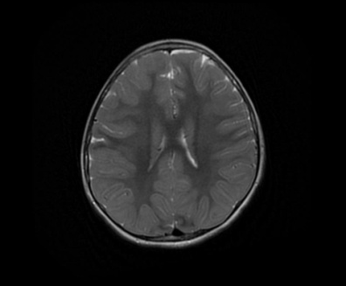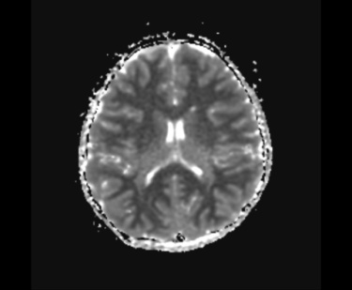
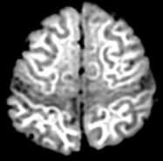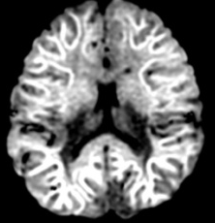

FIGURE 2: There is diffuse difusion restriction in the cerebral White matter, and perirolandic and perisylvian regions are spared.

