NEUROIMAGING CHARACTERISTICS OF TUBEROUS SCLEROSIS COMPLEX IN PAEDIATRIC PATIENTS AT A TERTIARY HEALTH FACILITY IN KENYA: A CASE SERIES

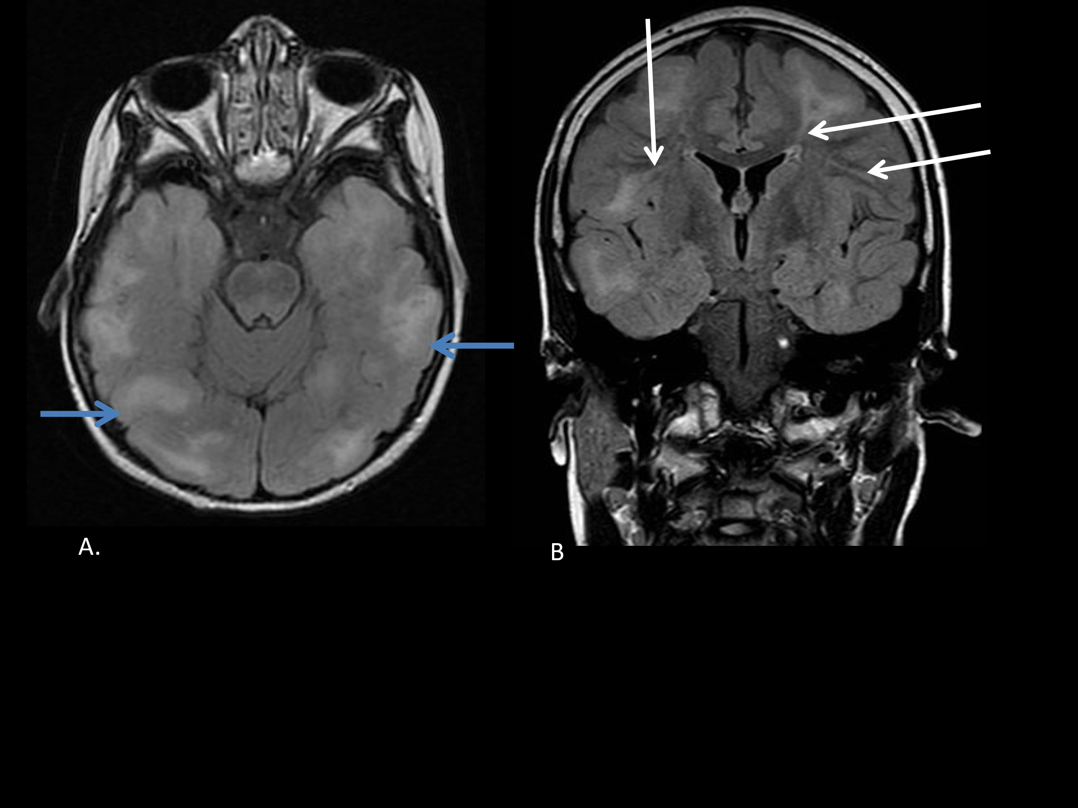

FIGURE 1. A. Axial Fluid Attenuation Inversion Recovery (FLAIR) and B. coronal FLAIR sequences demonstrating multiple temporal and occipital cortical tubers (blue arrows) and white matter radiation lines (white arrows)

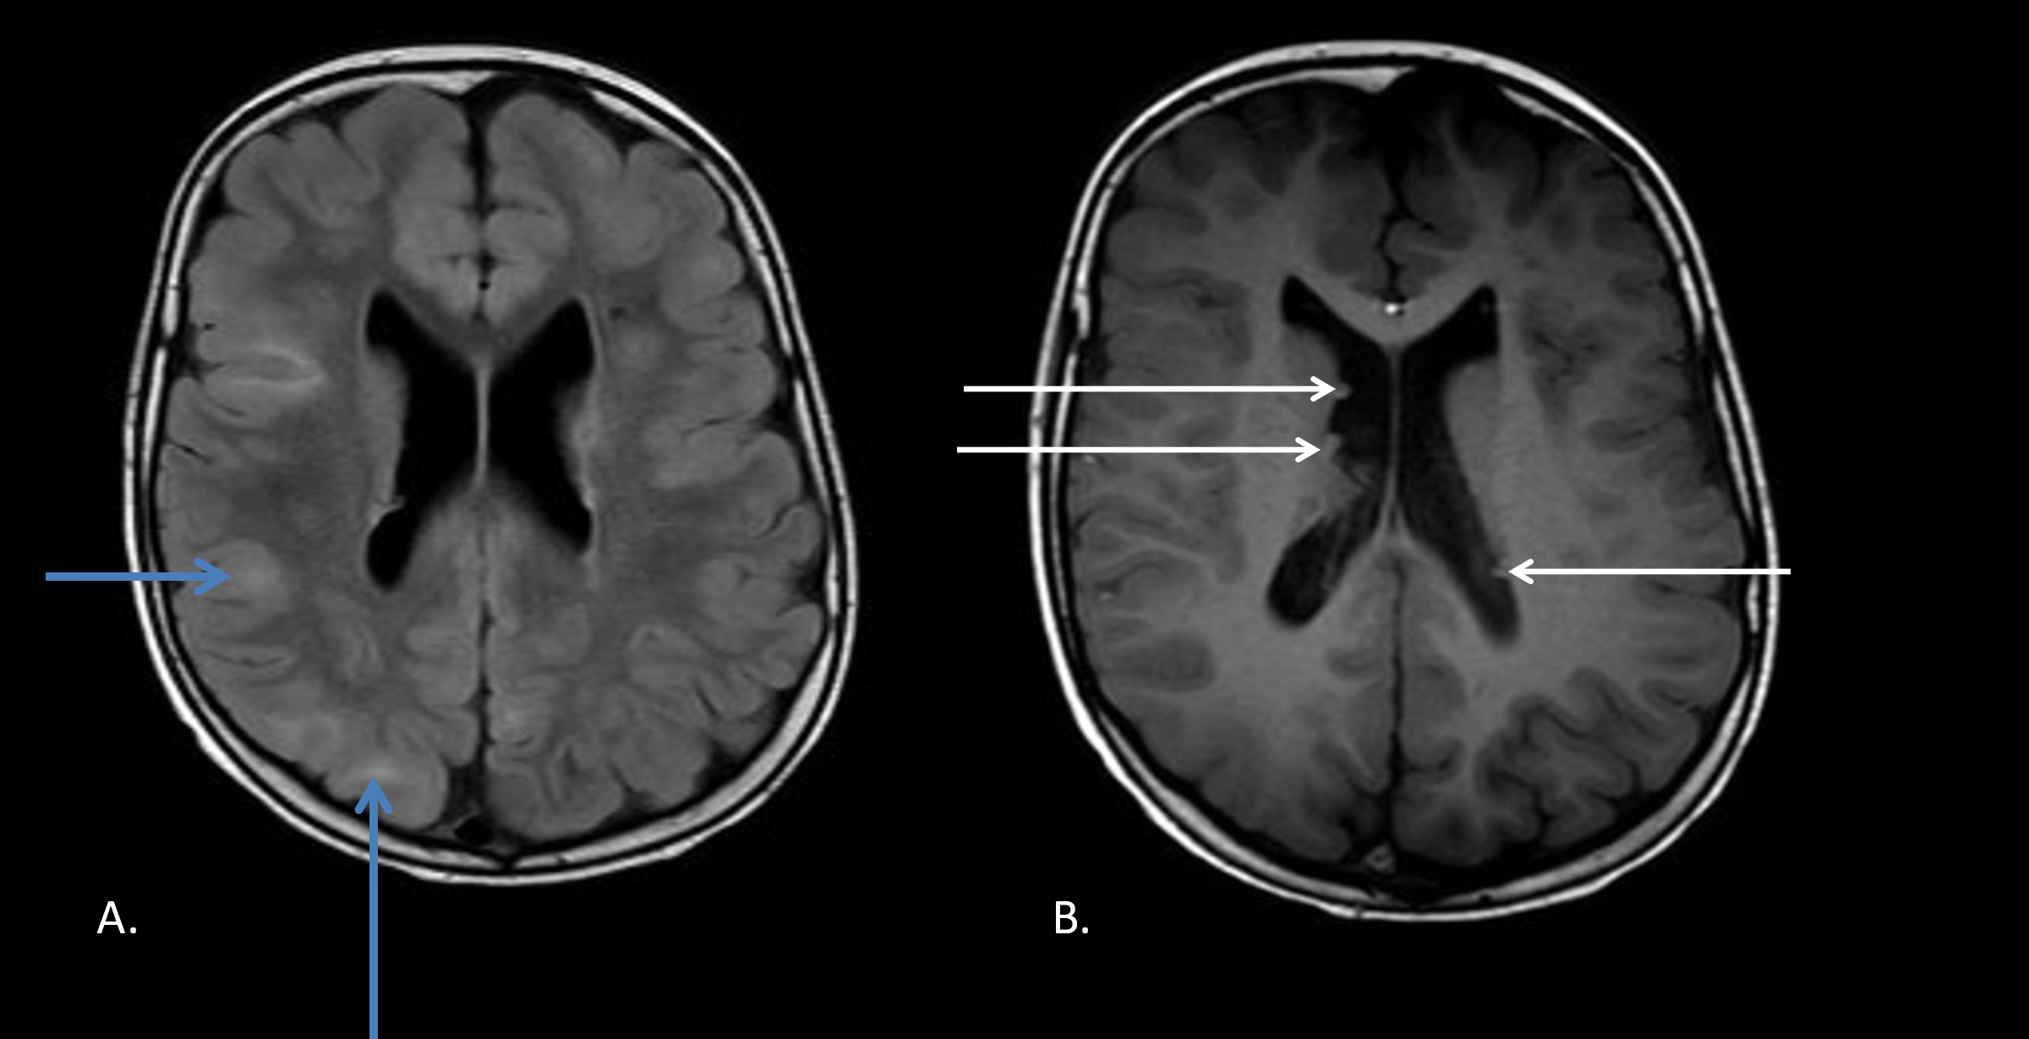

FIGURE 2. A. Axial FLAIR image demonstrating cortical tubers (blue arrows). B. Axial T1-weighted image demonstrating subependymal nodules (white arrows)
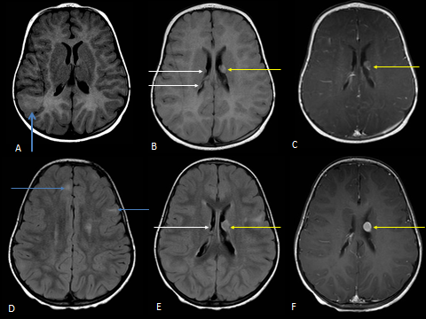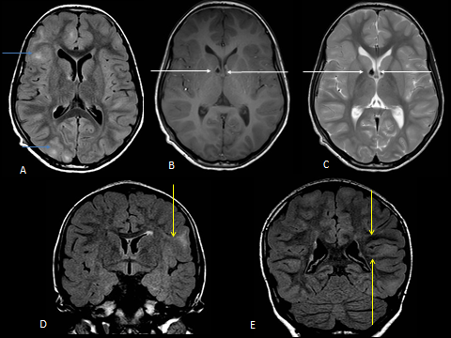
FIGURE 3. Top row- 4 months of age. A. Axial T1-weighted image showing a hypointense right parietal cortical tuber. B. Axial FLAIR image demonstrating hyperintense subependymal nodules (white arrows) including a large subependymal nodule (yellow arrow) which mildly enhances on the axial T1-weighted post-contrast sequence, C.
Bottom row- 3 years of age. D and E. Axial FLAIR sequences showing multiple hyperintense cortical tubers (blue arrows) and subependymal nodules (white arrows) and large subependymal nodule (yellow arrow). F. T1-weighted post-contrast image shows the previously mildly enhancing subependymal nodule is larger and with a more solid enhancing pattern, suggestive of transformation to subependymal giant cell astrocytoma (yellow arrow).

FIGURE 4. A. Axial FLAIR sequence shows hyperintense cortical tubers (blue arrows). B, C. T1 and T2-weighted hypointense frontal subependymal nodules that are likely calcified (white arrows).D and E. Coronal FLAIR sequences demonstrating hyperintense white matter radiation lines (yellow arrows).

