A case of Mitochondrial neuro-gastrointestinal encephalopathy or MNGIE syndrome, why not?
Figure1: Upper gastrointestinal series: gastroparesis
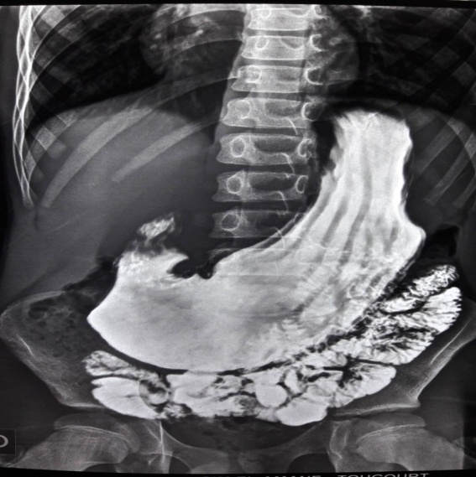
Figure2: Cerebral MRI: Leucodystrophy
