Table 1: Recordkeeping protocol of Electroencephalogram (EEG) of each subject.

Patient ID |  |  | Age
EEG |  |  | Normal / Abnormal  (if Abnormal, Characteristics ?)
Total Duration of recording |  |  | _______ minutes to _______ minutes
Artefact free epoch duration |  |  | _______ minutes to _______ minutes
Proportion of Rhythms in various channels in percentage
FP2-C4 | BETA % | ALPHA % |  | THETA % | DELTA %
FP1-C3 | BETA % | ALPHA % |  | THETA % | DELTA %
C4-O2 | BETA % | ALPHA % |  | THETA % | DELTA %
C3-O1 | BETA % | ALPHA % |  | THETA % | DELTA %
FP2-T4 | BETA % | ALPHA % |  | THETA % | DELTA %
FP1-T3 | BETA % | ALPHA % |  | THETA % | DELTA %
T4-O2 | BETA % | ALPHA % |  | THETA % | DELTA %
T3-01 | BETA % | ALPHA % |  | THETA % | DELTA %

Note: From each individual patient’s record, approximately 10 minutes epoch (specific time-windows extracted from the continuous EEG signal) was extracted by manual screening to quantify the percentage of different EEG rhythms by inbuilt EEG software feature. EEG waveforms were classified as delta (0.5 to 4Hz); theta (4 to 7Hz); alpha (8 to 12Hz) and beta (13 to 30Hz). Proportion of EEG waveforms in percentage was recorded separately for further analyses.

Figure 1(a). Box and whisker plot of GFAP distributed across different groups.
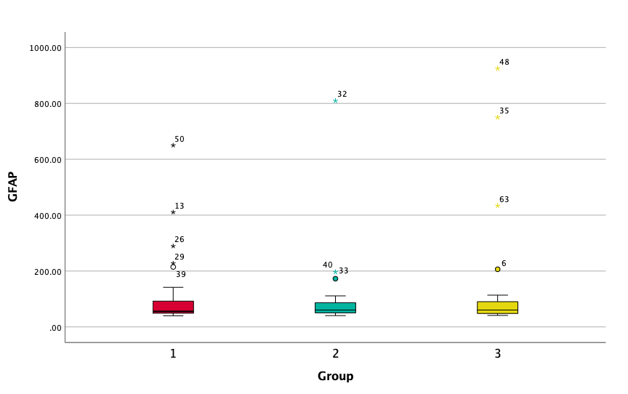
Note: Neurology group (1), Gastrointestinal group (2), Non-Gastrointestinal Non-Neurology group (3). Individual numerical marked alongside outliers indicate the sample ID from the raw data. See Figure1(b) for details of these sample ID(s).
Figure 1(b). GFAP outliers details from Figure 1(a).
Group / ID | GFAP (pg/ml) | Diagnosis | Chief Complaint | Presentation
Neuro / 50 | 650 | Febrile Seizures | Seizures | Acute
Neuro / 13 | 410.71 | Febrile Seizures | Seizures | Acute
Neuro / 26 | 289 | Febrile Seizures | Seizures | Acute
Neuro / 29 | 227.53 | Febrile Seizures | Seizures | Acute
Neuro / 39 | 214.89 | HIE | Respiratory Distress | Sub-Acute
GI / 32 | 809.37 | PEM | Severe Dehydration | Chronic
GI / 40 | 196.63 | E coli GE | Severe Dehydration | Acute
GI / 33 | 172.75 | Toxic Megacolon | Vomiting | Sub-Acute
NNGI / 48 | 925 | SSSS | Pustular eruptions | Acute
NNGI / 35 | 750 | Septicemia | Fever | Acute
NNGI / 63 | 433.93 | Septicemia | Lethargy | Acute
NNGI / 6 | 206.46 | Septicemia | Epistaxis | Acute
Note: Neurology group (Neuro), Gastrointestinal group (GI), Non-Gastrointestinal Non-Neurology group (NNGI), Gastroenteritis (GE), Hypoxic Ischemic Encephalopathy (HIE), Staphylococcal Scalded Skin Syndrome (SSSS), Protein energy malnutrition (PEM).

Figure 2. Correlation between Il-6 and GFAP.
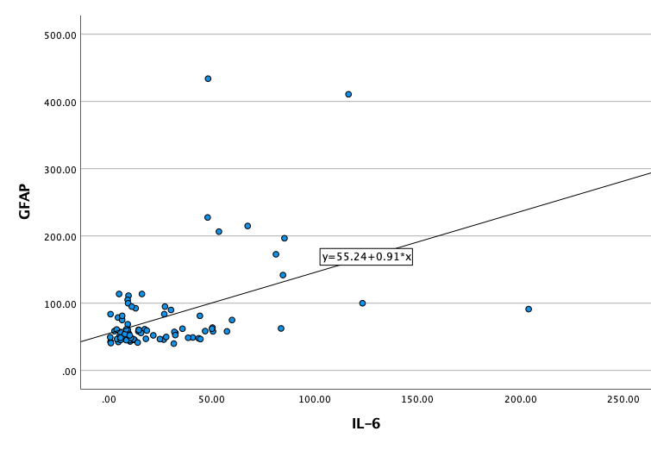

Model Summary and Parameter Estimates
Dependent Variable: GFAP, Independent variable: IL-6
Linear Equation | Model Summary
 | R Square | F | df1 | df2 | Sig.
 | 0.441ª | 19.557 | 1 | 81 | < 0.001
Linear curve fit model - Y = 55.24 +0.91*x

Spearman's rho Correlations
 |  | GFAP | IL-6
GFAP | Correlation Coefficient | 1.000 | 0.38**
 | Sig. (2-tailed) |  | < 0.001
 | N | 83 | 83
IL-6 | Correlation Coefficient | 0.38** | 1.000
 | Sig. (2-tailed) | < 0.001
 | N | 83 | 83
**. Correlation is significant at the 0.01 level (2-tailed).

Figure 3. Details of General Linear Model (GLM).
Figure 3(a)
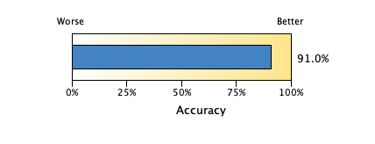
Figure 3(b)
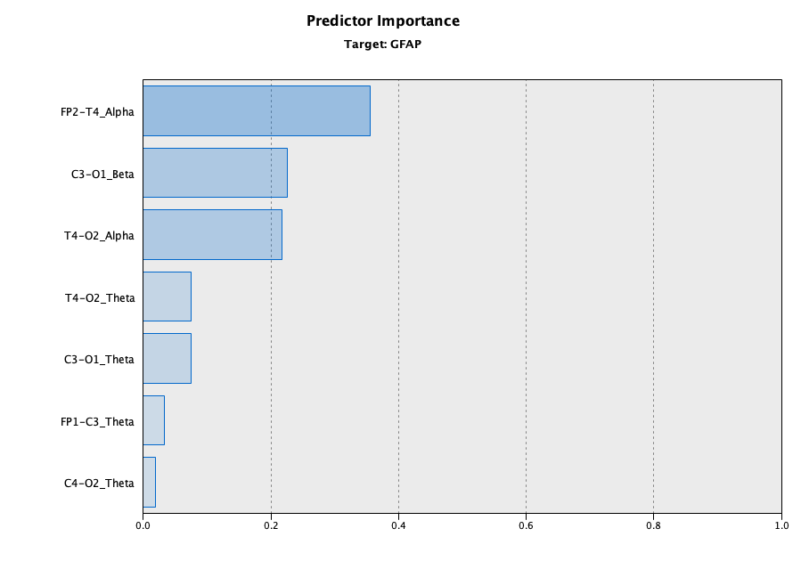
Figure 3(c)

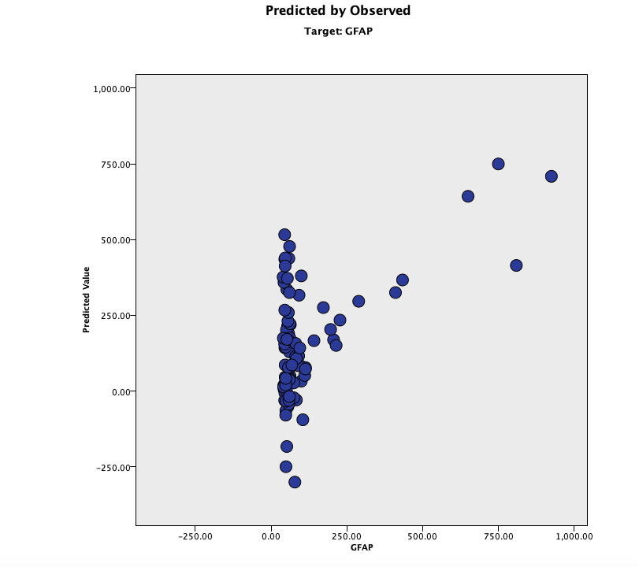

Figure 3(d)
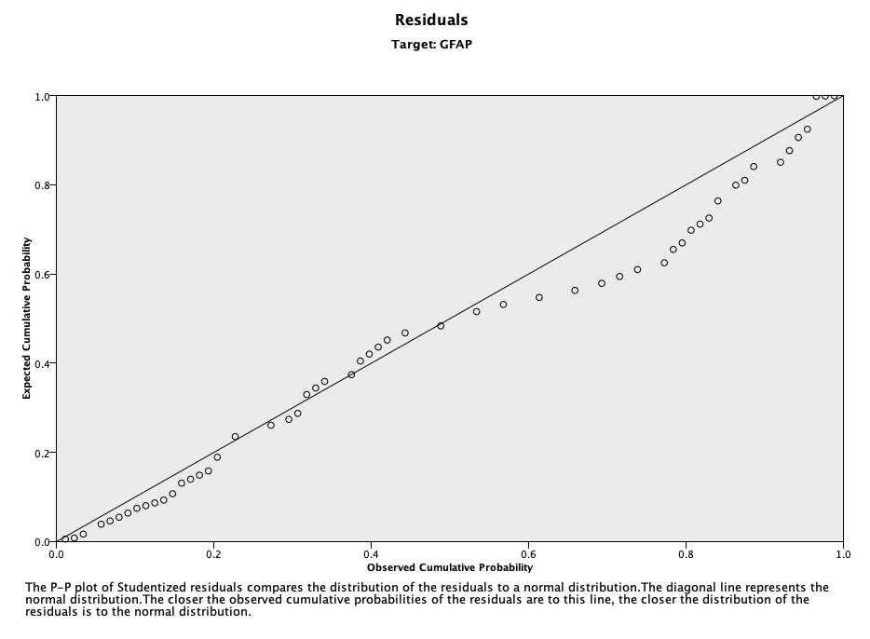
Note: The IBM SPSS linear regression model was used to analyze the predictive relationship between GFAP (continuous target) and EEG rhythms and IL-6 levels (continuous predictors). The SPSS Linear Engine predicts the model based on Linear regression and Analysis of variance. This model assumed a Linear regression is a linear model, i.e. a linear relationship between the input and output variables. In this model, since there were multiple input variables (predictors), the method used was multiple linear regression. In this Automatic linear regression module, X-variables were automatically transformed in order to provide an improved data fit, and SPSS (IBM) used rescaling of measurement values, outlier trimming, category merging for the purpose of model building. The overall model accuracy was acceptable at 91%. The model identified temporal-occipital frequencies as the most important predictors for serum GFAP target. In the predicted versus observed scatter plot – at higher GFAP levels of more than 200 pg/ml, the model shows good coherence. P-P plot of studentized residuals compared the distribution of the residuals to a normal distribution. The diagonal line represents the normal distribution. The closer the observed cumulative probabilities of the residuals are to this lines, the closer the distribution of the residuals is to the normal distribution. The p-p plot shows more or less a linear distribution suggesting a good model fit.

Appendix I
Deidentified Raw Data

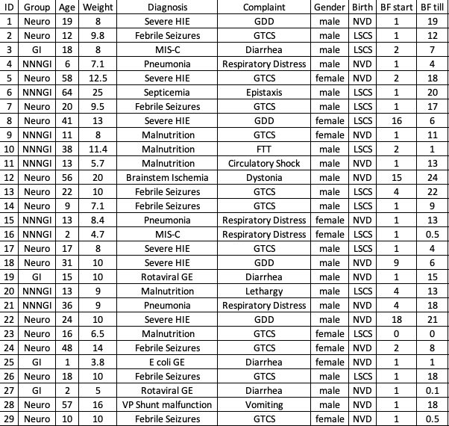

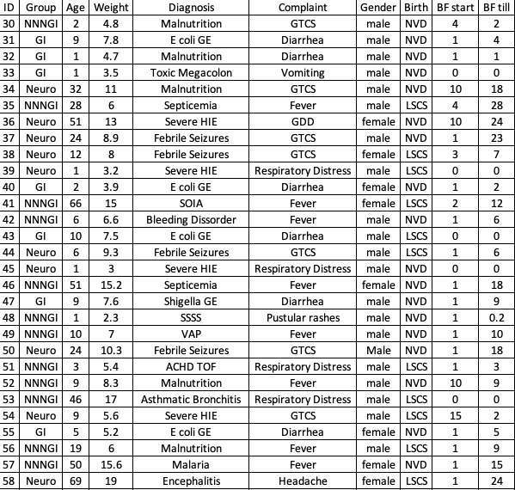

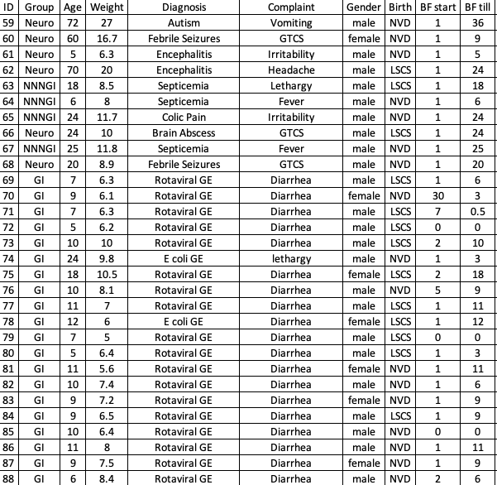

Appendix 3.
Deidentified Laboratory data
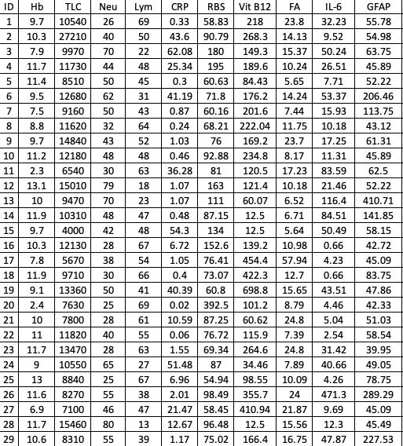

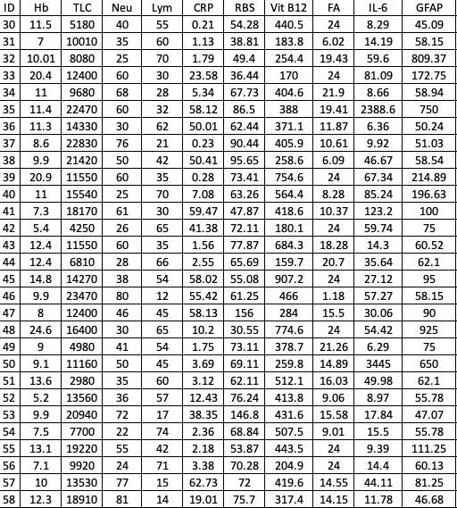

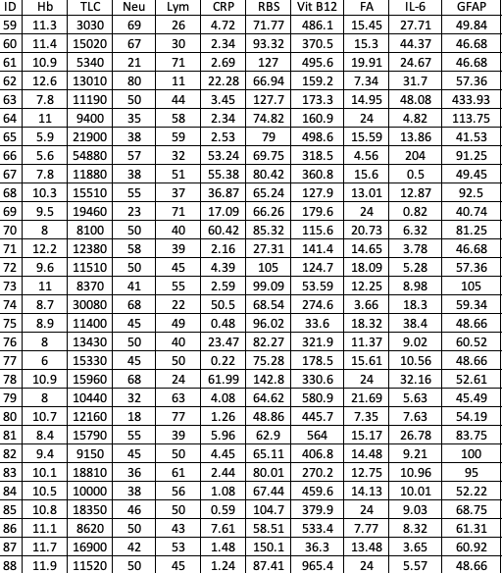

Appendix 4.
Deidentified EEG data
