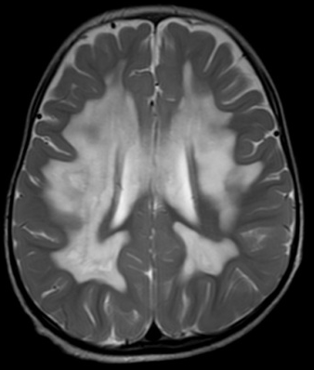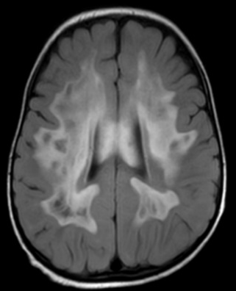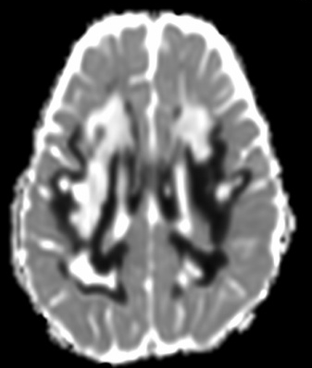
A
B
C
D
Figure 1. MRI brain showed abnormal symmetric T2 hyperintense signal in bilateral periventricular white matter, centrum semiovale and corona radiate(A), which were hypointense on T1W images and centrally suppressed on FLAIR images(B). The peripheral edges of the abnormal white matter showed restricted diffusion(C & D). Corpus callosum was also involved. Radiating stripes stretching across the rarefied white matter were suggestive of remaining tissue strands

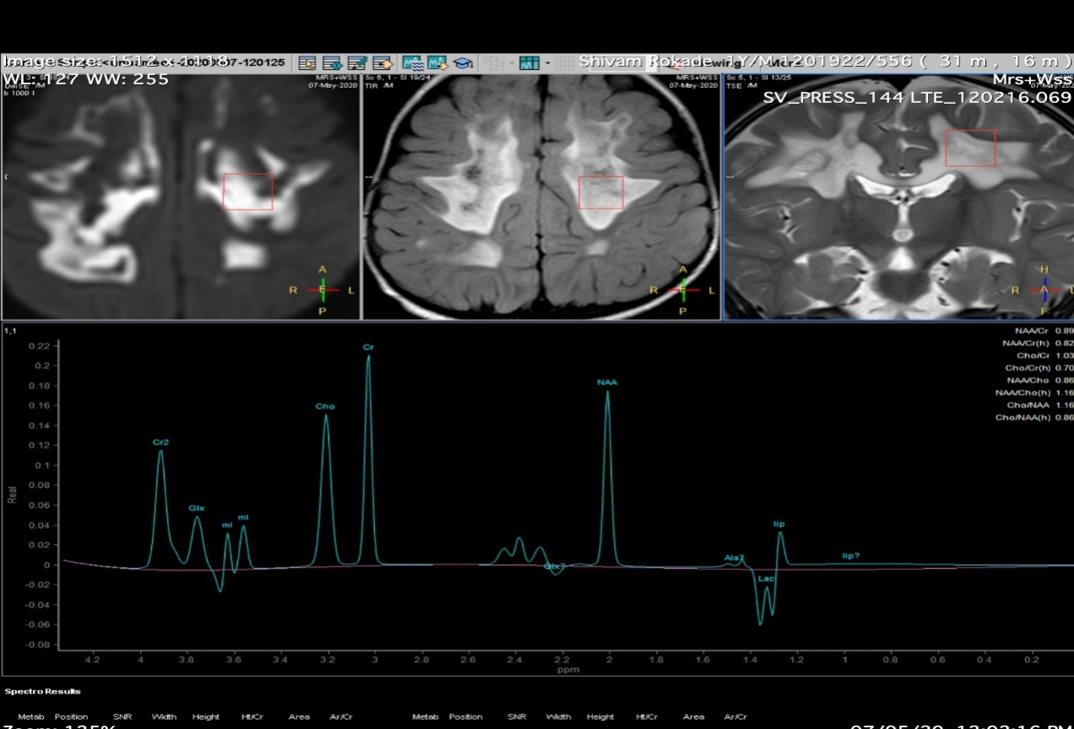
Figure 2. MRS short TE revealed an elevated lipid-lactate peak, with inversion of lactate doublet on intermediate TE. Mild decrease in NAA peak also was noted.

