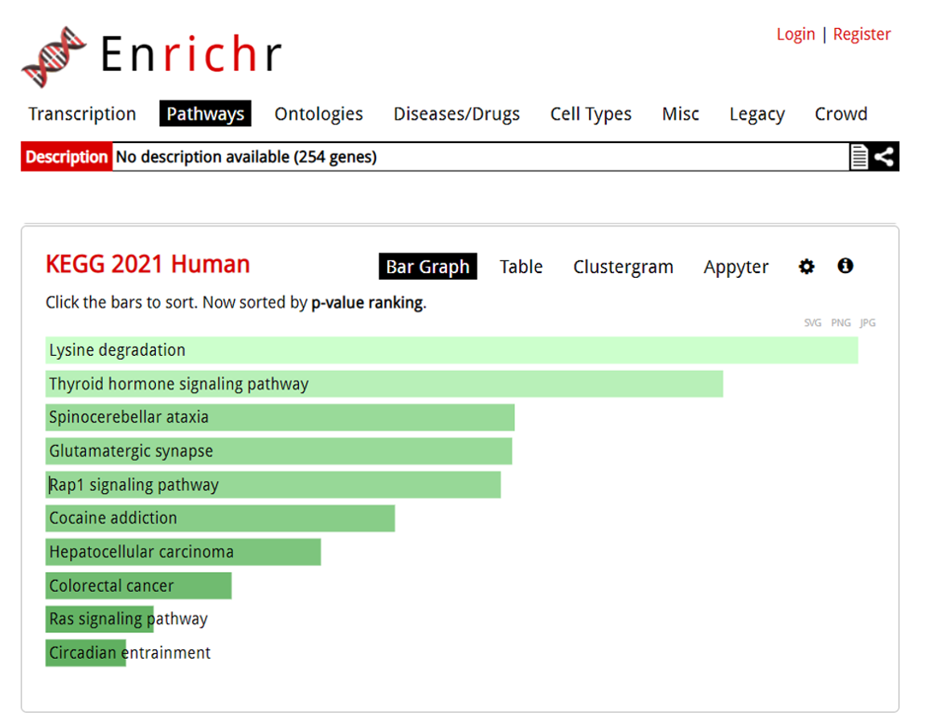
Figure 1: Pathway analysis of the genes related to NDDs according to KEGG 2021 Human
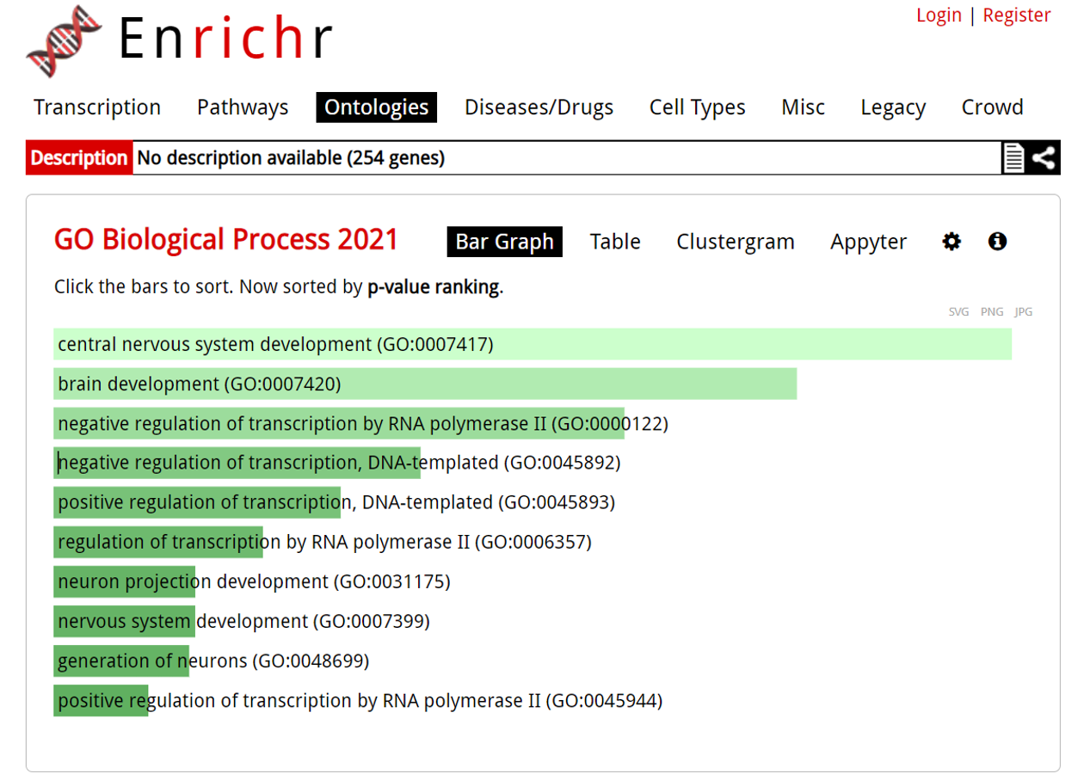
Figure 2a: GO Biological Process analysis of the genes related to NDDs
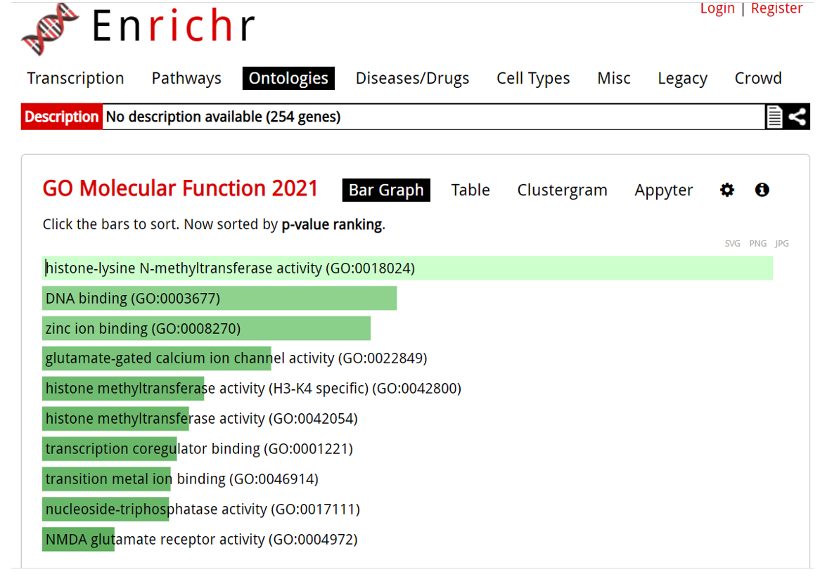
Figure 2b: GO Molecular Function analysis of the genes related to NDDs
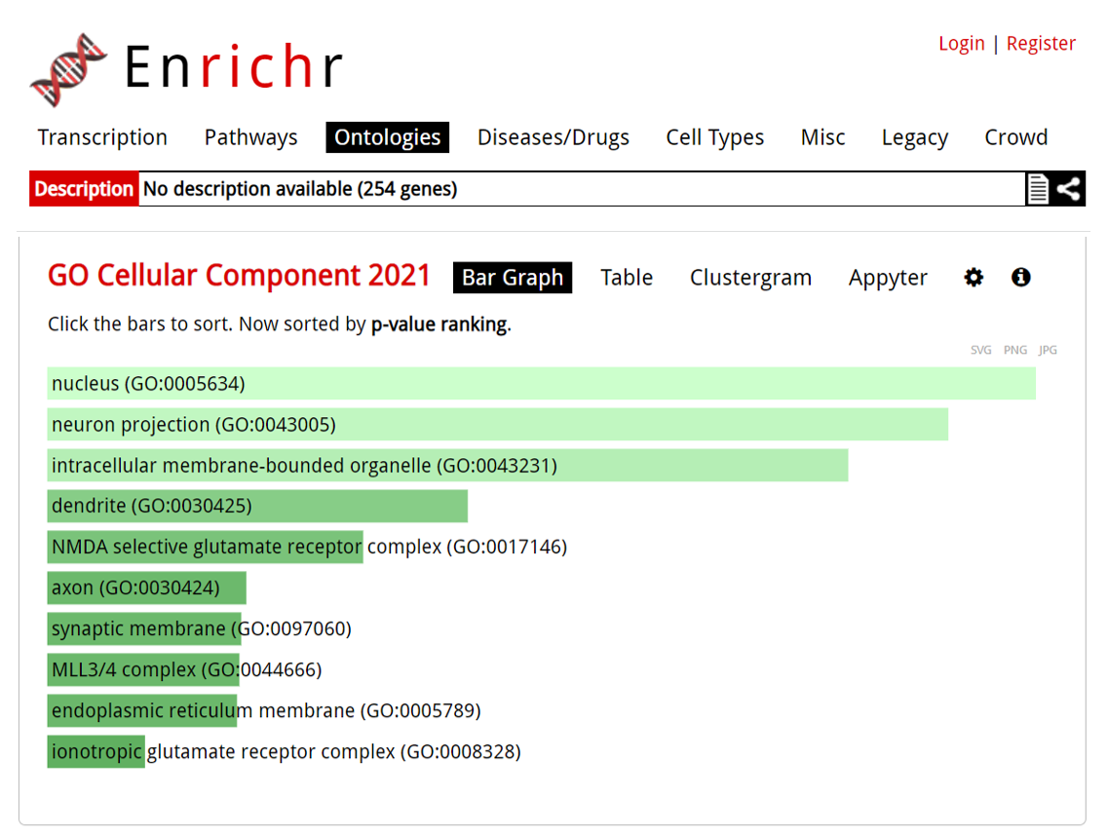
Figure 2c: GO Cellular Component analysis of the genes related to NDDs

