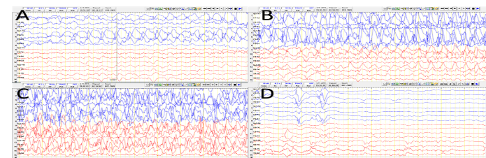

**Figure 1.** A: An electrographic seizure pattern with sharp-slow wave discharges originating from left central regions (C3), B: spread of discharges to right hemisphere (C4), C: radiating to both hemispheres, D: termination of electrographic activity with background slowing and supression