**FIGURE 1 : DIVISION OF INDIVIDUAL MALFORMATIONS**

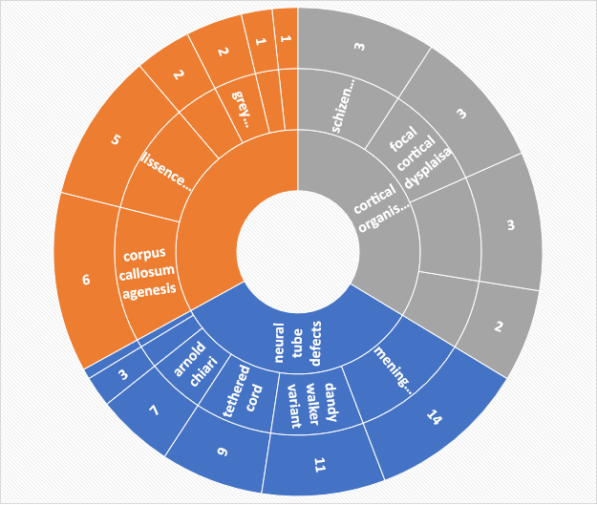

FIGURE 2: AGE WISE DISTRIBUTION OF CASES