

**Fıgure 1**:Distinctive facial features include a wide, a triangular face shape, widely spaced eyes (hypertelorism), wide eyebrows that may grow together in the middle , a prominent nasal bridge, a long space between the nose and upper lip,

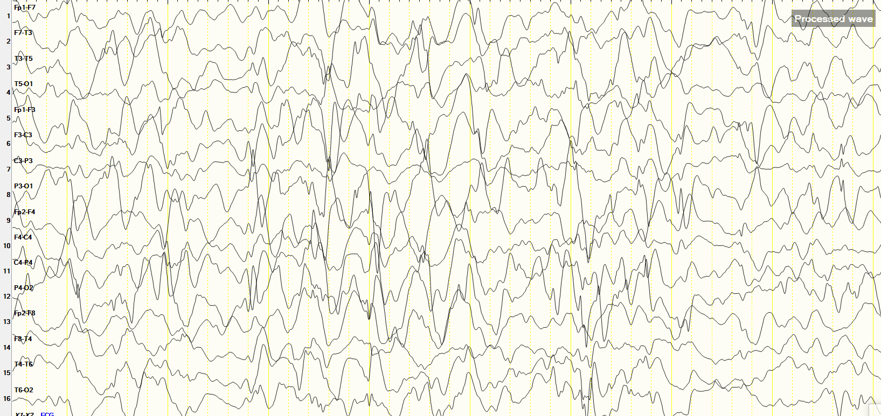

Figure 2 EEG: Very high-voltage, random (asynchron, non-rhythmıc), slow waves and spikes in all cortical areas