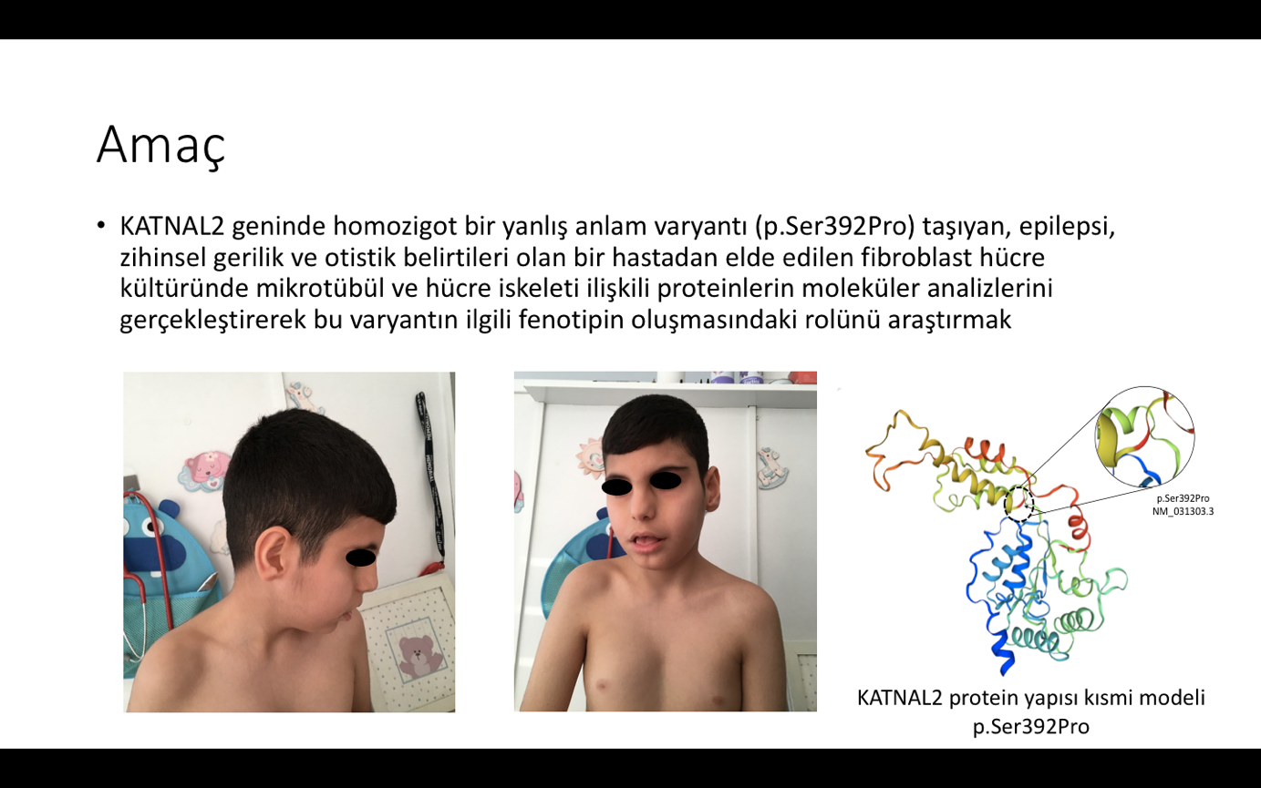 

1. b)

Figure 1: a)Facial appearance of the patient b)Segregation of the variant

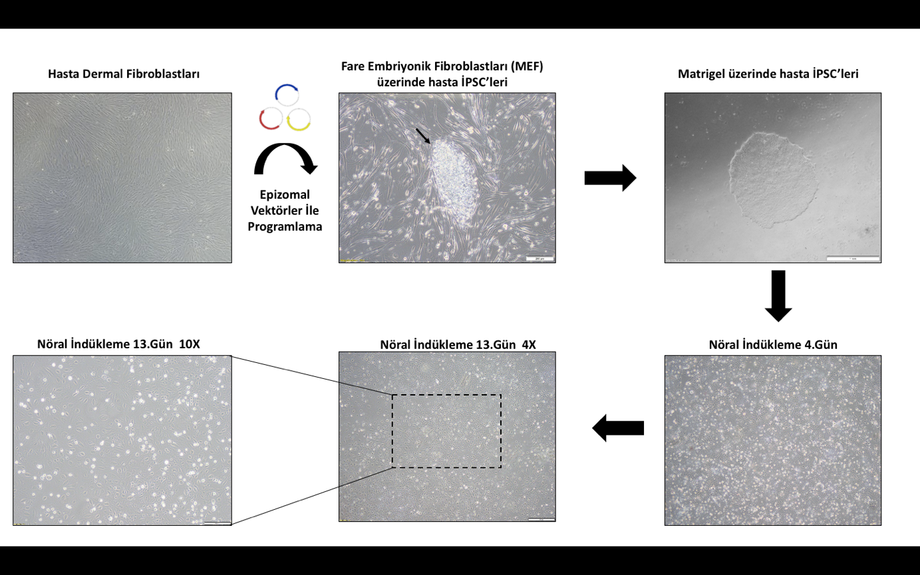

Figure 2: Appearance of patient’s iPSCs on day 5 after transfer to matrigel-coated plates and

neural progenitor cells at day 4 and 13 of neural induction

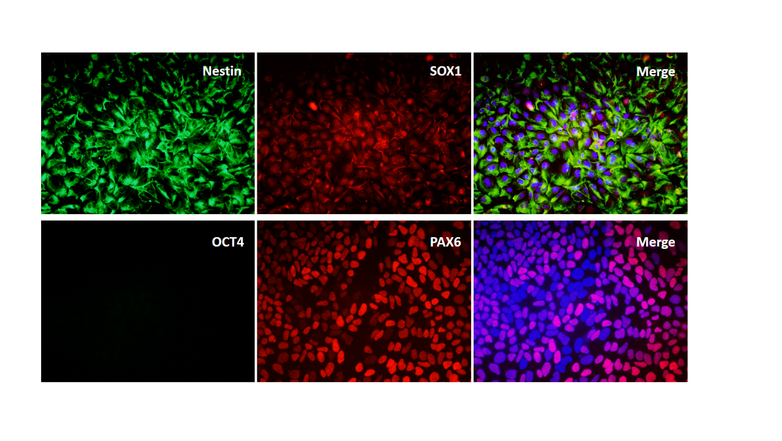

Figure 3: Staining of patient NPCs at day 14 with Pax6, Nestin, Sox1 and Oct4. Differentiated NPCs were shown to be negative for Oct4, a marker of pluripotency, and positive for Nestin, Pax6, and Sox1, which are neural precursor cell markers.

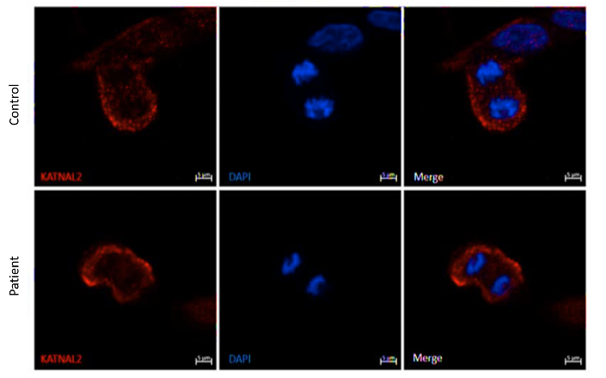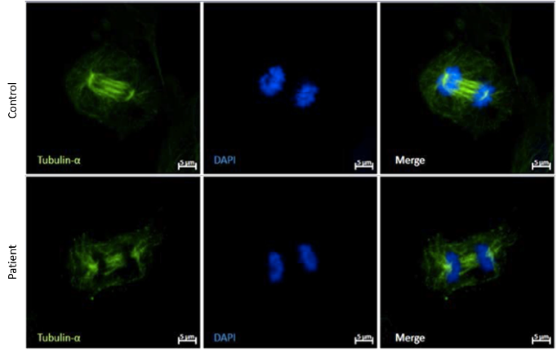

1. KATNAL2 IF staining of the fibroblasts b) Tubulin-α IF staining of the fibroblasts

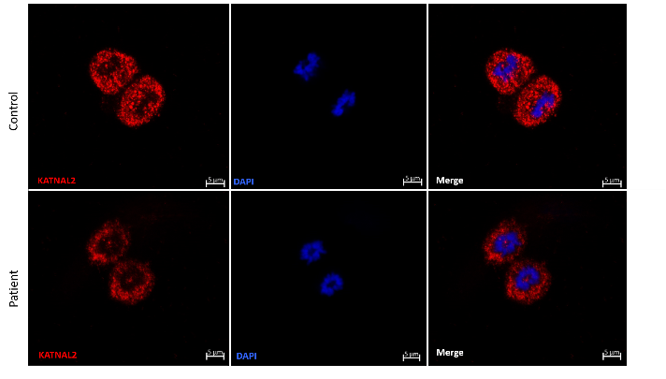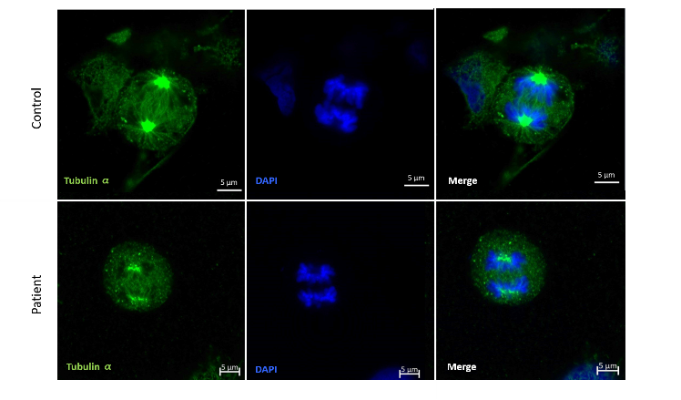

1. KATNAL2 IF staining of the NPCs d) Tubulin-α IF staining of the NPCs

Figure 4a-d: IF stainigs of fibroblasts and NPCs. In KATNAL2 IF staining, weaker staining was detected in the patient's fibroblasts(a) and NPCs(c) compared to the control case. In tubulin-α IF staining, the mitotic spindles were more irregular and dispersed in the patient's fibroblasts(b) and NPCs(d) compared to the control case.