Figures:

Figure 1
On initial presentation – Figure 1 (A) Sagittal T1 weighted imaging demonstrating absence of the posterior pituitary bright spot, (B) otherwise normal pituitary morphology on T2 weighted imaging. 24 months post-presentation (C, D) sagittal T1 and T2 weighted imaging demonstrates smooth thickening of the pituitary stalk respectively with (E) uniform enhancement post-gadolinium
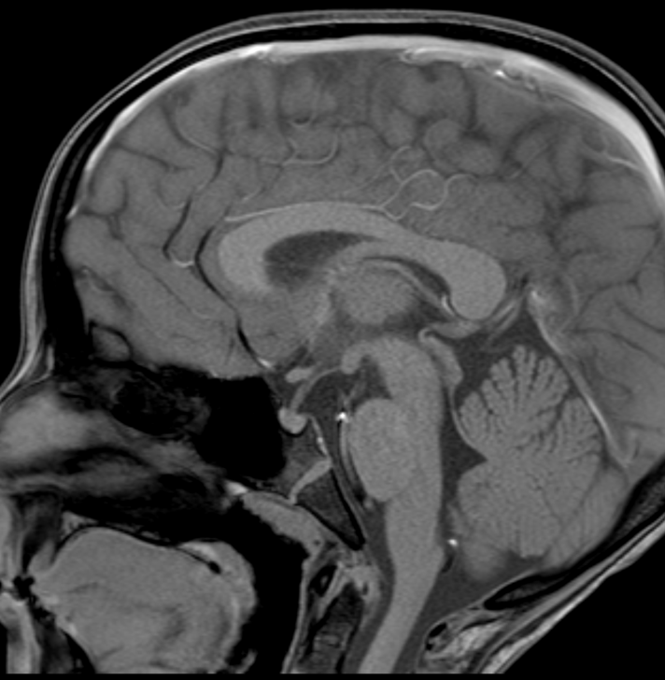
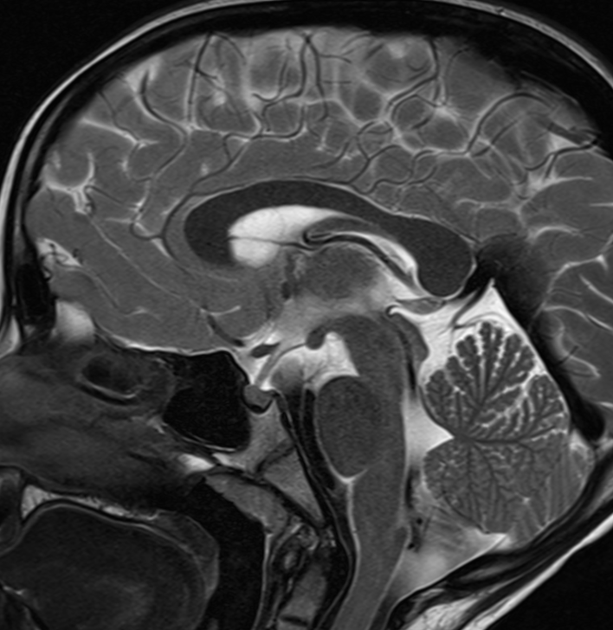
A

B

D
C

E

Figure 2
Initial presentation – Figure 2 (A) Coronal T1 weighted imaging demonstrating T1 intermediate signal marrow expansion and infiltration of the body and greater wing of both sphenoid bones with extension into the middle cranial fossa and masticator spaces. There is corresponding T2 intermediate-high signal (C) and contrast enhancement post-gadolinium (B). On surveillance imaging 30 months post-presentation (D-F) axial and sagittal T2, and coronal FLAIR demonstrating increased signal abnormality of the cerebellar peridentate white matter.
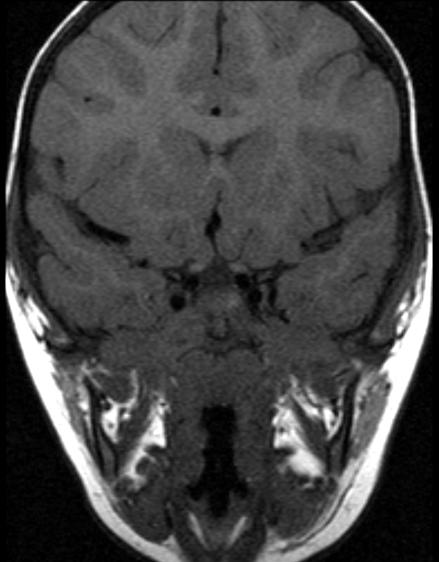
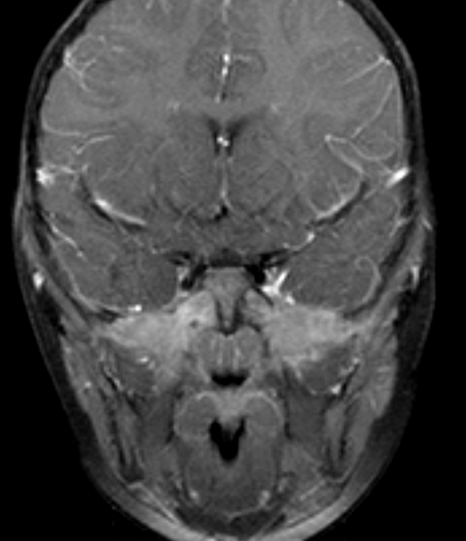
B
A

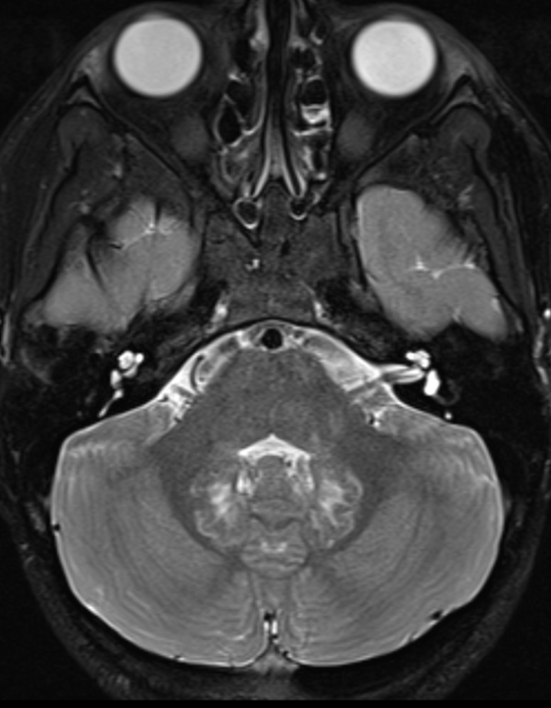
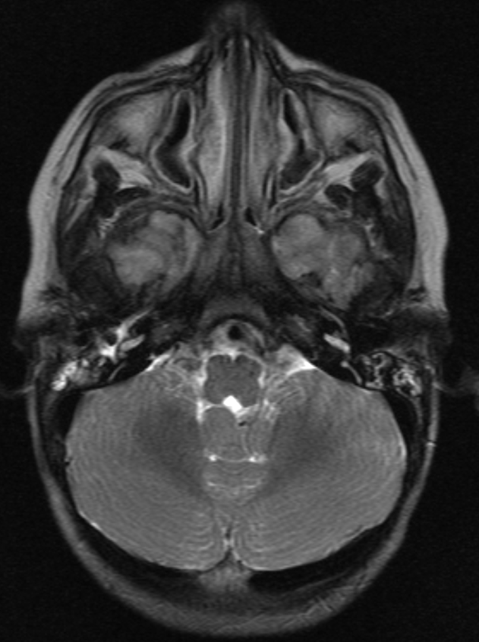
D
C

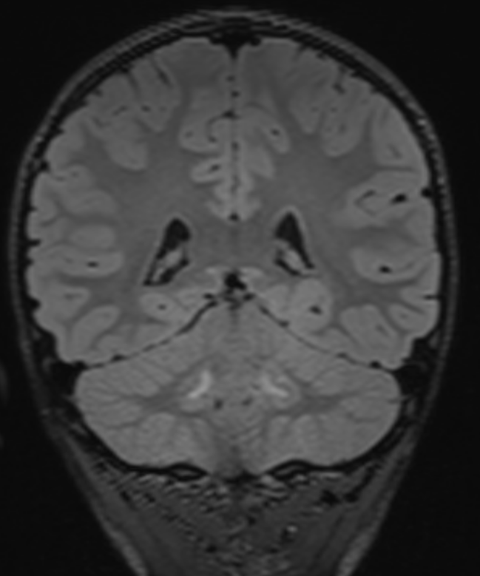
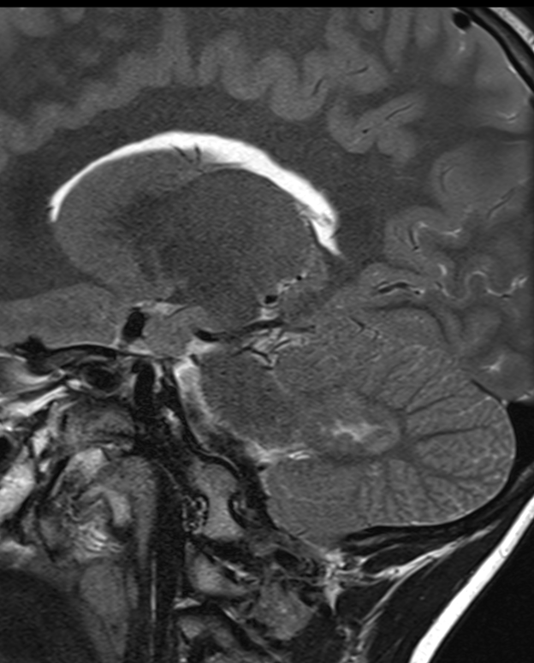
E
F

Figure 3
Figure 3 (A-C) Axial T2 weighted imaging and (D) sagittal T2 weighted imaging demonstrating diffuse T2 hyperintense signal abnormality in the supratentorial white matter (including the corpus callosum), deep grey matter structures, brainstem and cerebellum with multiple mildly hypointense perivascular nodules, many of which show enhancement on the axial and sagittal post-gadolinium sequences (E-H). There is (H) a large enhancing nodular lesion in the floor of the third ventricle/hypothalamus.

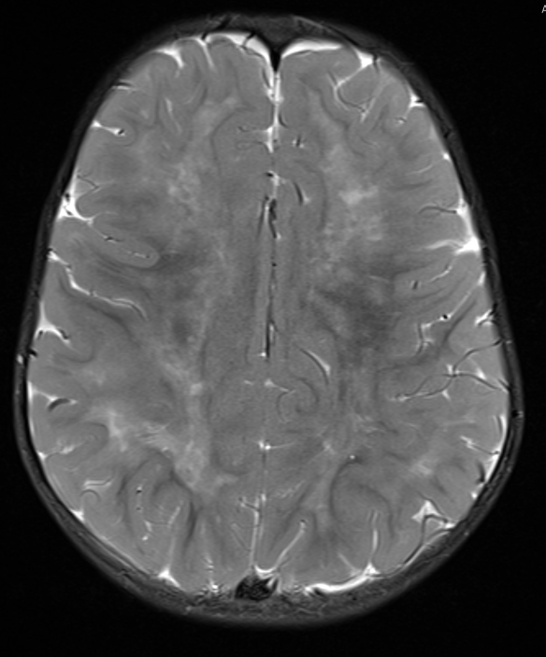
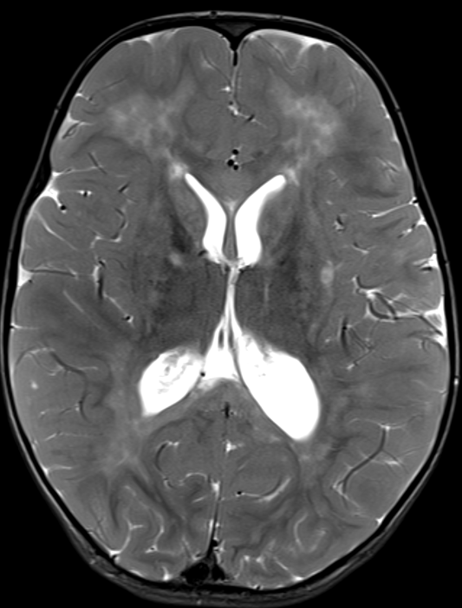
A
B

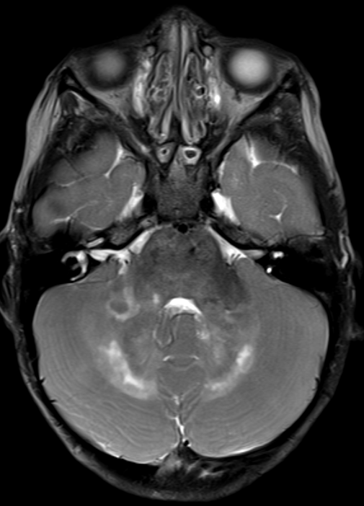
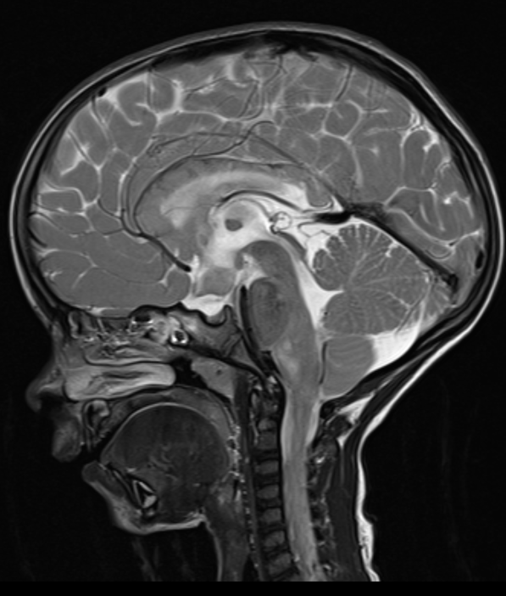
D
C

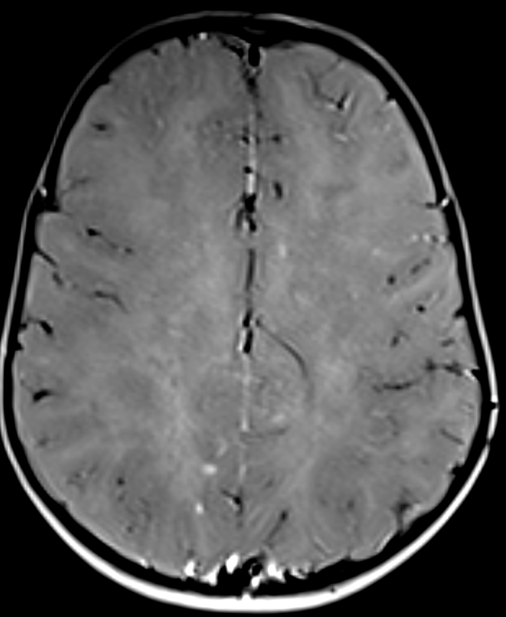
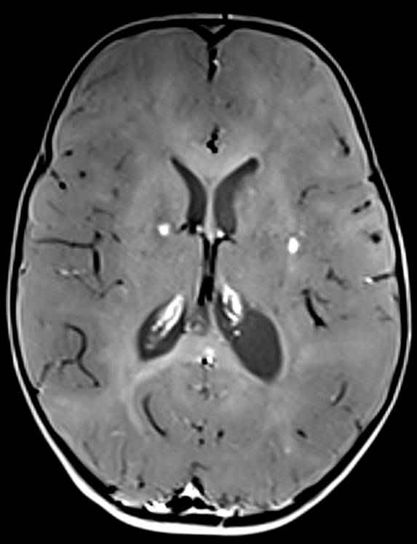
E
F

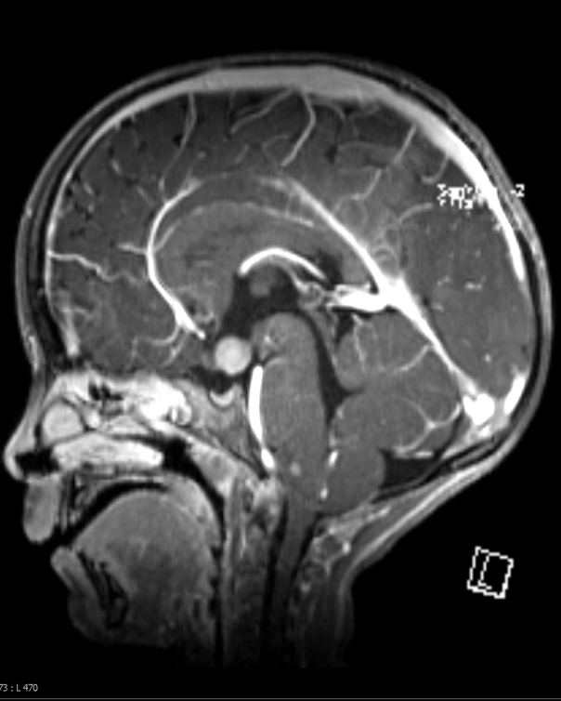
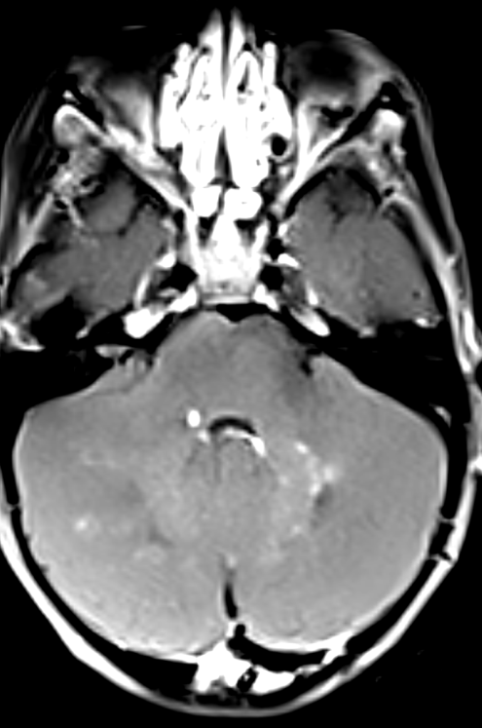
H
G

Figure 4
Figure 4 (A-B) Axial T2 and FLAIR sequences respectively showing a targetoid lesion in the right superior parietal lobe with perilesional T2 hyperintense oedema. (C-D) DWI trace and ADC map respectively showing restricted diffusion in the peripheral component of the lesion (E) Axial T1 weighted imaging showing concentric bands of alternating T1 high and low signal (F-G) Post gadolinium imaging, MPRAGE and blood suppressed respectively showing intense enhancement (H) Susceptibility weighted imaging showing central punctate haemosiderin.

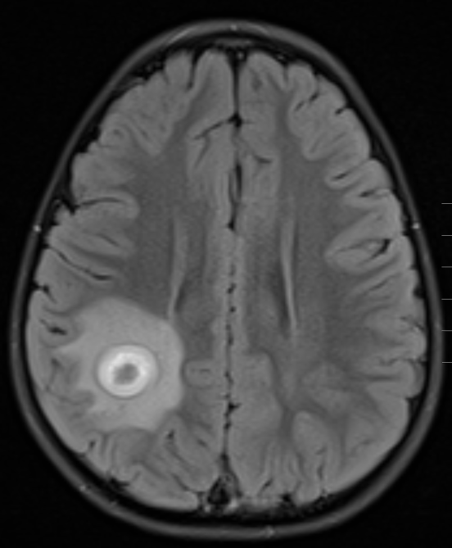
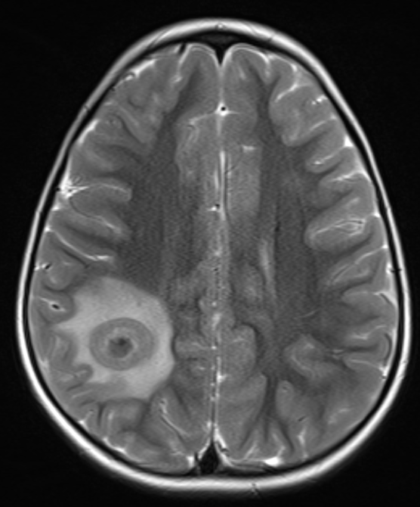
B
A

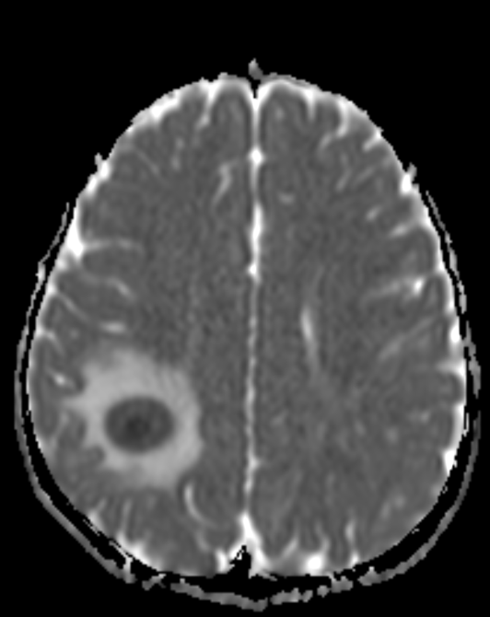
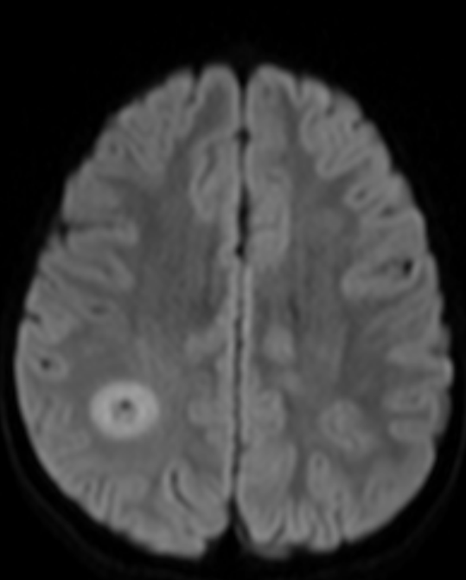
C
D

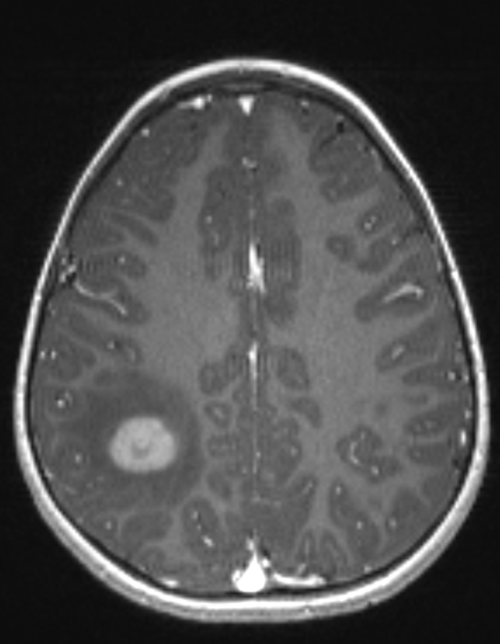
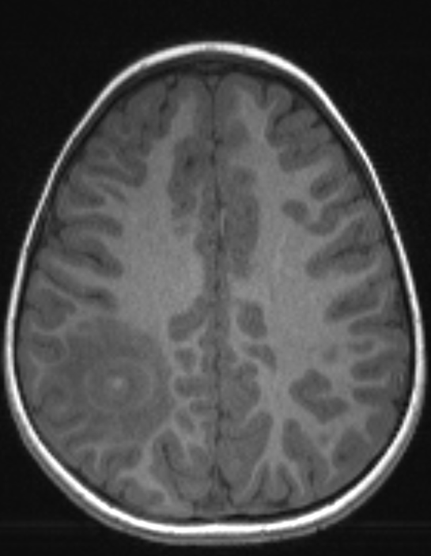
F
E

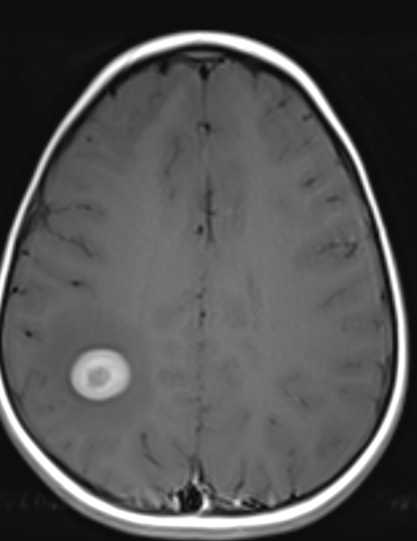
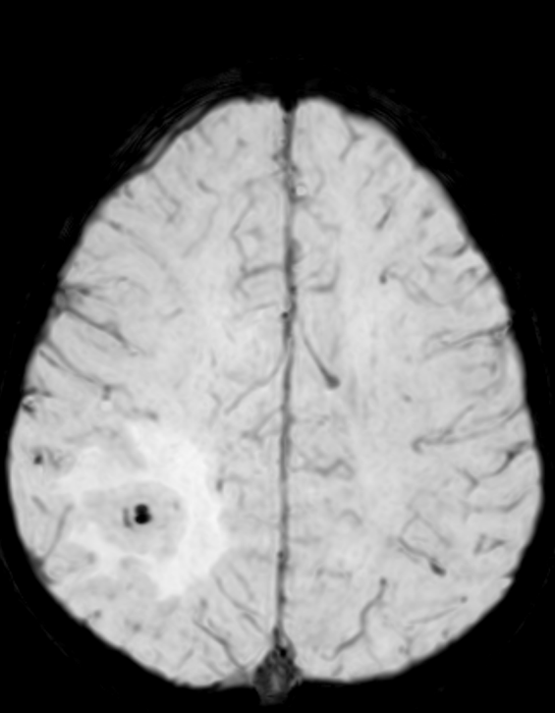
H
G

Figure 5
Figure 5 (A, D and G) Axial T2, coronal FLAIR and Sagittal FLAIR demonstrating T2 hyperintense cortical signal abnormality in the right frontal and bilateral parasagittal parietal lobes associated with (B-E) T1 hypointensity on axial and sagittal T1 weighted imaging respectively and punctate enhancement post-gadolinium (C and F).
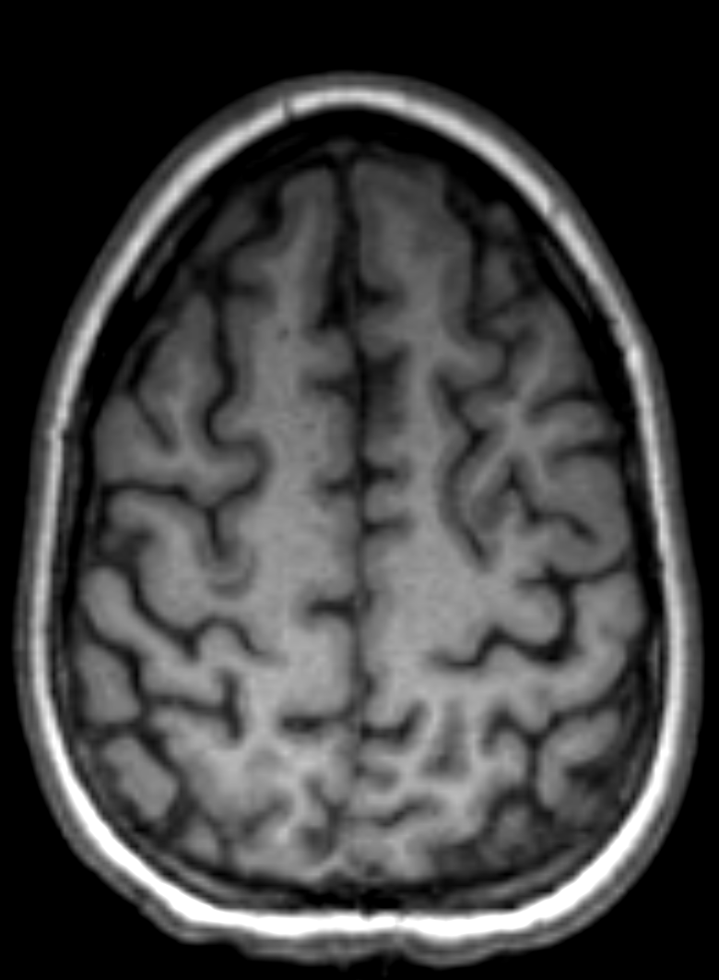
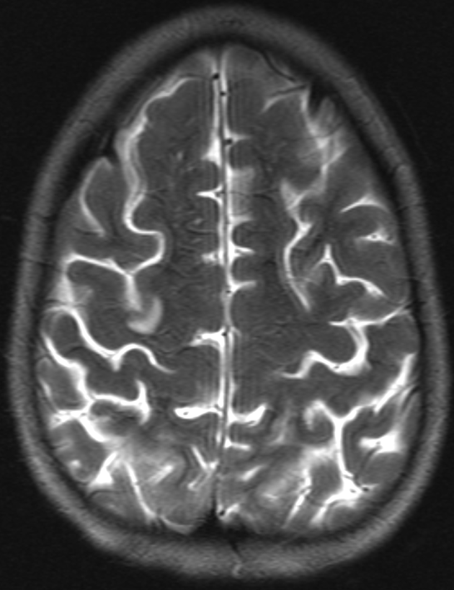
B
A

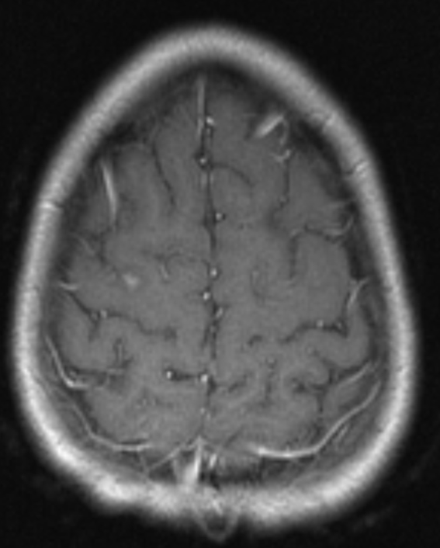
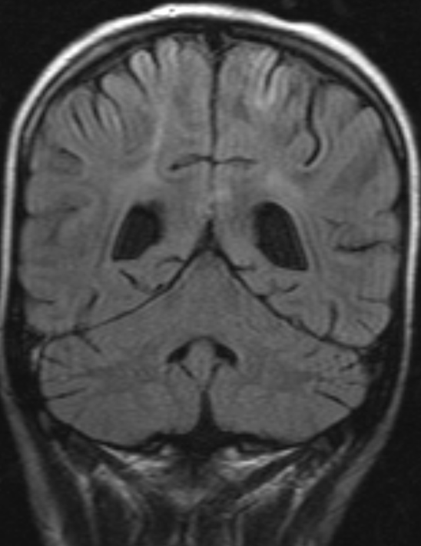
D
C

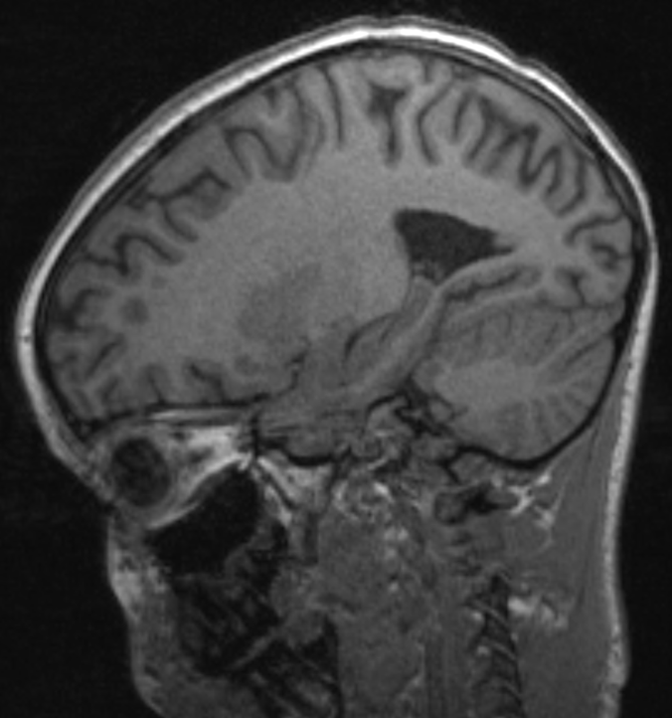
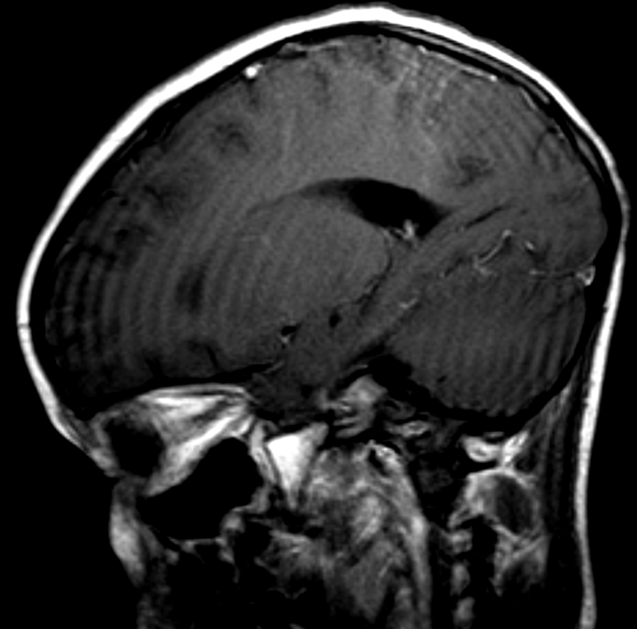
F
E

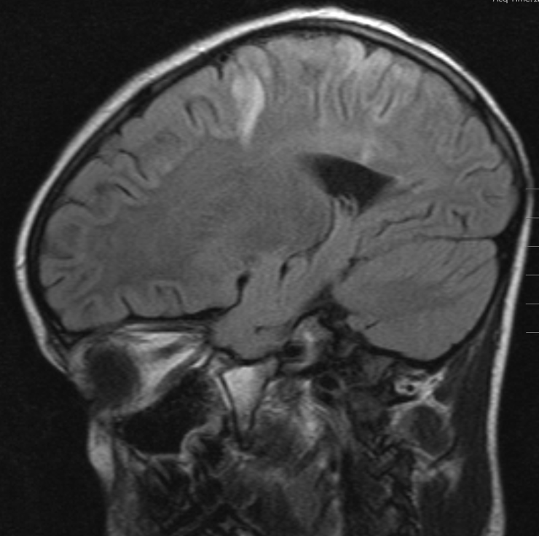
G

Figure 6
Figure 6 (A-D) Unenhanced axial and coronal CT images demonstrate an erosive rounded soft tissue lesion at the frontal process of the right maxilla. Intermediate signal (E, F) demonstrated on axial T2 and T1 weighted imaging with (G) mild uniform enhancement.

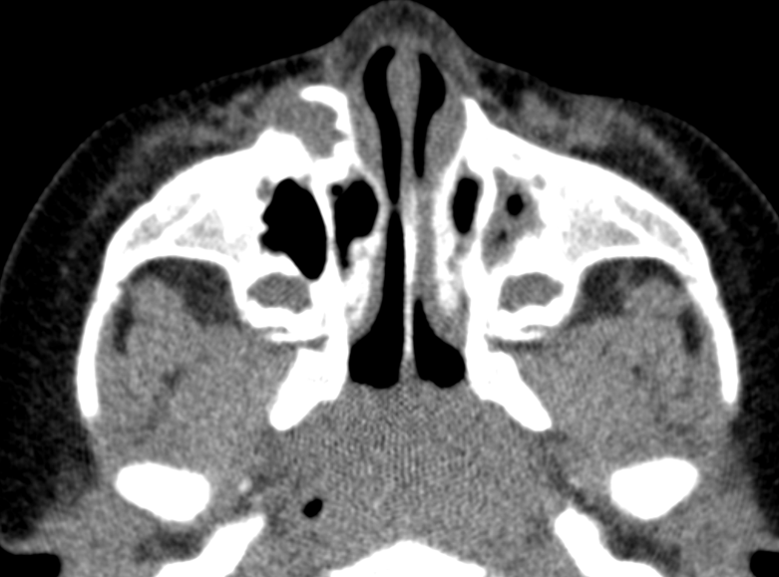
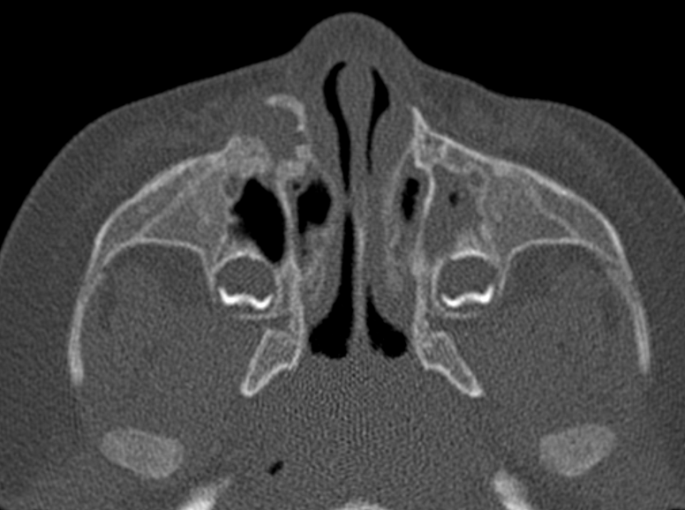
A
B

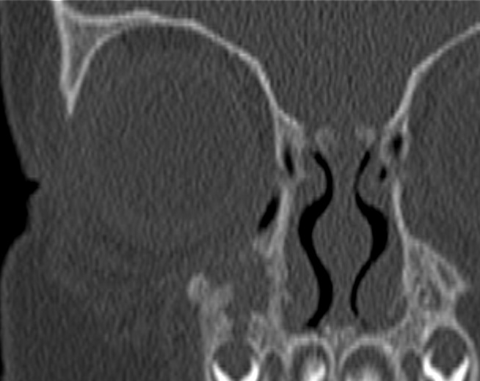
C
D

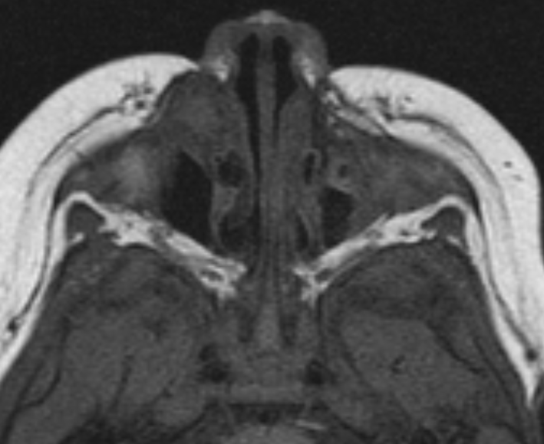
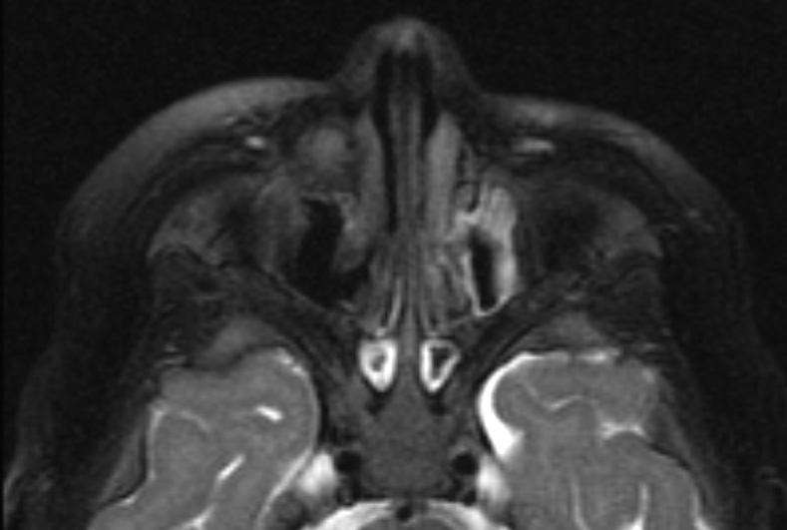
F
E

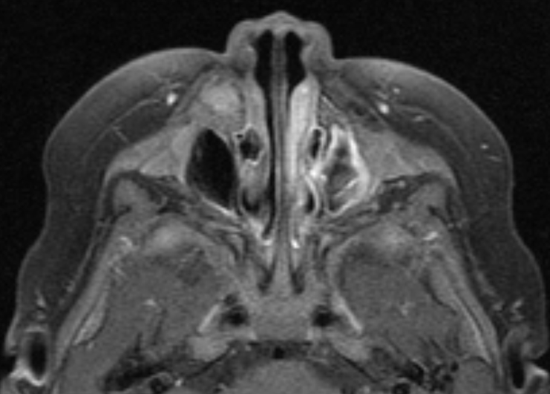
G

Figure 7
Figure 7 (A, D, F) Axial and sagittal T2 and coronal FLAIR demonstrating a T2 hyperintense finger-like white matter signal abnormality in the superior parasagittal cerebellar white matter associated with (B, E) T1 hypointensity on axial and sagittal T1 weighted imaging respectively and no enhancement post-gadolinium (C).

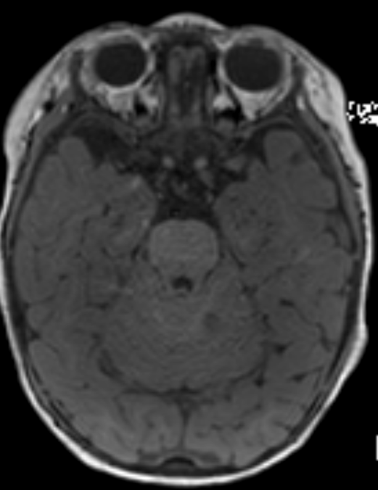
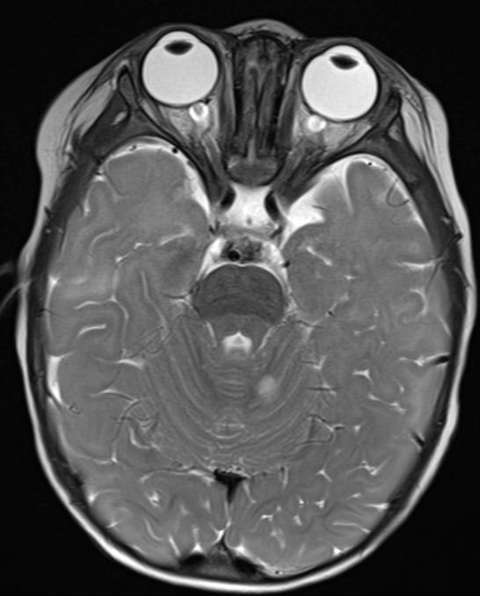
B
A

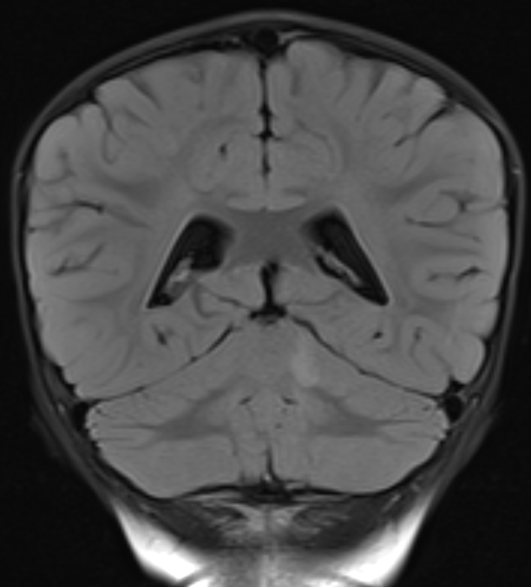
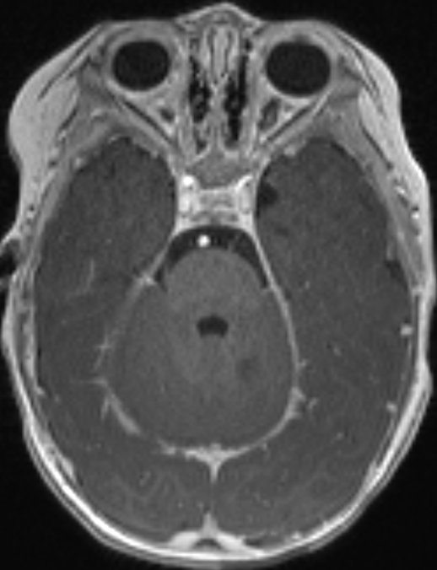
D
C

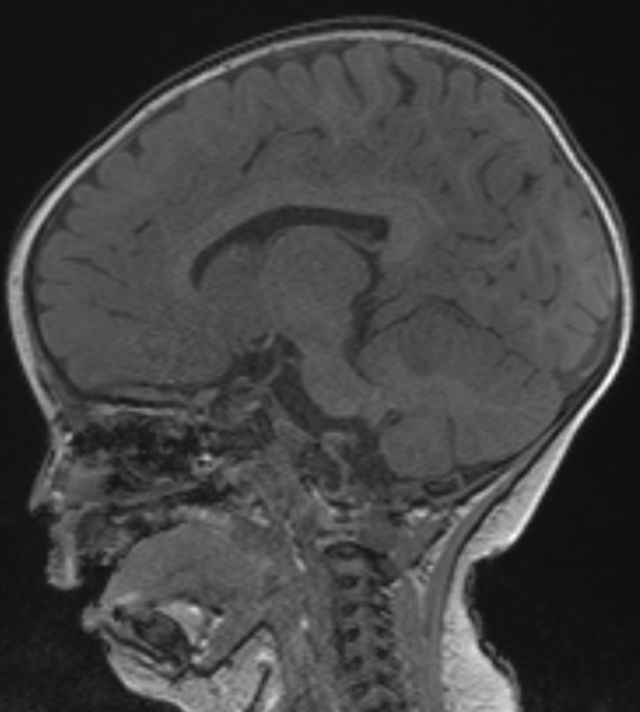
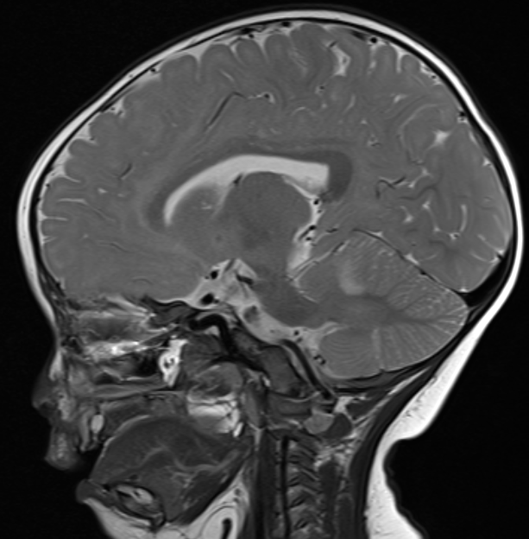
F
E

