Table1: clinical presentation and outcome of 6 patients with biotinidase deficiency
NO. | Age of onset | Presenting symptoms | Alopecia/skin rash |  | Increased anion gap metabolic acidosis |  | Age at diagnosis | Follow up period | outcome
1 | 1 M | Seizures ,stridor  Consanguinity+ | +/- |  |  | NO | 1.5 months | 6 months | Seizures controlled with in 48 hours  Development normal, hair grown back to normal
2 | 1.5 M | Seizures, epileptic encephalopathy(EME),  Consanguinity + | +/- |  |  | NO | 2 M | 6M | Clinical and electrographic remission of seizures in 72 hours.development normal, hair growth became normal.
3 | 1.5 M | seizures | +/+  Seborrhiec dermatitis |  |  | NO | 2 M | 3 M | Seizures improved  Development normal, rash improved,hair grown back to normal
4 | 2.5 M | Refractory status epilepticus, stridor | +/- |  |  | YES | 3 months | 1 year | Seizures free within 48-72 hours.  Mild motor delay. hair growth normal
5 | 7 M | Developmental regression | -/+ |  |  | YES | 7.5 M | LOST FOLLOW UP | Rash improved in 2 weeks but died after discharge in home town due to poor compliance and follow up
6 | 3.5 Y | Developmental delay,seizures  Spastic diplegia | -/- |  |  | YES | 3.6 Y | 1 Y | Seizures controlled  Spastic diplegia
7

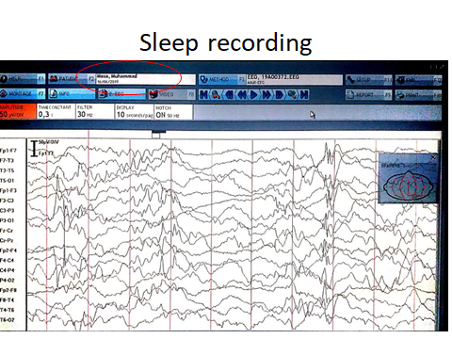
EEG Showing burst suppression pattern durind sleep (EME)
BEFORE TREATMENT
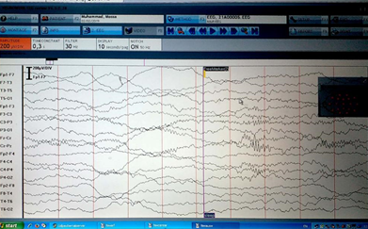
AFTER BIOTIN TREATMENT
NORMAL EEG

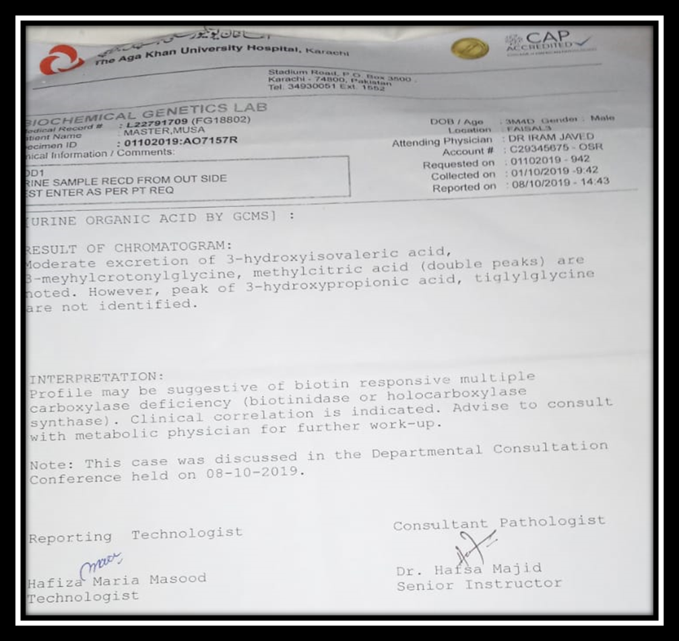
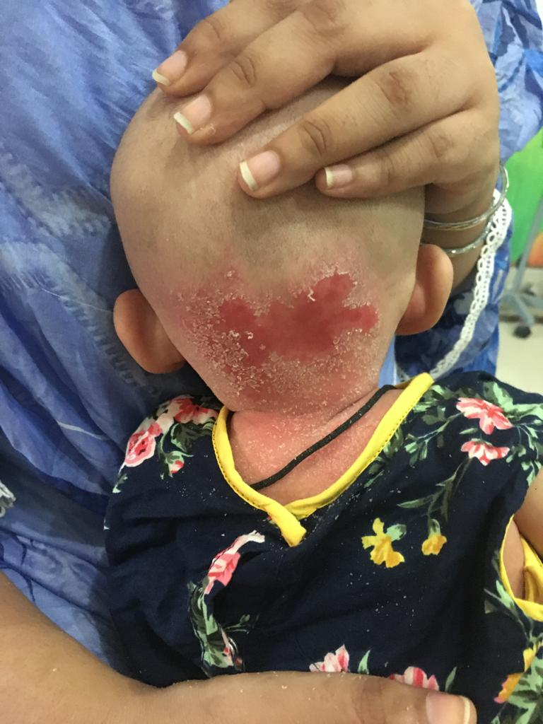BEFORE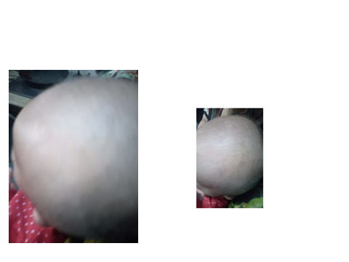BEFOREAFTER

AFTERAFTER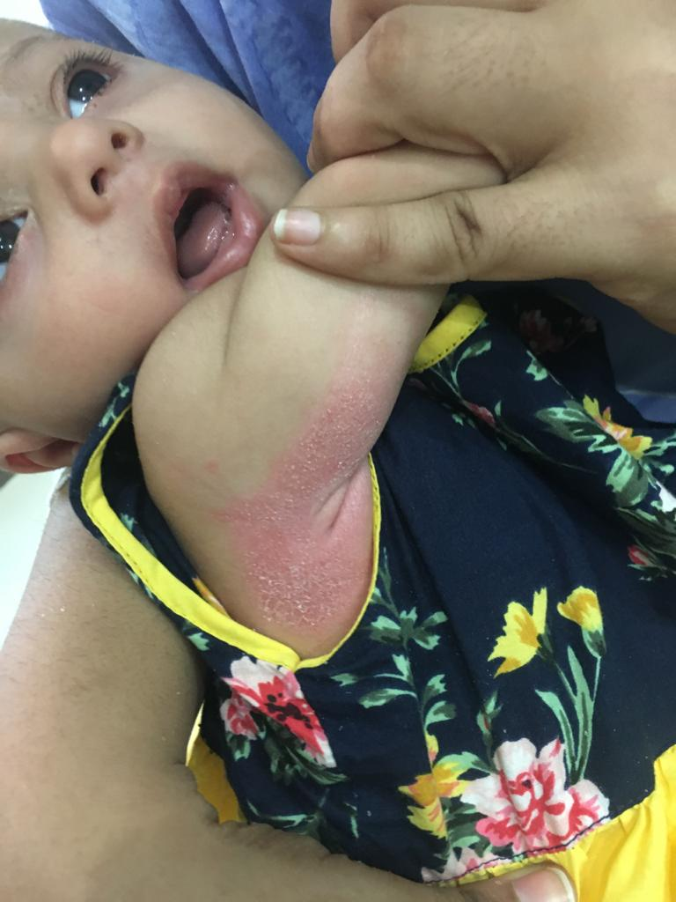BEFORE
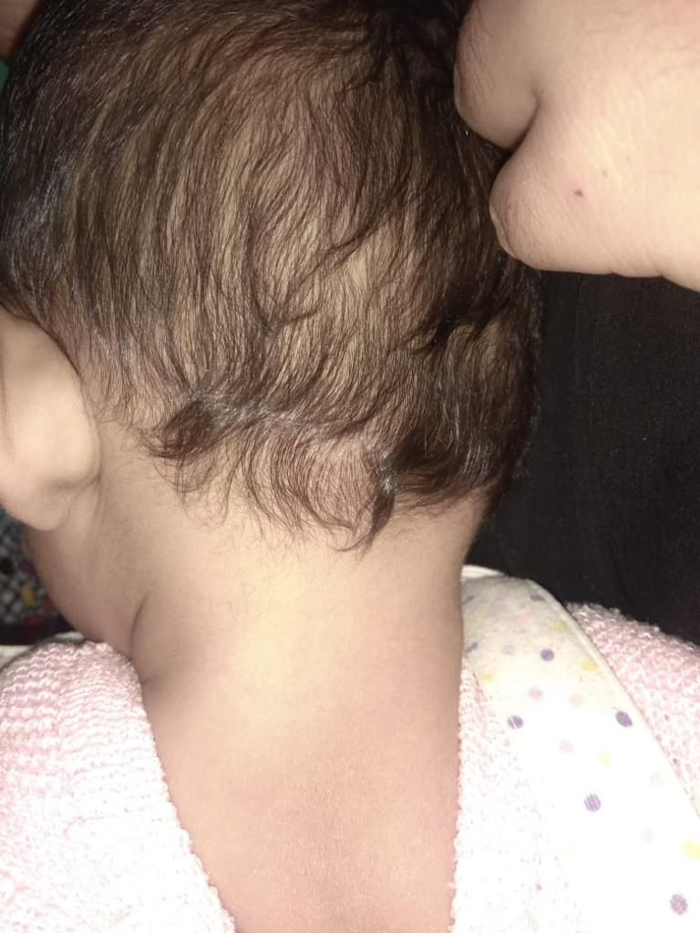AFTER

