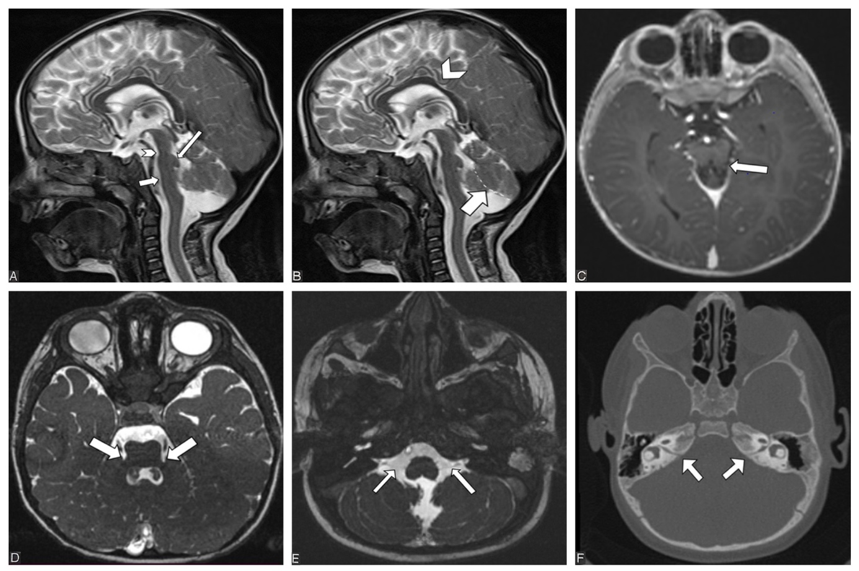

Figure 1: Cranial MRI and CT findings of patient 1: A) Midsagittal T2-weighted image shows flattening of the ventral pons (thick arrow). The dorsal upper pons has a cap-shaped dysmorphic appearance and protrudes towards the fourth ventricle (thin arrow). Mesencephalon pons junction level (isthmus) is hypoplastic (arrowhead). B) In sagittal T2-weighted series, hypoplastic cerebellar vermis separated by dotted lines is observed. The corpus callosum is thin and dysmorphic (arrowhead). C)Axial post-contrast T1-weighted image shows ‘molar tooth appearance’ of elongated superior cerebellar peduncles (arrow). D) Axial Constructive Interference in Steady State (CISS) sequence shows hypoplastic middle cerebellar peduncles (arrows). E) Axial Constructive Interference in Steady State (CISS) sequence shows hypoplastic vestibulocochlear and facial nerves (arrows) F) Narrow and hypoplastic internal acoustic canal is observed in axial CT images (arrows).

