Figure 1. Mean Bayley-III Total Language Score by Visit, Studies AADC-010 and AADC-011ª (N=20)
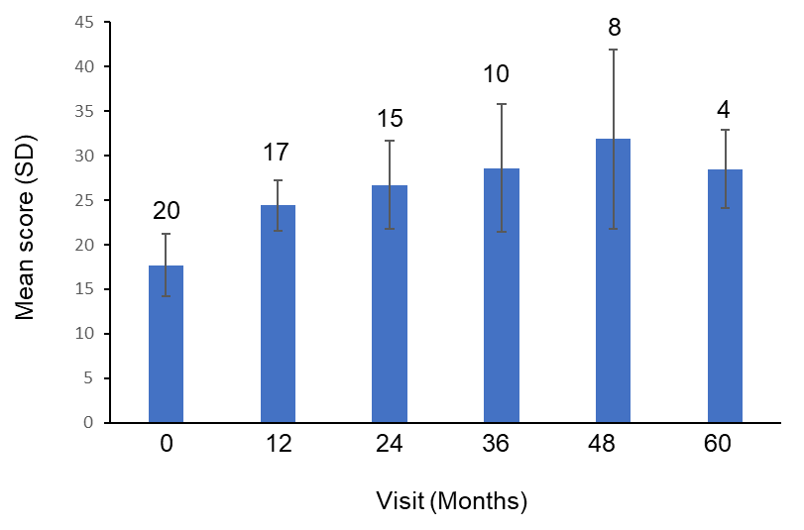
ªNumbers above each bar represent the number of patients evaluated at that timepoint.
Bayley-III, Bayley Scales of Infant Development, 3rd edition; SD, standard deviation.

