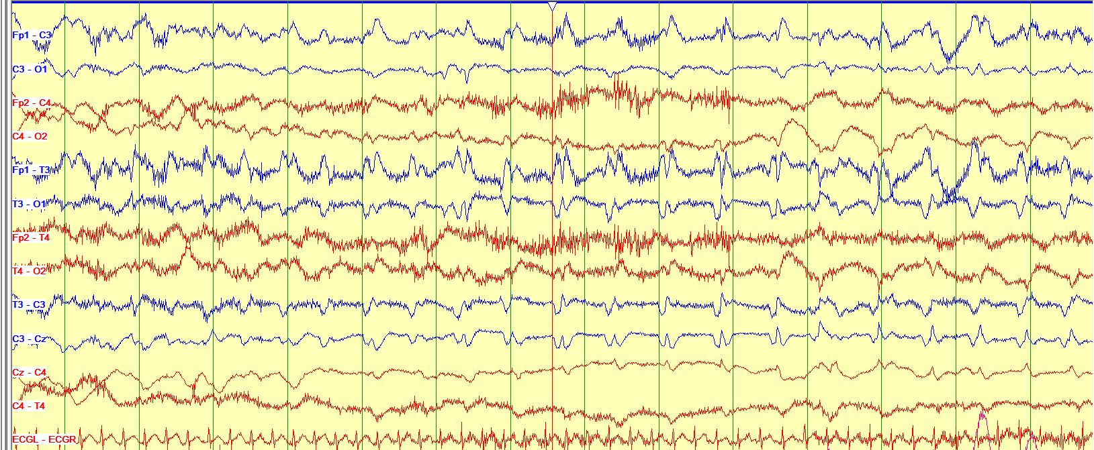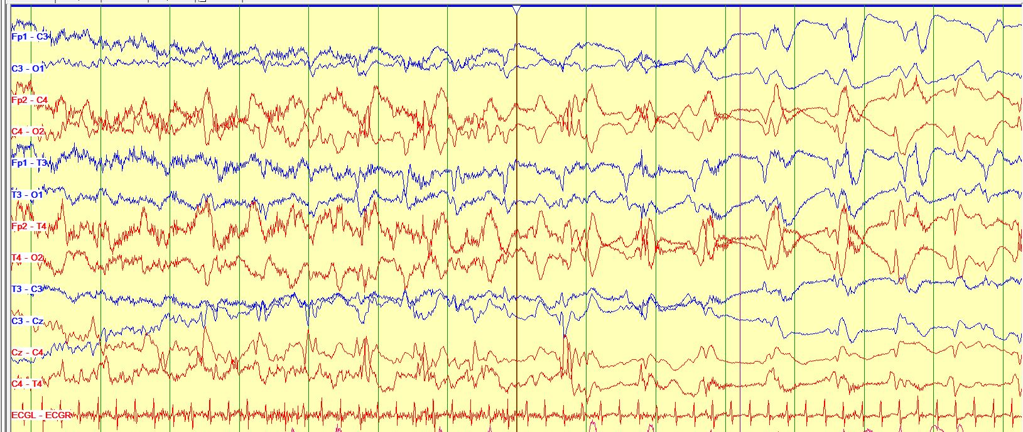

Figure 1: Top: EEG showing rhythmic electrographic seizure activity in the left hemisphere in the temporal chain
Figure 1: Bottom: Migration of same seizure to the right hemisphere which shows high amplitude rhythmic epileptic discharges with relative attenuation of the seizure activity on the left side.

