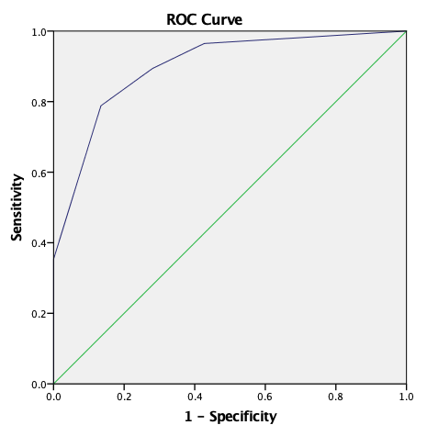
Figure 1. ROC Curve of Systemic part showed cut-off score ≥3, sensitivity of 78.8%, specificity of 86.6% with AUC of 89.9% (95% CI 85.2-94.5%; p<0.001))

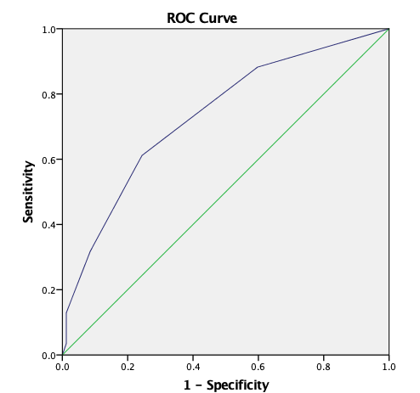
Figure 2. ROC Curve of Neurologic part showed score ≥2, sensitivity of 61.2%, specificity of 75.2% with AUC of 73.3% (95% CI 65.8-80.9%; p<0.001)

Table 1. Multiple Logistic Regression Analysis on Diagnostic Factors for Differentiation Between TBM and non-TB meningitis
Variables | p value | β coefficient | S.E | Score
Prodromal period ≥10 days | 0,004 | 1,340 | 0,466 | 1
Systemic symptoms of TB | <0,001 | 2,301 | 0,696 | 2
Close contact of adult with TB | 0,001 | 2,425 | 0,494 | 1
Chest X-ray indicates TB | 0,005 | 3,349 | 1,203 | 1
GCS score ≤12 | 0,012 | 0,855 | 0,349 | 1
Any meningeal sign | 0,013 | 0,774 | 0,348 | 1
Any cranial nerve paralysis | 0,007 | 1,387 | 0,518 | 2
Any hemiparesis | 0,068 | 0,869 | 0,489 | 1

Table 2. Parameters of Final Scoring System
Parameters | Score
Systemic
Prodromal period ≥10 days | 1
Systemic symptoms of TB | 2
Close contact of adult with TB | 1
Chest X-ray indicates TB | 1
Neurologic
GCS score ≤12 | 1
Any meningeal sign | 1
Any cranial nerve paralysis | 2
Any hemiparesis | 1

These parameters when used together and met the cut-off score respectively, showed sensitivity 47.1%, specificity 95.1%, positive predictive value 90.9%, and positive likelihood ratio 9,65 times to predict diagnose of TBM in children

