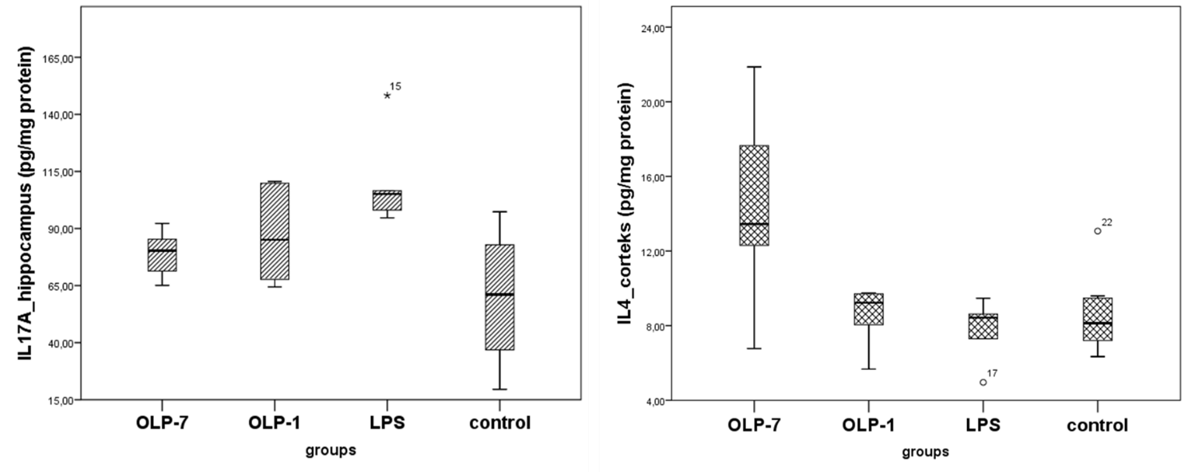
Figure 1. Levels of IL-17a in the hippocampus and IL-4 in the cortex in LPS, OLE and control groups. (OLP-1 group: a single dose OLE before LPS; OLP-7 group: seven days OLE before LPS. LPS: lipopolysaccharide, OLE: oleuropein).

