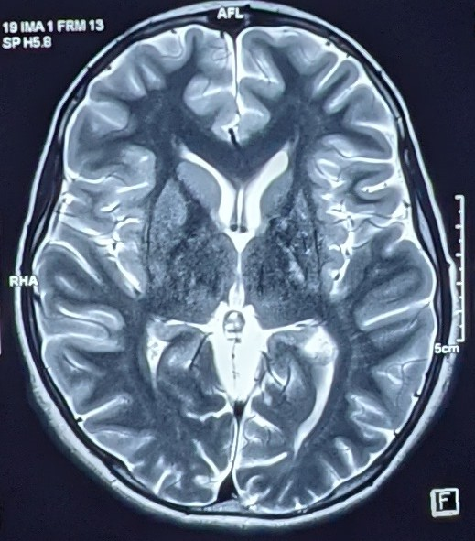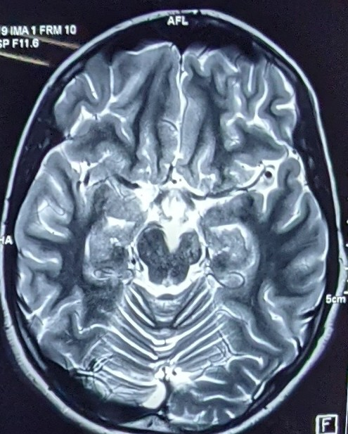
B
A
Figure 1. MRI at the onset of disease. T2 weighted axial images revealed atrophy of left caudate with Wallerian degeneration of left internal capsule(A) and left crus of midbrain(B).

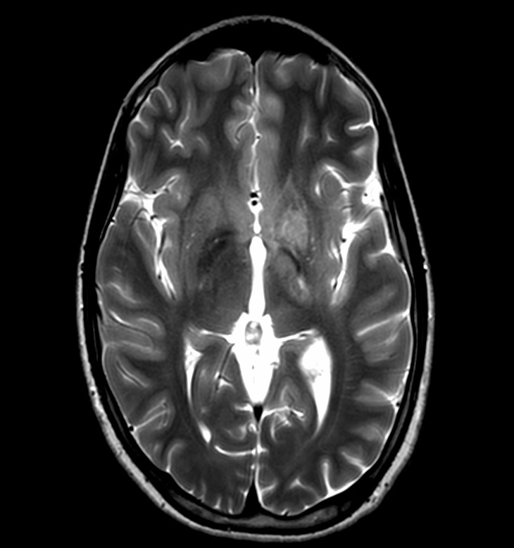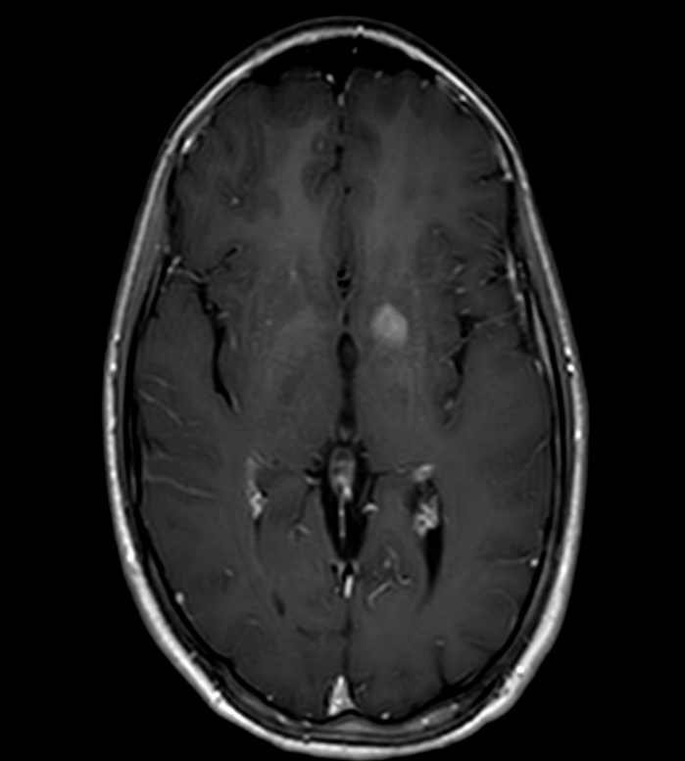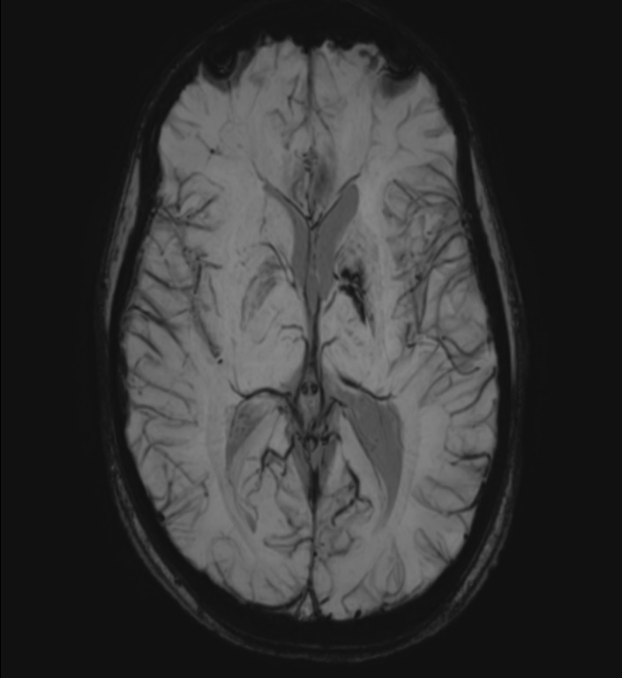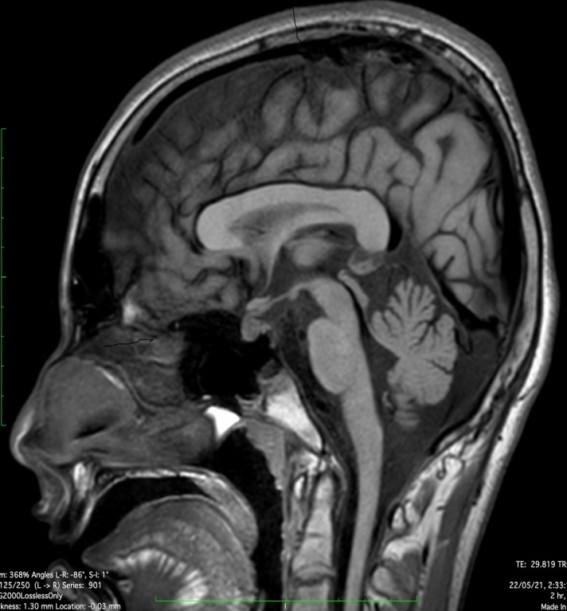
D
C
B
A
Figure 2. MRI brain 2 years later also revealed abnormal signal intensity over left ganglio-capsulo-thalamic region (A) which was contrast enhancing (B), with SWI image showing calcification (C). Sagittal T1 images also revealed absence of posterior pituitary bright spot (D).

