Table 1. Morphological and TUNEL staining findings in the experimental group
 | Group 1  (Kontrol grubu) | Group 2  (ZNS) | Group 3 (STM) | Group 4  (LCM) | Group 5  (CLB) | Group 6  (RUF) | p value
Number of follicles | 20,10±1,66  (18-23)  * | 7,80±1,93  (4-10)  *, ** | 12,50±1,58  (10-15)  *, **, *** | 16,30±2,31  (13-21)  *, **,*** ,**** | 12,80 ±2,14  (10-16)  *, **, ****,***** | 16,30 ±2,11  (14-21)  *, **,***,***** | p<0,001  (*p<0,001  **p<0,001  ***p<0,001  ****p=0,003  *****p=0,003)
Number of corpus luteum | 2,40±1,07  (1-4)  * | 8,00±2,11  (4-11)  *, **, *** **** | 5,70±1,34  (4-8)  *, ** | 6,70±1,16  (5-8)  * | 5,80±1,03  (4-7)  *, *** | 6,00±1,88  (4-9)  *, **** | p<0,001  (*p<0,001  **P=0,013  ***p=0,020  ****p=0,045)
TUNEL positive ovarian follicle count | 1,70± 0,67  (1-3)  ^ | 8,80 ± 1,48  (7-11)  ^, ^^, ^^^ | 4,60 ±0,97  (3-6)  ^ | 3,00 ± 1,05  (2-5)  ^^ | 5,40±1,07  (4-7)  ^ | 3,00±1,33  (1-5)  ^^^ | p<0,001  (^p<0,001  ^^p<0,001  ^^^p<0,001)
TUNEL positive granulosa cell count | 3,30 ± 1,42  (2-6)  * | 19,80±3,39  (16-16)  *,** | 14,00± 2,49  (10-18)  *,**,*** | 11,00± 1,63  (9-14)  *,** | 13,80±2,86  (10-18)  *,**  • Data presented as mean ± standard deviation (min-max), p < 0.001. ZNS, zonisamide, STM, sultiam; LCM, lacosamide; CLB, clobazam; RUF, rufinamide. **,***,****,***** p<0.001; Anova analysis and posthoc analysis results between groups. ^, ^^, ^^^ p<0.001; Kruskall Wallis Analysis of Variance and Posthoc Analysis Results Between Groups | 10,40±1,71  (8-13)  *,**,*** | p<0,001  (*p<0.001  **P<0,001  ***p=0,025)

Table 2. HSCORE of immunohistochemical staining in experimental groups
 | Group 1  (Kontrol grubu) | Group 2  (ZNS) | Group 3  (STM) | Group 4  (LCM) | Group 5  (CLB) | Group 6  (RUF) | p value
IGF-1 | 207,30±15,06  (186-232)  * | 68,20±5,85  (60- 78)  *, ** | 116,40±9,37  (102-132)  *,**,*** | 148,90±12,42  (132-168)  *,**,***,**** | 109,50 ±5,91  (102-120)  *,**,***,**** | 146,50±7,82  (136-159)  *,**,*** | p<0,001  *p<0,001  **p<0,001  ***p<0,001  ****p<0,001
EGF | 190,30±10,73  (171-206)  * | 64,40±5,21  (58-73)  *,** | 112,60±6,58  (104-128)  *,**,*** | 145,00±12,01  (128-163)  *,**,***,**** | 106,30±6,60  (98-116)  *,**,**** | 142,10±8,02  (131-155)  *,**,*** | p<0,001  *p<0,001  **p<0,001  ***p<0,001  ****p<0,001
GDF-9 | 72,40 ± 5,06  (67-82)  * | 10,00 ± 1,49  (8-12)  *,** | 11,10 ± 1,20  (9-13)  *,*** | 11,10 ± 2,02  (8-14)  *,**** | 10,10±1,66  (8-13)  * | 59,30±6,82  (52-72)  *,**,***,**** | p<0,001  *p<0,001  **p<0,001  ***p<0,001  ****p<0,001
• Data presented as mean ± standard deviation (min-max), p < 0.001 . ZNS, zonisamide, STM, sulthiam; LCM, lacosamide; CLB, clobazam; RUF, rufinamide. IGF-1, insulin-like growth factor 1; EGF, Epidermal Growth Factor; GDF-9, growth and differentiation factor-9. **, ***, ****, ***** p<0.001; Anova analysis and Cross-Group Posthoc analysis results

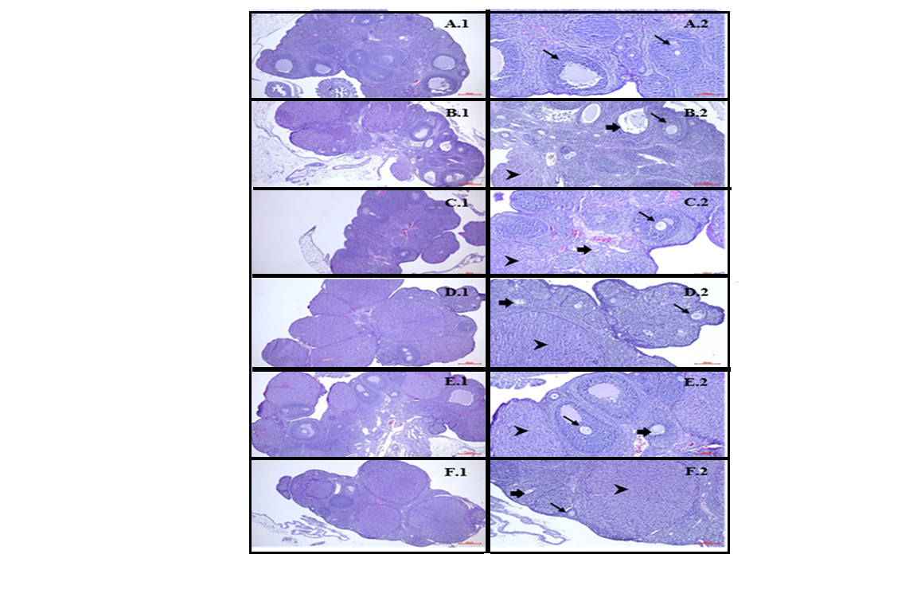

Figure 1: Ovarian hematoxylin-eosin staining. : Corpus Luteum : Atretic follicle, : Healthy follicle. Control (A), ZNS (B), STM (C), LCM (D), CLB (E), RUF (F).
Whole ovarian tissue (1) (x40) Bar = 30μm, (2) (X100) Bar = 200μm.

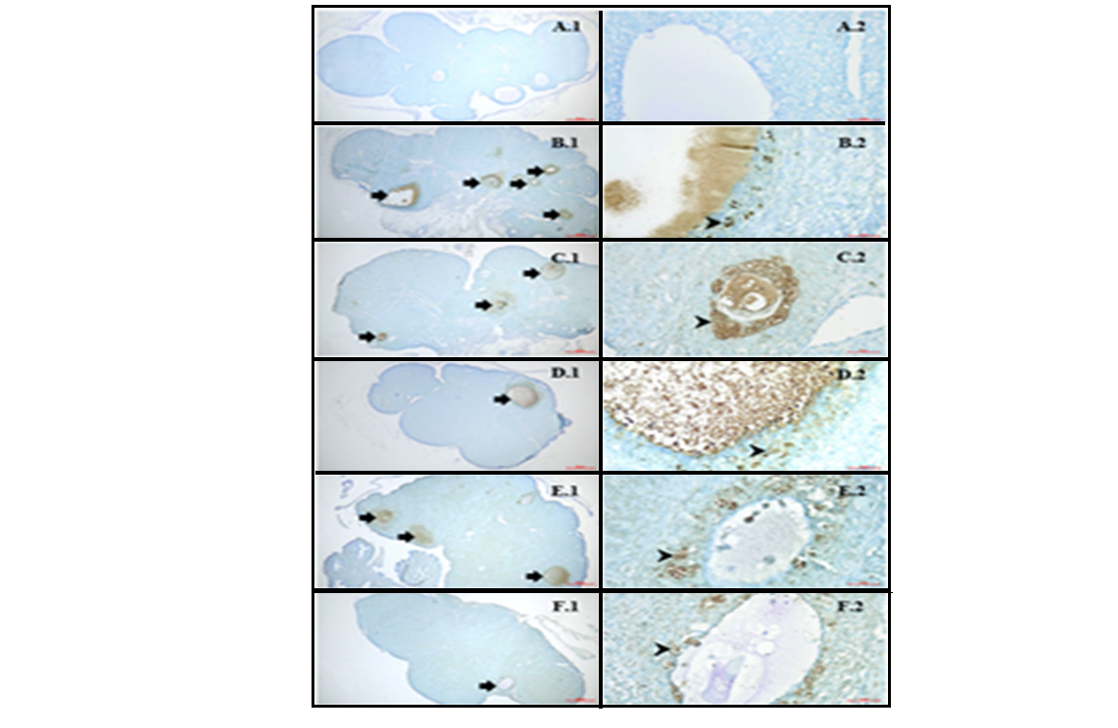

Figure 2: Ovarian Tunnel staining. : Atretic follicle, : Tunnel positive cells. Control (A), ZNS (B), STM (C), LCM(D), CLB (E), RUF (F). Whole ovarian tissue (1) (x40) Bar = 30μm, (2) (X40) Bar = 4μm.
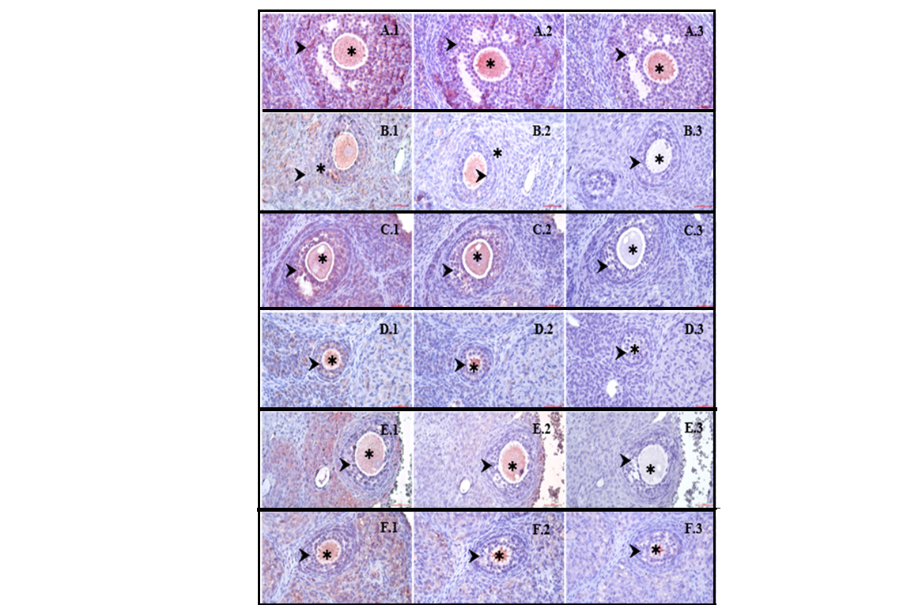

Figure 3: Ovary multilaminar primary follicle immunohistochemistry staining. : oocyte, : Granulosa cells. Control (A), ZNS (B), STM (C), LCM (D), CLB (E), RUF (F). Whole ovarian tissue. EGF (1), IGF-1 (2), GDF-9 (3). (x400) Bar = 4μm

