Supplementary data

Table ： the features of 14 patients suffered from West syndrome with MACF1 mutations.
Case [Reference] |  | Seizure onset | sex | head circumstance (SD) | weight (SD) | height (SD) | brain MR | seizure types | developmental delay | Muscle tension | Protein variants
1 | Dobyns et al.(2018) ^{[1]} | 5 months | female | 50.5cm(0) | 13.7kg(-1.7) | 105.0cm(-0.5) | lissencephaly with brainstem malformation | ISS | global | poor | p.Cys5177Phe (GENEBANK:NM_012090.5)
2 | Dobyns et al.(2018) ^{[1]} | 6 months | male | 53.0cm(+0.7) | 28.0kg(+1.0) | 128.0cm(0) | lissencephaly with brainstem malformation | ISS,LGS | global | poor | p.Cys5177Phe (GENEBANK:NM_012090.5)
3 | Dobyns et al.(2018) ^{[1]} | 3 months | female | 45.5cm(-1.0) | 13.5kg(+1.7) | 103.0cm(-1.0) | lissencephaly with brainstem malformation | SE,LGS | global | poor | p.Asp5228Tyr (GENEBANK:NM_012090.5)
4 | Dobyns et al.(2018) ^{[1]} | 3 months | male | 47.0cm(+0.5) | 14.0kg(-3.0) | 116.0cm(-1.0) | lissencephaly with brainstem malformation | MYO | global | poor | p.Asp5228Tyr (GENEBANK:NM_012090.5)
5 | Dobyns et al.(2018) ^{[1]} | 7 months | female | 49.5cm(-4.0) | 32.5kg(-3.0) | 150.0cm(-2.0) | lissencephaly with brainstem malformation | FSIA,LGS | global | poor | p.Cys5230Phe (GENEBANK:NM_012090.5)
6 | Dobyns et al.(2018) ^{[1]} | 5 months | female | 47.7cm(-5.0) | 29.0kg(-4.0) | 137.0cm(-4.0) | lissencephaly with brainstem malformation | FSIA,FTCS,GTCS | global | poor | p.Cys5230Phe (GENEBANK:NM_012090.5)
7 | Dobyns et al.(2018) ^{[1]} | 6 months | male | ND | 22.0kg(-0.4) | 50.0cm(-2.0) | lissencephaly with brainstem malformation | probable GTCS | global | poor | p.Cys5230Gly (GENEBANK:NM_012090.5)
8 | Dobyns et al.(2018) ^{[1]} | 5 years | female | 47.2cm(-0.4) | 10.0kg(-1.6) | 82.5cm(-1.6) | lissencephaly with brainstem malformation | MYO,GTCS | global | normal | *deletion
9 | Dobyns et al.(2018) ^{[1]} | 4 years,3 months | female | 51.3cm(0) | 20.4kg(+0.7) | 107.9cm(-0.1) | lissencephaly with brainstem malformation | FSIA,GTCS | mild | normal | p.Gly4706Arg (GENEBANK:NM_012090.5)
10 | Bölsterli et al.(2021) ^{[2]} | < 1 year | female | ND | ND | ND | pachygyria with brainstem malformation | ISS | global | ND | p.Asp5228Tyr (GENEBANK:ND)
11 | Lulu Kang et al.(2020) ^{[3]} | 1 year | male | ND | ND | ND | white matter dysplasia | ND | global | poor | p.Thr506Ile&p.Ile3885Thr (GENEBANK:ND)
12 | Cox et al.(2019) ^{[4]} | ND | female | ND | ND | ND | ND | ISS | ND | ND | p.Rrg4344Gln&p.Val3535Phe (GENEBANK:ND)
13 | Cox et al.(2019) ^{[4]} | ND | female | ND | ND | ND | ND | ISS | ND | ND | p.Ala3264Ser&p.Phe5885Leu (GENEBANK:ND)
14 | Present patient | 5 months | male | 43.0cm(-0.8) | 8.5kg(+0.2) | 66.0cm(-1.4) | pachygyria and lissencephaly | ISS | moderate | normal | p.Met5089Thr (GENEBANK:NM_012090.5)
FSIA, focal seizure with impaired awareness; FTCS, focal tonic-clonic seizure; GT, gastrostomy tube; GTCS, generalized tonic-clonic seizure; ISS, infantile spasm; LGS, Lennox-Gastaut epilepsy syndrome with atonic, tonic, tonic-clonic, and myoclonic seizures; MYO, myoclonic seizure; ND, no data available; SD, standard deviation;*Deletion of exons 58–89 (p.Ala3540_Arg5192; GenBank: NM_012090.5)

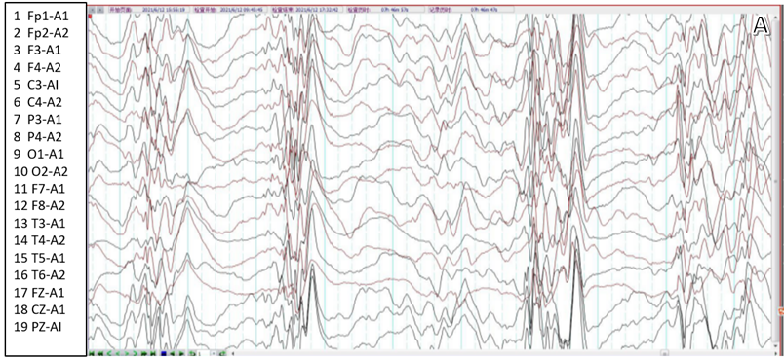
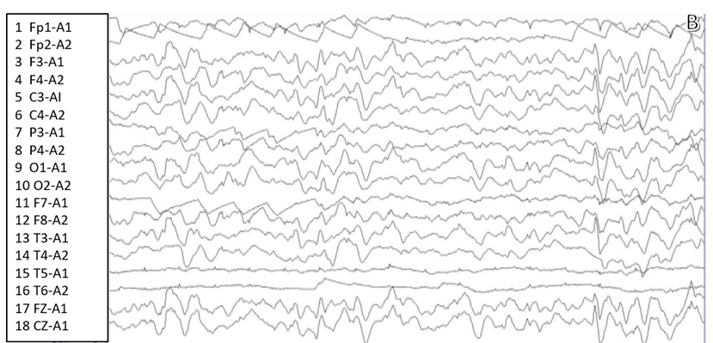
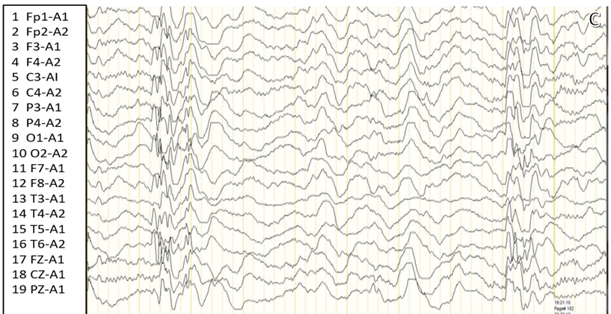
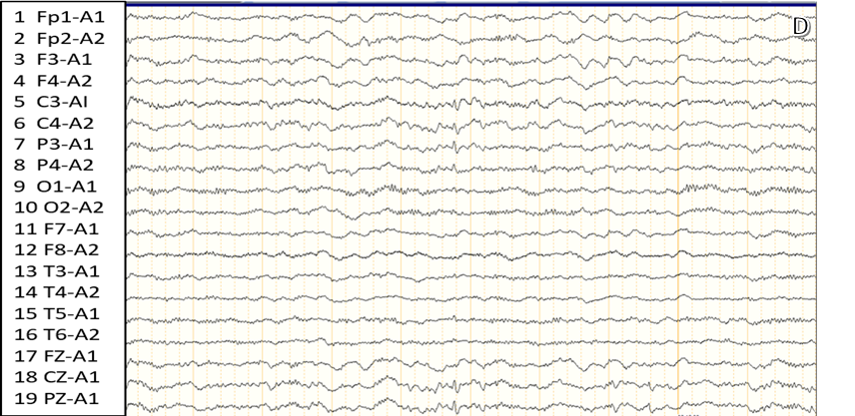
Fig.1. Video-electroencephalogram ﬁndings.
Panel A Hypsarrhythmia was observed in the whole brain area with increased slow background waves in waking and sleeping periods.
Panel B Re-examination of VEEG showed scattered spikes and slow waves of low-medium amplitude in the whole brain area at both periods of waking and sleeping. No obvious hypsarrhythmia was found.
Panel C Hypsarrhythmia recurred in the whole brain area at both periods of waking and sleeping.
Panel D After adding Vigabatrin, no obvious epileptiform wave was found in VEEG during the waking period. Few low-medium amplitude sharp waves were scattered in bilateral central and parietal areas during sleep.

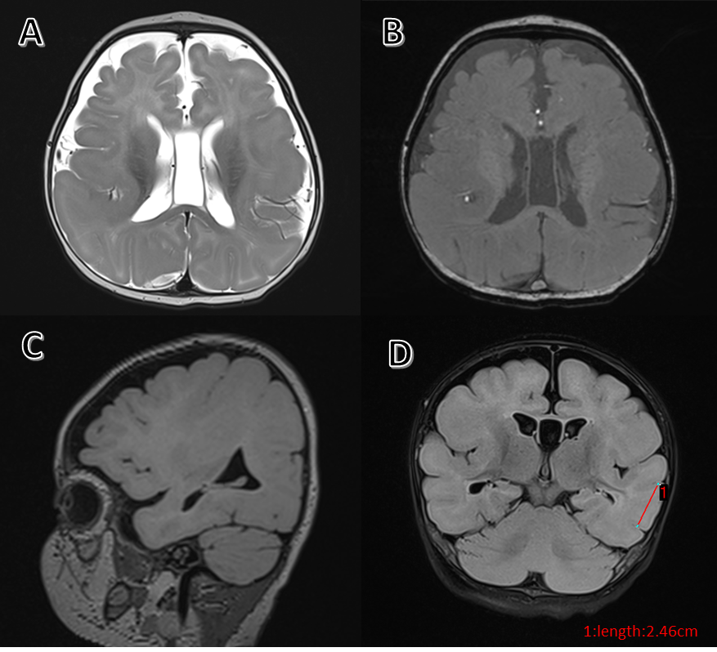
Fig.2. Panels A–D: Magnetic Resonance Imaging scans. (A) Axial T2-weighted imaging; (B) Axial T1-weighted imaging; (C) Sagittal T2 dark-fluid imaging; (D) Coronal T2-weighted imaging. The MRI scans revealed pachygyria and lissencephaly: posterior > anterior gradient.

References
[1] Dobyns, W.B., et al., MACF1 Mutations Encoding Highly Conserved Zinc-Binding Residues of the GAR Domain Cause Defects in Neuronal Migration and Axon Guidance. Am J Hum Genet, 2018. 103(6): p. 1009-1021.
[2] Bolsterli, B.K., et al., Lissencephaly with Brainstem Hypoplasia and Dysplasia: Think MACF1. Neuropediatrics, 2021. 52(3): p. 227.
[3] Kang, L., et al., Mutations of MACF1, Encoding Microtubule-Actin Crosslinking-Factor 1, Cause Spectraplakinopathy. Front Neurol, 2019. 10: p. 1335.
[4] Cox, A.J., et al., In trans variant calling reveals enrichment for compound heterozygous variants in genes involved in neuronal development and growth. Genet Res (Camb), 2019. 101: p. e8.
[5] Ka, M., J.J. Moffat, and W.Y. Kim, MACF1 Controls Migration and Positioning of Cortical GABAergic Interneurons in Mice. Cereb Cortex, 2017. 27(12): p. 5525-5538.

