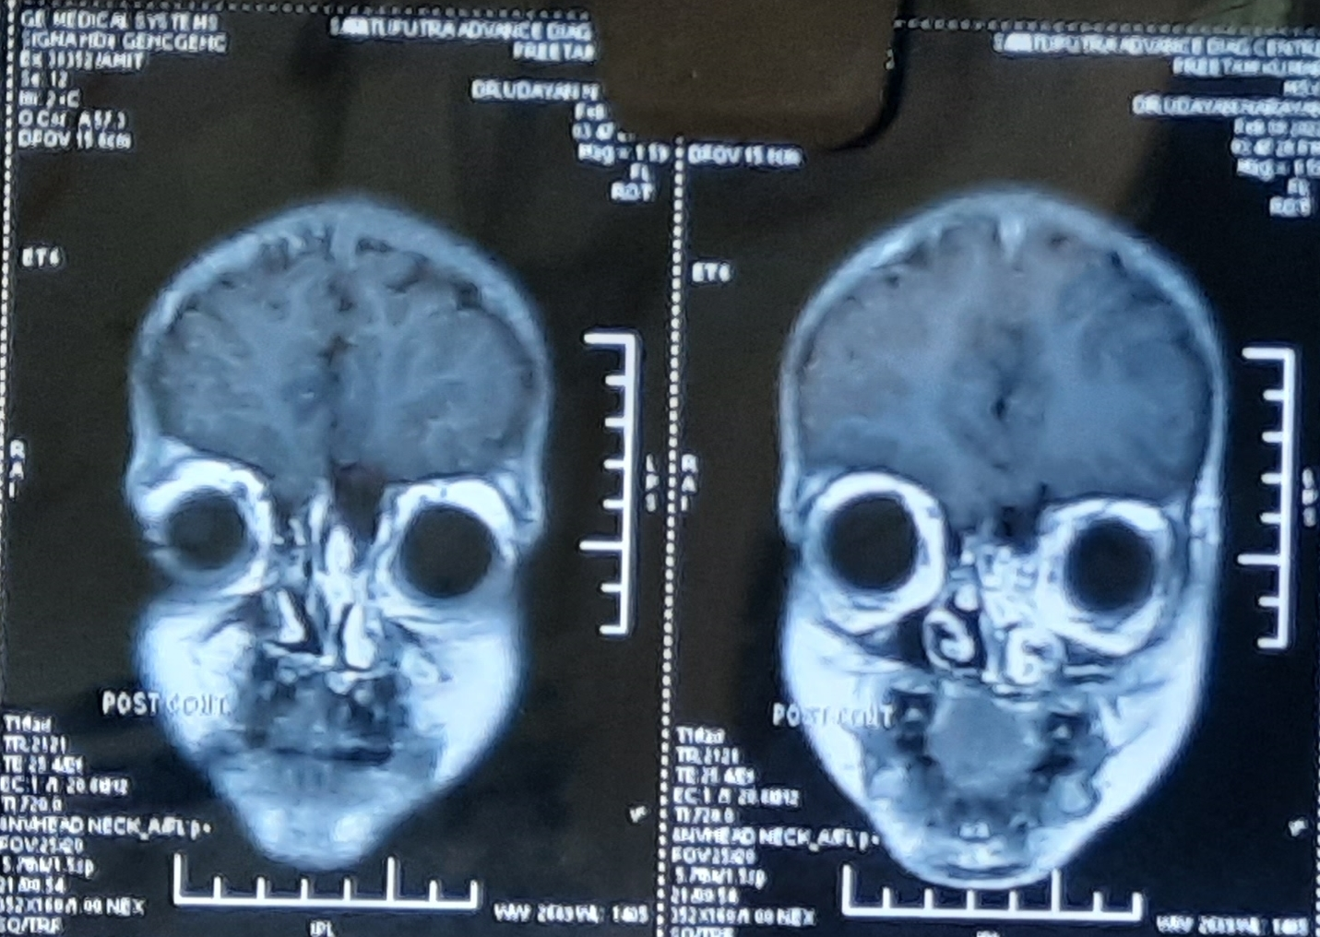

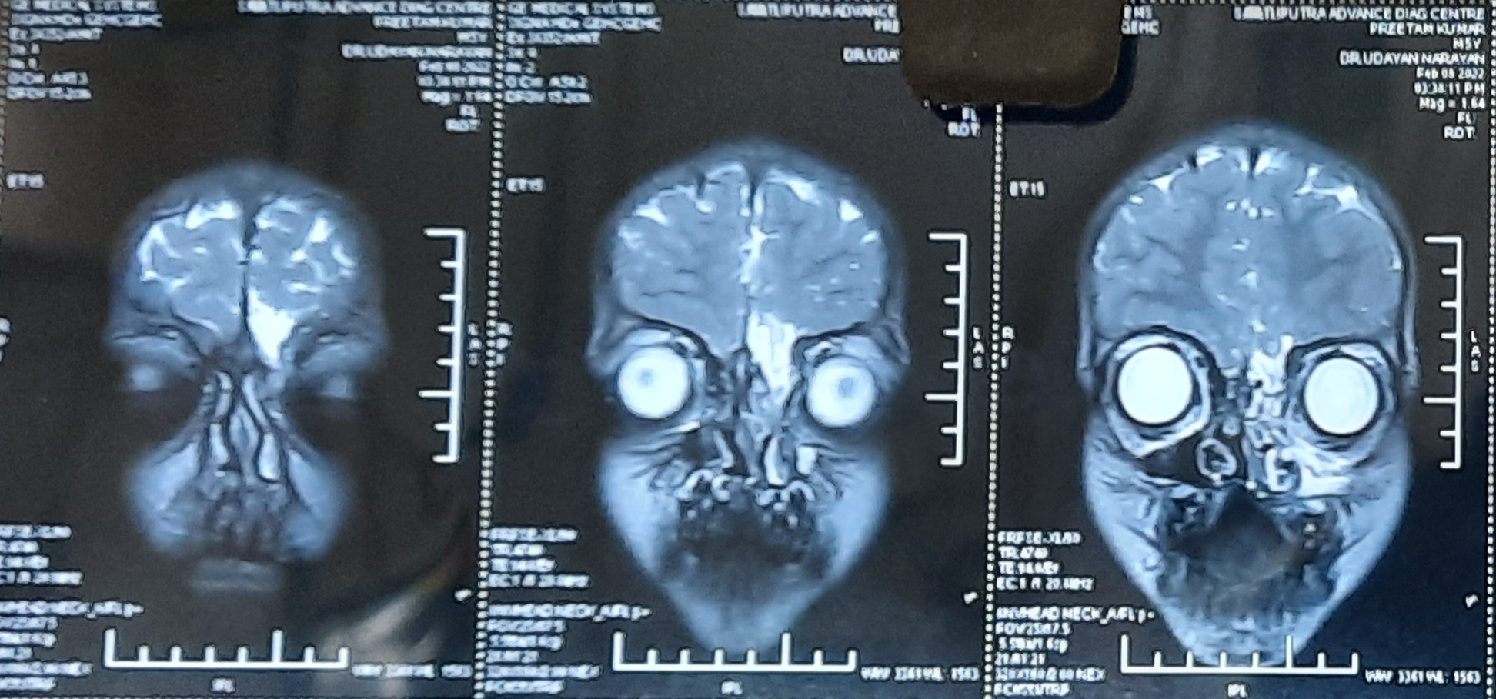

Post GAD T1 images (above) showing a small sized area of cystic encephalomalacia with gliosis in left basifrontal lobe along olfactory groove with herniation through cribriform plate into naso ethmoid region and T2 images (below) with hyperintense signal intensities.

