Figure 1: Showing response to treatment
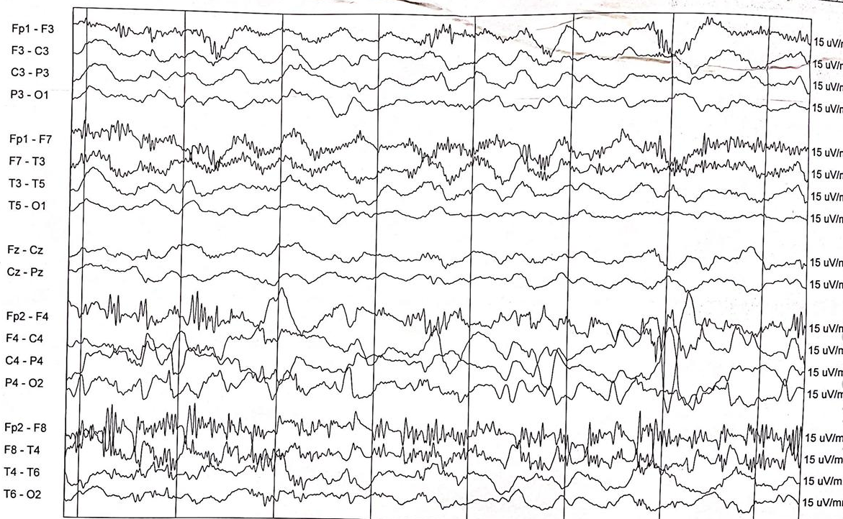
Figure 2: Delta-brush pattern on EEG

