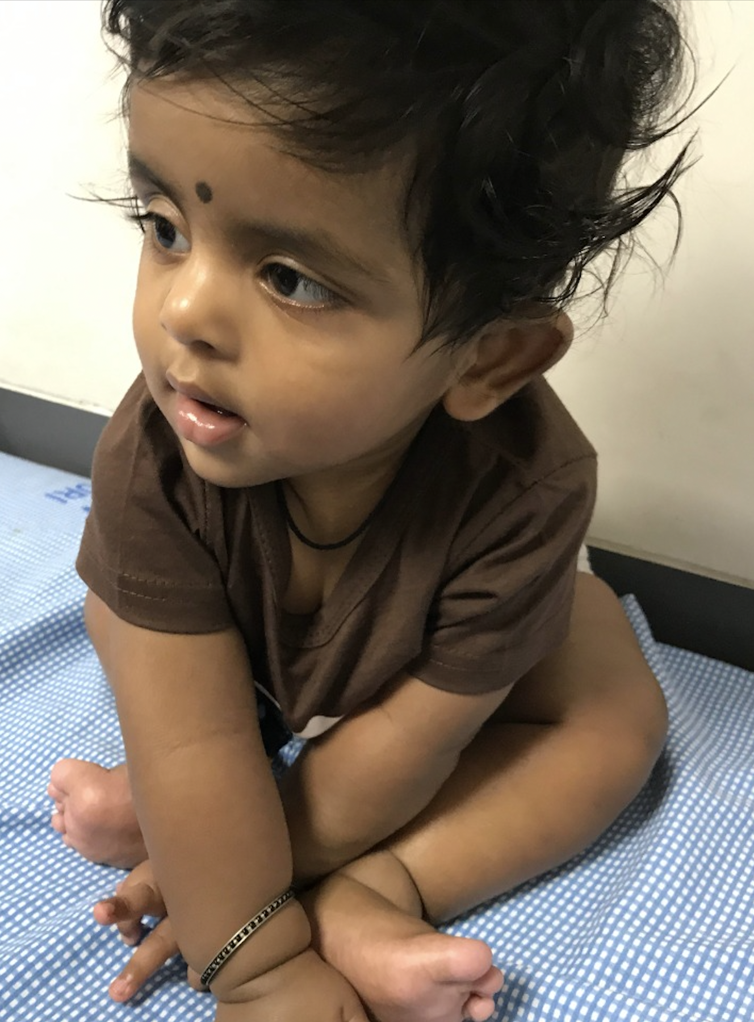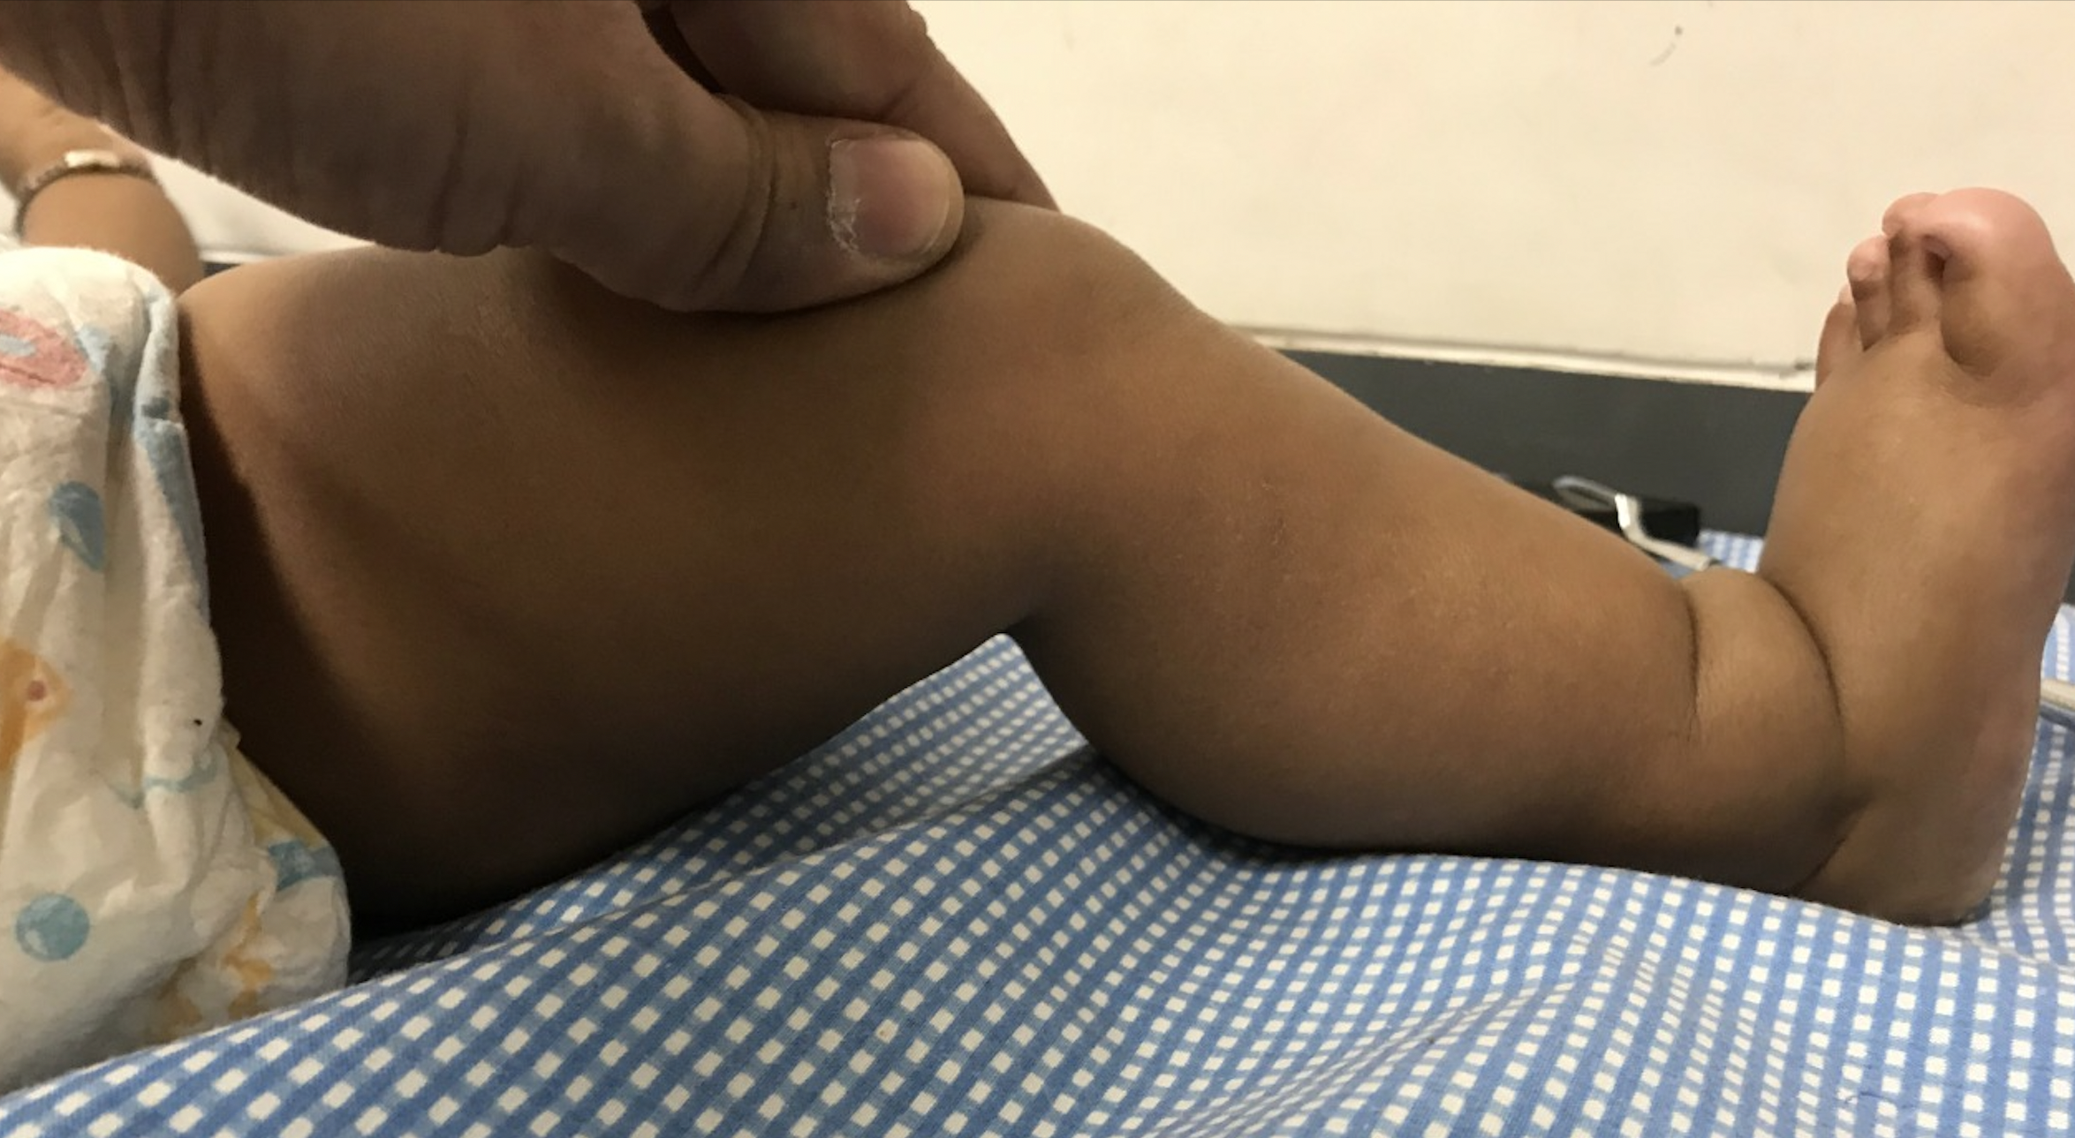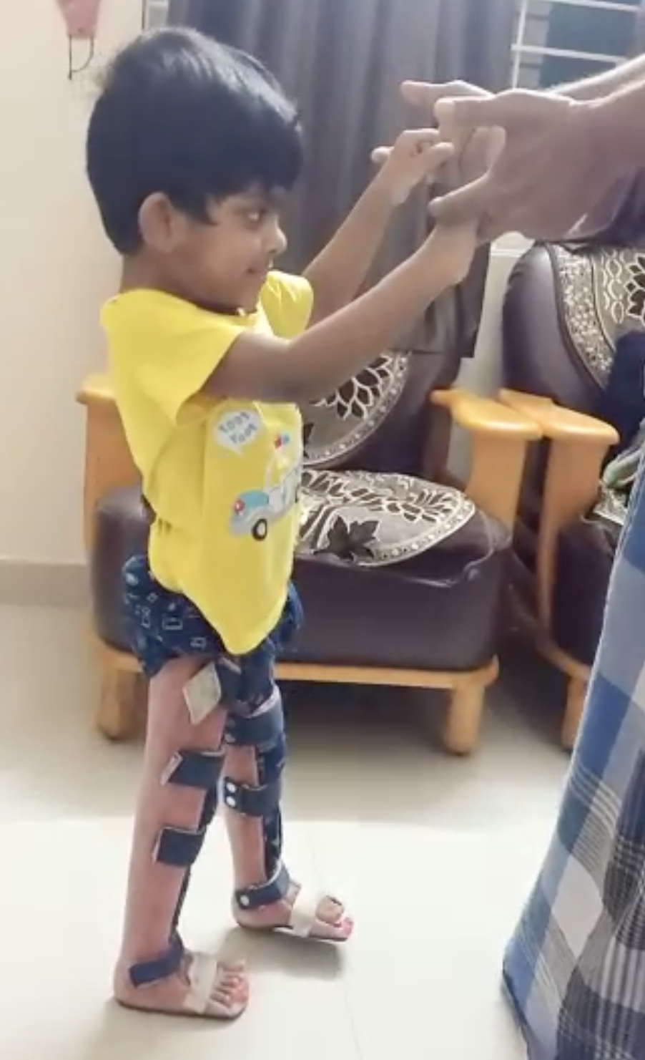

Figure 1: Child (case 1) with SMALED due to DYNC1H1 mutations, showing lower limb predominant weakness with preserved upper limb and upper trunk strength (A), atrophy and contractures of foot (B), and improving motor function (standing with orthotic support) (C)

