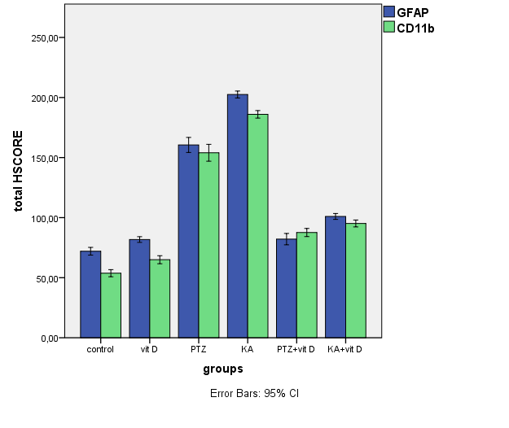
Figure 1. Comparison of astrocyte (GFAP) and microglia (CD11b) activation between groups. While GFAP and CD11b activation in PTZ and KA groups were significantly higher than in the control group (p<0.001), these values were significantly decreased in the groups that pretreated with vitamin D (p<0.001). [The total score was obtained by adding each H-score of five randomly selected areas in the hippocampus. The H-score was defined as previously reported by the following equation: H-score = ΣPi (i + 1) (i, staining intensity ranging from 0 to 3; Pi, percentage of cells stained for each intensity ranging from 0 to 100).]

