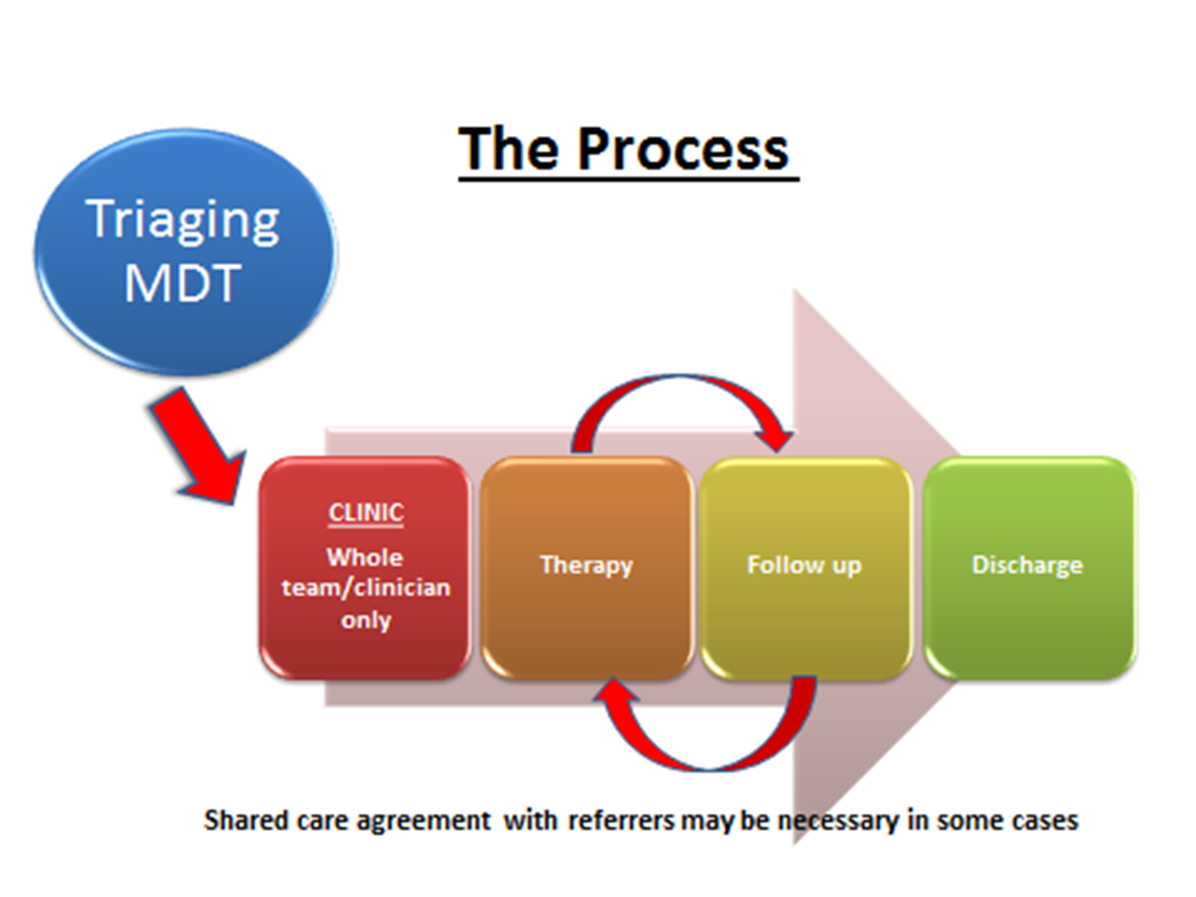

Key Challenges during set up
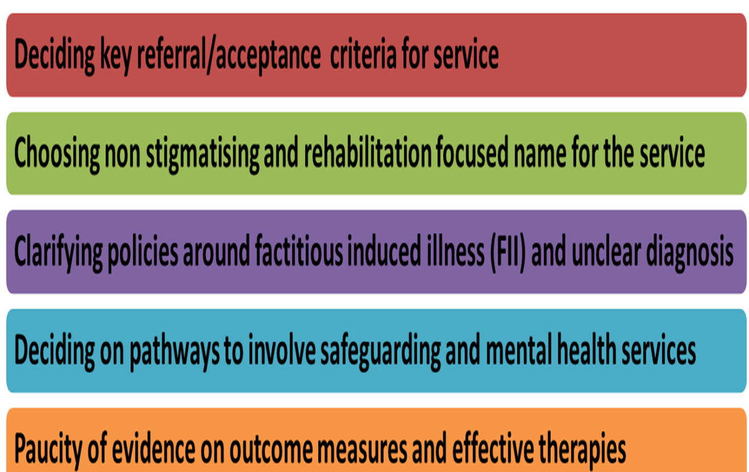

Team structure
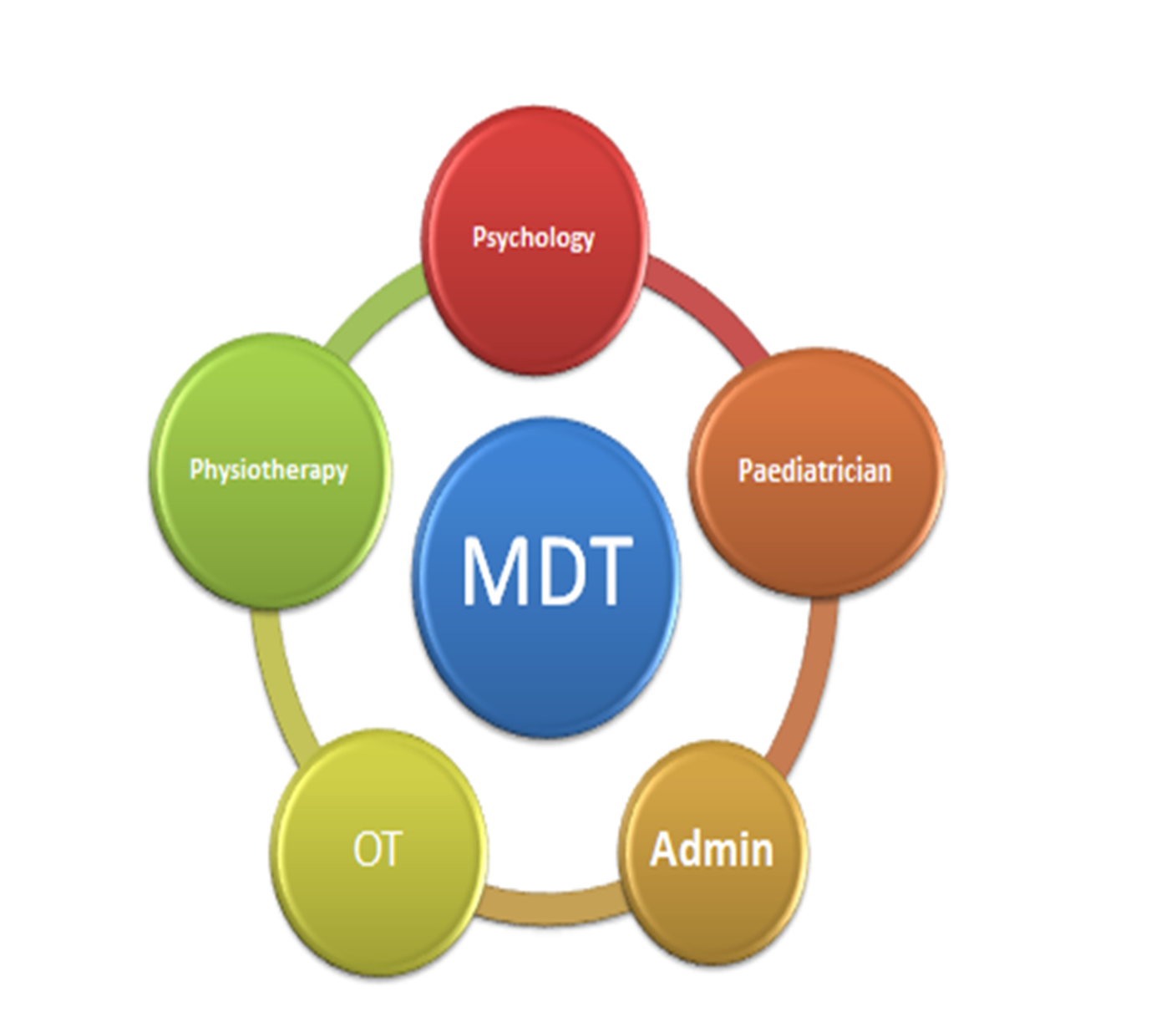

Treatment modalities
- Tailored to individual cases
- Joint working with families, carers and wider systems (e.g. school liaision & signposting to community activities)
- Cognitive behavioural therapy, mindfulness-based and systemic approaches
- Group therapy offered for appropriate patients
- Pain psychoeducation and education regarding mind-body interaction
- Exercise programme/advice, pacing and grading of activities
- Advice on sensory processing difficulties
- Sleep management
- Referral to art therapy and yoga sessions in hospital

Figure 2a

Figure 2b

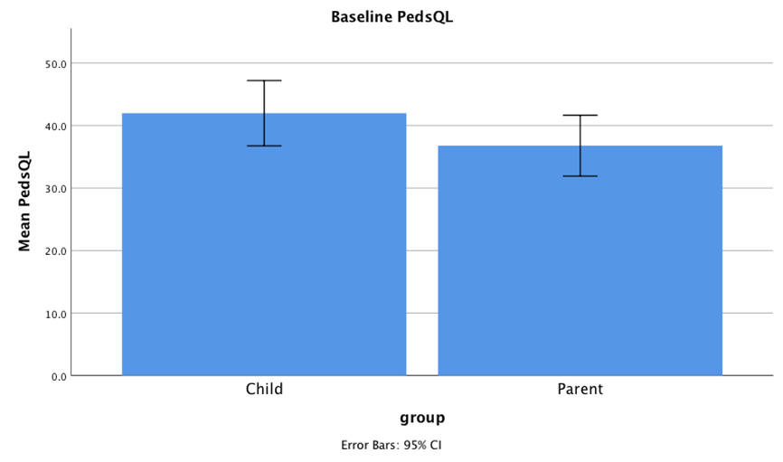

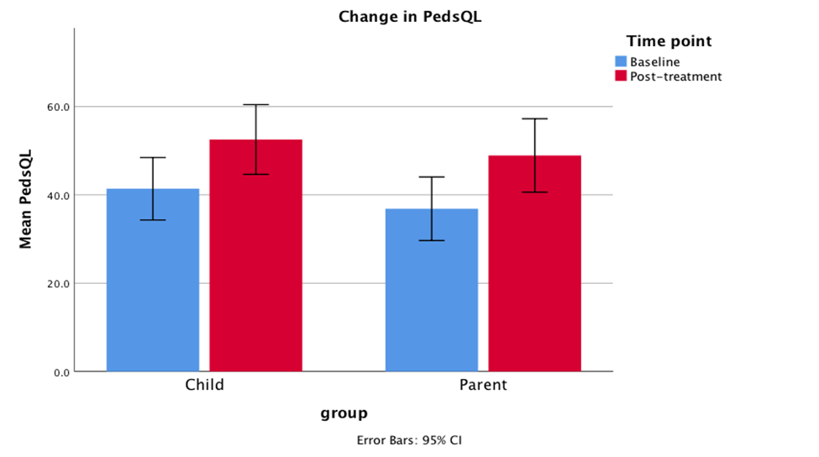

Chronic health condition | Study | Average PedsQL (child) score (±SD) | Average PedsQL (parent) score (±SD) | Sample (child, parent)
Asthma | Varni et al. (2004) | 74.7 (±15.8) | 72.4 (± 16.6) | 403, 516
ADHD | Varni et al. (2006) | 70.2 (±18.3) | 69.5 (±16.2) | 72, 69
Cancer | Varni et al. (2006) | 69.0(±15.2) | 60.7(±19.1) | 66, 71
Cerebral Palsy | Varni et al. (2006) | 66.3(±15.9) | 56.3(±17.3) | 57, 57
Type 1 & Type 2 Diabetes | Varni et al. (2003) | 80.4(±12.9) | 76.6(±14.1) | 300, 307
Rheumatic disease | Varni et al. (2002) | 72.1(±16.9) | 71.0 (±18.5) | 231, 244
Healthy | Varni et al. (2006) | 84.3(±12.6) | 79.9(±16.2) | 3256, 3251
Functional illness(Current Study) |  | 42.0(±19.5) | 36.8(±17.8) | 56, 54

