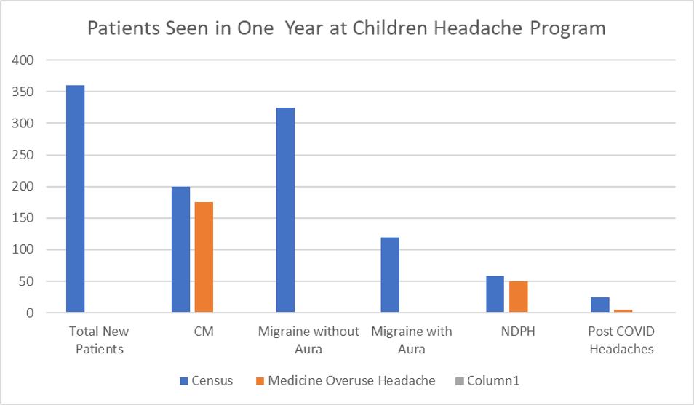
FIGURE :1 Demographics and Disease Distribution

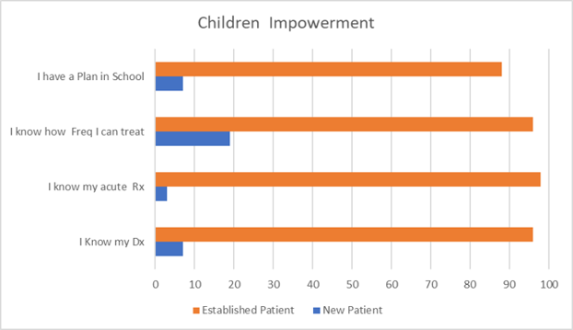

Figure 2: Children/Caregiver Understanding before and after seeing Pediatric Headache Specialist

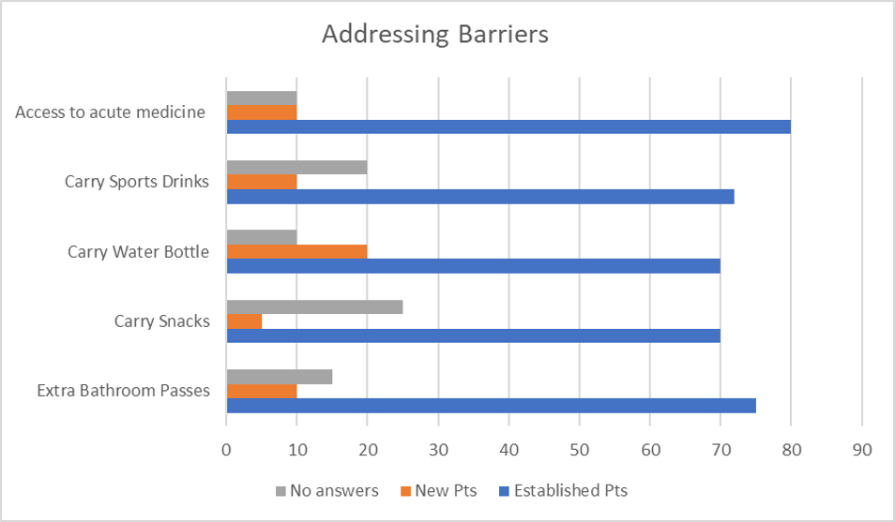

Figure 3: Identifying and Addressing Barriers to Treatment before and after seeing a pediatric headache specialist

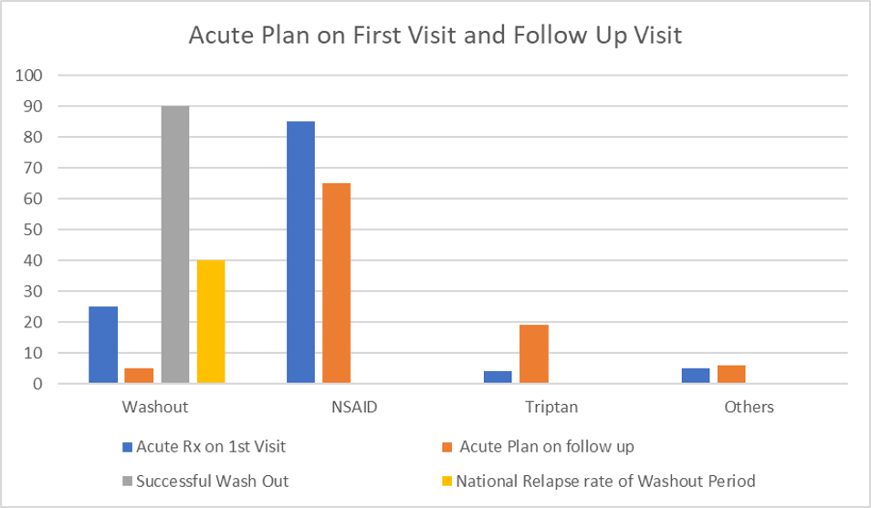
Figure 4: Acute Treatment including washout period as per American Headache Society Recommendation
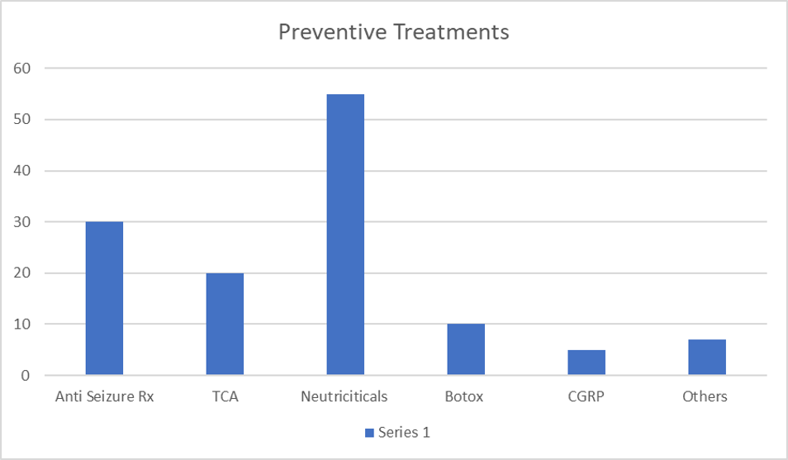
Figure 5: Preventive Treatment matrices including Life style changes and Vitamins ( Nutraceuticals)
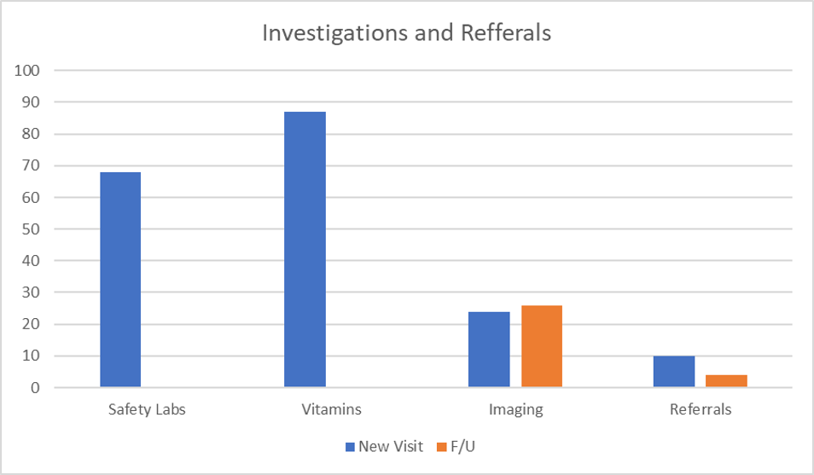

Figure 6: Financial and Safety Impact

