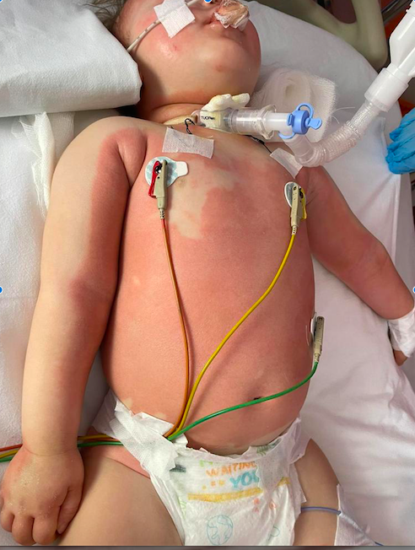

Figure1: Skin lesions of the Naxe Gene mutation

